COURSE CONTENT (SYLLABUS)

UNIT - I

Problem Solving Using Computers :Computer Overview, Introduction to components of a computer system, Algorithms ,Flowchart, Pseudo code with examples, Number systems(Decimal & Binary Conversion).

Overview of C :History of C, Basic structure of C- program, Creating and Running C-Program, Input and output statements.

UNIT - II

Fundamentals of C: C-Tokens, Data types, Operators, Expressions, Type conversions, Types of Errors , Input and output statements.

Control Statements in C

Decision making and branching, Decision making and Looping statements.

UNIT – III

Structured Programming :Functions: Syntax, Steps ,Types and Category of Functions, parameter passing mechanism. Recursion and Storage Classes

Dynamic memory allocation: malloc(), calloc(), realloc(), free() with example

UNIT - IV

Arrays & Strings: Declaration , Initialization and Accessing Elements, String handling functions, Array of Strings.

Structures and Unions: Defining structures, initializing structures, unions, Array of structures, self referential structures.

Pointers: Types of Pointers Use of Pointers, Dereferencing operations, Examples

UNIT - V

Numerical methods: Roots, Integration and Differentiation Methods, Examples

Linked List: Definition, Types, Implementation Using Self referential Structures:

Files: (only if time is available, otherwise should be done as part of the lab)

Text Books:

1. Byron Gottfried, Schaum’s Outline of Programming with C, McGraw-Hill.

2. B.A. Forouzan and R.F. Gilberg C Programming and Data Structures, Cengage Learning, (3rd Edition).

3. Ashok N. Kamthane, Programming in C, 2/e, Pearson Education.

4. Programming with C, by K.R. Venugopal, Tata Mcgraw Hill Publishing Co Ltd

References Books:

1. Brian W. Kernighan and Dennis M. Ritchie, The C Programming Language, Prentice Hall of India.
2. R.G. Dromey, How to solve it by Computer, Pearson (16th Impression).
3. Programming in C, Stephen G. Kochan, Fourth Edition, Pearson Education.
4. Herbert Schildt, C: The Complete Reference, Mc Graw Hill, 4th Edition.

Online Resources (SWAYAM/NPTEL/MOOCS/COURSERA):

1. <https://www.coursera.org/learn/computational-thinking-problem-solving>
2. nptel.ac.in/courses/106105085/4
3. nptel.ac.in/courses/106105085/2

Web Reference/E-Books:

1. <https://onlinecourses.nptel.ac.in/noc18_cs33/preview>
2. <http://www.thenewboston.com/>
3. <https://www.codesdope.com/>

UNIT – I

Problem Solving Using Computers: Computer Overview, Introduction to components of a computer system, Algorithms, Flowchart, Pseudo code with examples, Number systems(Decimal & Binary Conversion).

Overview of C: History of C, Basic structure of C- program, Creating and Running C-Program, Input and output statements.

Introduction to C:

C programming is a general-purpose, procedural, imperative computer programming language developed in 1972 by Dennis M. Ritchie at the Bell Telephone Laboratories to develop the UNIX operating system. C is the most widely used computer language. It keeps fluctuating at number one scale of popularity along with Java programming language, which is also equally popular and most widely used among modern software programmers.

Why to Learn C Programming?

C programming language is a MUST for students and working professionals to become a great Software Engineer specially when they are working in Software Development Domain. I will list down some of the key advantages of learning C Programming:

* Easy to learn
* Structured language
* It produces efficient programs
* It can handle low-level activities
* It can be compiled on a variety of computer platforms

# Applications of C Programming

C was initially used for system development work, particularly the programs that make-up the operating system. C was adopted as a system development language because it produces code that runs nearly as fast as the code written in assembly language. Some examples of the use of C are -

* Operating Systems
* Language Compilers
* Assemblers
* Text Editors
* Print Spoolers
* Network Drivers
* Modern Programs
* Databases
* Language Interpreters
* Utilities

What is a computer?

An electronic device which is capable of receiving information (data) in a particular form and of performing a sequence of operations in accordance with a predetermined but variable set of procedural instructions (program) to produce a result in the form of information or signals.A digital computer is an electronic programmable machine that can process almost all kinds of data

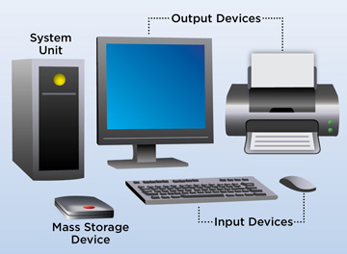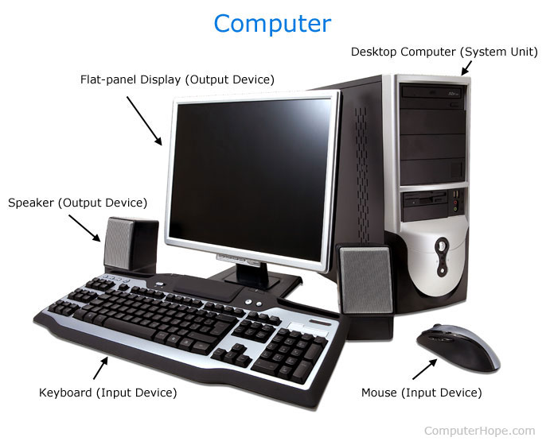

# What does a computer consist of?

Every computer mainly consists of three things and those are...

1. Hardware
2. Software
3. User

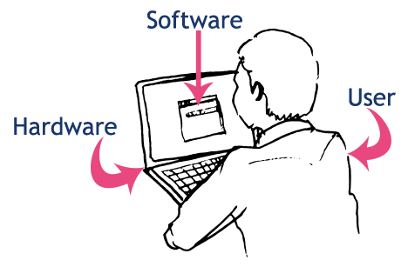

Computer Systems: A computer is a system made of two major components: hardware and software. The computer hardware is the physical equipment. The software is the collection of programs (instructions) that allow the hardware to do its job.



What is Computer Hardware?

All physical components of the computer are called as computer hardware. A user can see, touch and feel every hardware of the computer. All hardware components perform any task based on the instructions given by the computer software.

The computer hardware is the physical part of a computer.

The computer hardware components are as follows...

1. Input Devices - These are the parts through which a user can give the data to the computer.
2. Output Devices - These are the physical components of a computer through which the computer gives the result to the user.
3. Storage Devices - These are the physical components of a computer in which the data can be stored.
4. Devices Drives - Using drives, user can read and write data on to the storage devices like CD, floppy, etc.,
5. Cables - Various cables (Wires) are used to make connections in a computer
6. Other Devices - Other than the above hardware components, a computer also contains components like Motherboard, CPU (Processor), SMPS, Fans, etc.,

Computer Software

Computer software is divided in to two broad categories: system software and application software .System software manages the computer resources .It provides the interface between the hardware and the users.Application software, on the other hand is directly responsible for helping users solve their problems

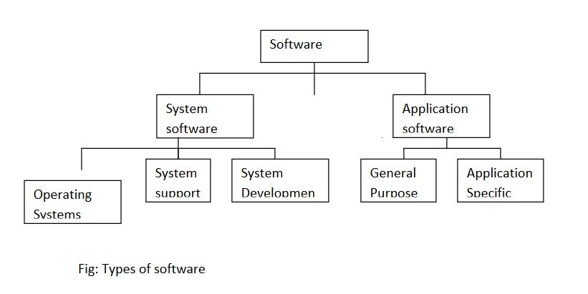

System Software:

System softwareconsists of programs that manage the hardware resources of a computer and perform required information processing tasks. These programs are divided into three classes: the operating system, system support, and system development.

The operating system provides services such as a user interface, file and database access, and interfaces to communication systems such as Internet protocols. The primary purpose of this software is to keep the system operating in an efficient manner while allowing the users access to the system

System support software provides system utilities and other operating services. Examples of system utilities are sort programs and disk format programs. Operating services consists of programs that provide performance statistics for the operational staff and security monitors to protect the system and data

The last system software category ,system development software, includes the language translators that convert programs into machine language for execution ,debugging tools to ensure that the programs are error free and computer –assistedsoftware engineering(CASE) systems.

Application software

Application software is broken in to two classes :general-purpose software and application –specific software. General purpose softwareis purchased from a software developer and can be used for more than one application. Examples of general purpose software include word processors ,database management systems ,and computer aided design systems. They are labeled general purpose because they can solve a variety of user computing problems.

Application –specific software can be used only for its intended purpose

A general ledger system used by accountants and a material requirements planning system used by a manufacturing organization are examples of application-specific software. They can be used only for the task for which they were designed they cannot be used for other generalized tasks

The relation ship between system and application software is shown in fig-2.In this figure, each circle represents an interface point .The inner core is hard ware. The user is represented by the out layer. To work with the system,the typical user uses some form of application software. The application software in turn interacts with the operating system ,which is apart of the system software layer. The system software provides the direct interaction with the hard ware. The opening at the bottom of the figure is the path followed by the user who interacts directly with the operating system when necessary.

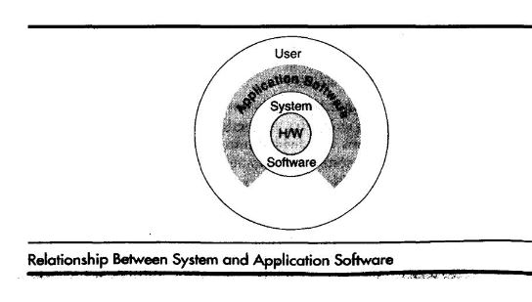

CPU Block Diagram:

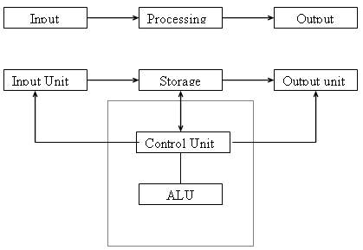

# Input Unit

# Computers need to receive data and instruction in order to solve any problem. Therefore we need to input the data and instructions into the computers. The input unit consists of one or more input devices. Keyboard is the one of the most commonly used input device. Other commonly used input devices are the mouse, pen drive, magnetic tape, SSD(Solid state Drive) etc. All the input devices perform the following functions.

# Accept the data and instructions from the outside world.

# Convert it to a form that the computer can understand.

# Supply the converted data to the computer system for further processing.

Computer input devices are the physical components of the computer which are used to give the data given by the user to the computer. Using input devices the user can give the data to the computer.



1. Output Unit

The output unit of a computer provides the information and results of a computation to outside world. Printers, Visual Display Unit (VDU) are the commonly used output devices.



1. Processing Unit: have fallowing categories

Storage Unit

The storage unit of the computer holds data and instructions that are entered through the input unit, before they are processed. Storages are divided into two types:

1. Primary Storage: Stores data and is very fast. This memory is generally used to hold the program being currently executed in the computer, the data being received from the input unit, the intermediate and final results of the program. The primary memory is temporary in nature. The data is lost, when the computer is switched off. Ex: DDR4 RAM (Volatile).
2. Secondary Storage: Secondary storage is used like an archive. It stores several programs, documents, data bases etc. The secondary memory is slower and cheaper than the primary memory. Some of the commonly used secondary memory devices are

Hard disk, CD, etc., 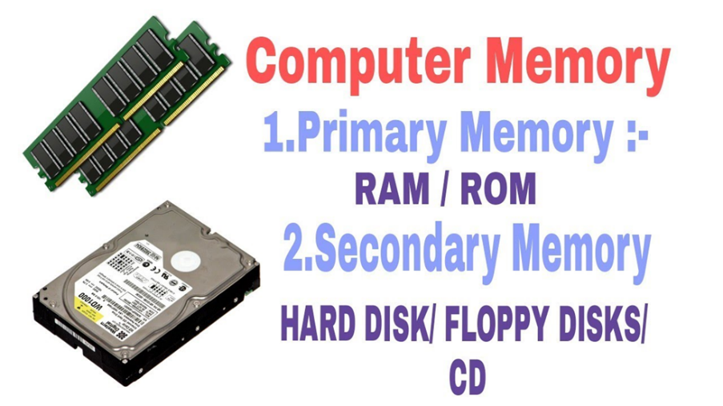



# Arithmetic Logical Unit

# All calculations are performed in the Arithmetic Logic Unit (ALU) of the computer. It also does comparison and takes decision. The ALU can perform basic operations such as addition, subtraction, multiplication, division, etc and does logic operations viz, >, <, =, ‘etc.

# Image result for ALU

# Whenever calculations are required, the control unit transfers the data from storage unit to ALU once the computations are done, the results are transferred to the storage unit by the control unit and then it is send to the output unit for displaying results.

# Control Unit

# It controls all other units in the computer. The control unit instructs the input unit, where to store the data after receiving it from the user. It controls the flow of data and instructions from the storage unit to ALU. It also controls the flow of results from the ALU to the storage unit.Image result for control unit

# CPU (Central Processing Unit)

# The control unit and ALU of the computer are together known as the Central Processing Unit (CPU).

# 1. Control Unit: It is responsible for directing and coordinating most of the computer system activities. It does not execute instructions by itself. It tells other parts of the computer system what to do. It determines the movement of electronic signals between the main memory and arithmetic logic unit as well as the control signals between the CPU and input/output devices.

# 2. Arithmetic logic Unit: ALU performs all the arithmetic and logical functions i.e. addition, subtraction, multiplication, division and certain comparisons. These comparisons include greater than, less than, equals to etc. The ALU controls the speed of calculations.

# 3. Registers: It is a special temporary storage location within the CPU.

# 4. Bus: The term Bus refers to an electrical pathway through which bits are transmitted between the various computer components.

# Device Drives

Computer Device drives are the physical components of the computer which are used to read and write data on the storage devices.



# Computer Cables

In a Computer, various cables are used to make connections among the various hardware components of the computer.



# Other Devices

Other devices of the computer are shown below...

# CPU (Processor)

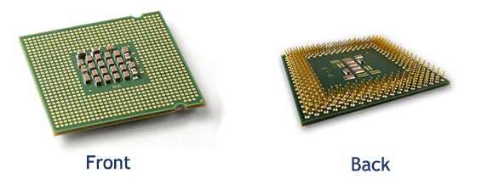

# SMPS

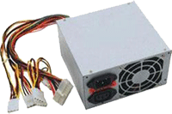

# CPU Fan (Heat Sink)

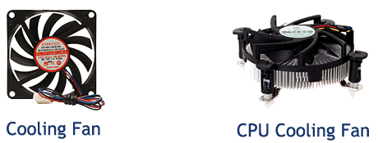

# Motherboard

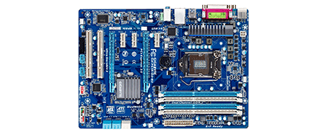

# How does Computer work?

When a user wants to communicate with the computer, the user interacts with an application. The application interacts with the operating system, and the operating system makes hardware components to work according to the user given instructions. The hardware components send the result back to the operating system, then the operating system forwards the same to the application and the application shows the result to the user.By using input devices, the user interacts with the application and the application uses output devices to show the result. All input and output devices work according to the instructions given by the operating system.The working process of a computer is shown in the following figure.

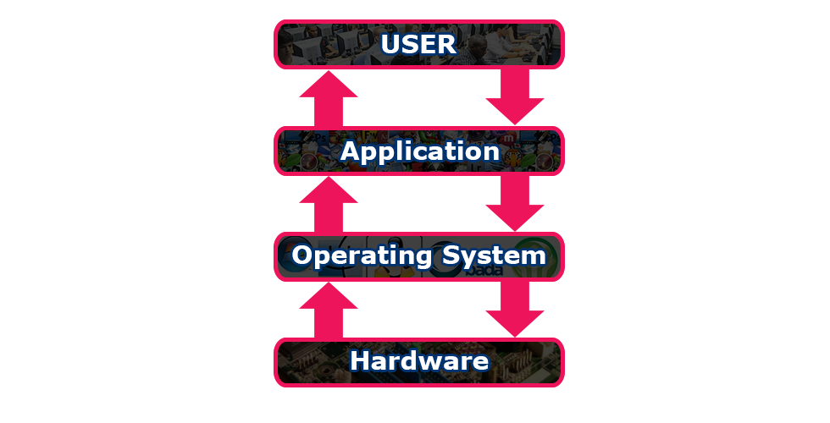

What is an Operating System?

* An operating system (OS) is system software that manages computer hardware and software resources and provides common services for computer programs. It acts as an interface between computer and user.
* The low-level software that supports a computer's basic functions, such as scheduling tasks and controlling peripherals.
* Types of Operating Systems: MS-DOS, Windows 98, Windows 2000, Windows XP, Linux, Unix, MAC-OS etc.
* Different categories of OS: Time-sharing, Batch OS, Distributed OS, Network OS, Real Time OS

|  |
| --- |
|  |
| Operating System is a program with the following features −   * An operating system is a program that acts as an interface between the software and the computer hardware. * It is an integrated set of specialized programs used to manage overall resources and operations of the computer. * It is a specialized software that controls and monitors the execution of all other programs that reside in the computer, including application programs and other system software.   Objectives of Operating System  The objectives of the operating system are −   * To make the computer system convenient to use in an efficient manner. * To hide the details of the hardware resources from the users. * To provide users a convenient interface to use the computer system. * To act as an intermediary between the hardware and its users, making it easier for the users to access and use other resources. * To manage the resources of a computer system. * To keep track of who is using which resource, granting resource requests, and mediating conflicting requests from different programs and users. * To provide efficient and fair sharing of resources among users and programs.   An operating system has three main functions:  (1) manage the computer's resources, such as the central processing unit, memory, disk drives, and printers,  (2) establish a user interface, and  (3) execute and provide services for applications software. |

Computing Environments

What is Computing Environment?

When we want to solve a problem using a computer, the computer makes use of various devices which work together to solve that problem. There may be a various number of ways to solve a problem. We use the various number of computer devices arranged in different ways to solve different problems. The arrangement of computer devices to solve a problem is said to be a computing environment. The formal definition of the computing environment is as follows.

Computing Environment is a collection of computers which are used to process and exchange information to solve various types of computing problems.

Types of Computing Environments

The following are the various types of computing environments.

1. Personal Computing Environment
2. Time-Sharing Computing Environment
3. Client-Server Computing Environment
4. Distributed Computing Environment
5. Grid Computing Environment
6. Cluster Computing Environment

Personal Computing Environment

Personal computing is a stand-alone machine. In a personal computing environment, the complete program resides on the stand-alone machine and executed from the same machine. Laptops, mobile devices, printers, scanners and the computer systems we use at home, office are the examples for the personal computing environment.



# Time-Sharing Computing Environment

The time-sharing computing environment is a stand-alone computer in which a single user can perform multiple operations at a time by using a multitasking operating system. Here the processor time is divided among different tasks and this is called “Time-sharing”. For example, a user can listen to music while writing something in a text editor. Windows 95 and later versions of Windows OS, iOS and Linux operating systems are the examples for this computing environment.



Client-Server Computing Environment

The client-server environment contains two machines (Client machine and Server machine). These both machines will exchange the information through an application. Here Client is a normal computer like PC, Tablet, Mobile, etc., and Server is a powerful computer which stores huge data and manages the huge amount of file and emails, etc., In this environment, client requests for data and server provides data to the client. In the client-server environment, the communication between client and server is performed using HTTP (Hyper Text Transfer Protocol).

Distributed Computing Environment

In the distributed computing environment, the complete functionality of the software is not on a single computer but is distributed among multiple computers. Here we use a method of computer processing in which different programs of an application run simultaneously on two or more computers. These computers communicate with each other over a network to perform the complete task. In a distributed computing environment, the data is distributed among different systems and that data is logically related to each other.

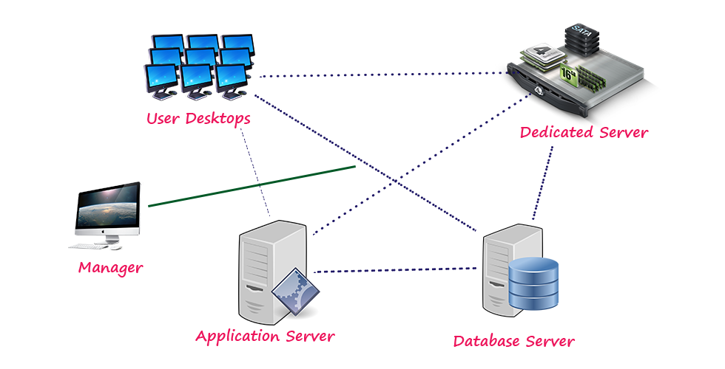

Grid Computing Environment

Grid computing is a collection of computers from different locations. All these computers work for a common problem. A grid can be described as a distributed collection of a large number of computers working for a single application.

Cluster Computing Environment

Cluster computing is a collection of interconnected computers. These computers work together to solve a single problem. In a cluster computing environment, a collection of systems work together as a single system.

What is Computer Language?

Generally, we use languages like English, Hindi, etc., to make communication between two persons. That means when we want to make communication between two persons we need a language through which persons can express their feelings. Similarly, when we want to make communication between user and computer or between two or more computers we need a language through which user can give information to the computer and vice versa. When a user wants to give any instruction to the computer the user needs a specific language and that language is known as a computer language.  
  
The user interacts with the computer using programs and that programs are created using computer programming languages like C, C++, Java, etc.,

Computer languages are the languages through which the user can communicate with the computer by writing program instructions.

Every computer programming language contains a set of predefined words and a set of rules (syntax) that are used to create instructions of a program.

Computer Languages Classification

Over the years, computer languages have been evolved from Low-Level to High-Level Languages. In the earliest days of computers, only Binary Language was used to write programs. The computer languages are classified as follows...

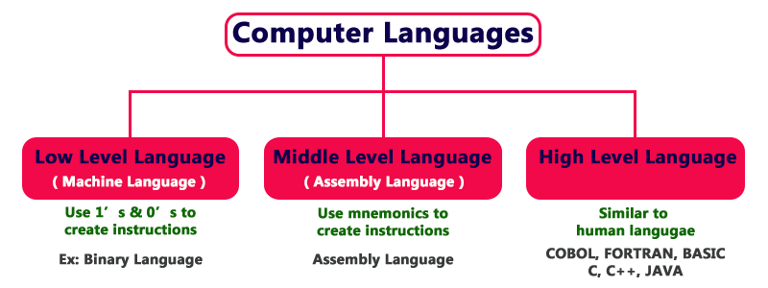

Low-Level Language (Machine Language)

Low-Level language is the only language which can be understood by the computer. Binary Language is an example of a low-level language. Low-level language is also known as Machine Language. The binary language contains only two symbols 1 & 0. All the instructions of binary language are written in the form of binary numbers 1's & 0's. A computer can directly understand the binary language. Machine language is also known as the Machine Code.  
  
As the CPU directly understands the binary language instructions, it does not require any translator. CPU directly starts executing the binary language instructions and takes very less time to execute the instructions as it does not require any translation. Low-level language is considered as the First Generation Language (1GL).

Advantages

* A computer can easily understand the low-level language.
* Low-level language instructions are executed directly without any translation.
* Low-level language instructions require very less time for their execution.

Disadvantages

* Low-level language instructions are very difficult to use and understand.
* Low-level language instructions are machine-dependent, that means a program written for a particular machine does not execute on another machine.
* In low-level language, there is more chance for errors and it is very difficult to find errors, debug and modify.

Middle-Level Language (Assembly Language)

Middle-level language is a computer language in which the instructions are created using symbols such as letters, digits and special characters. Assembly language is an example of middle-level language. In assembly language, we use predefined words called mnemonics. Binary code instructions in low-level language are replaced with mnemonics and operands in middle-level language. But the computer cannot understand mnemonics, so we use a translator called Assembler to translate mnemonics into binary language. Assembler is a translator which takes assembly code as input and produces machine code as output. That means, the computer cannot understand middle-level language, so it needs to be translated into a low-level language to make it understandable by the computer. Assembler is used to translate middle-level language into low-level language.

Advantages

* Writing instructions in a middle-level language is easier than writing instructions in a low-level language.
* Middle-level language is more readable compared to low-level language.
* Easy to understand, find errors and modify.

Disadvantages

* Middle-level language is specific to a particular machine architecture, that means it is machine-dependent.
* Middle-level language needs to be translated into low-level language.
* Middle-level language executes slower compared to low-level language.

High-Level Language

A high-level language is a computer language which can be understood by the users. The high-level language is very similar to human languages and has a set of grammar rules that are used to make instructions more easily. Every high-level language has a set of predefined words known as Keywords and a set of rules known as Syntax to create instructions. The high-level language is easier to understand for the users but the computer can not understand it. High-level language needs to be converted into the low-level language to make it understandable by the computer. We use Compiler or interpreter to convert high-level language to low-level language.  
  
Languages like COBOL, FORTRAN, BASIC, C, C++, JAVA, etc., are examples of high-level languages. All these programming languages use human-understandable language like English to write program instructions. These instructions are converted to low-level language by the compiler so that it can be understood by the computer.

Advantages

* Writing instructions in a high-level language is easier.
* A high-level language is more readable and understandable.
* The programs created using high-level language runs on different machines with little change or no change.
* Easy to understand, create programs, find errors and modify.

Disadvantages

* High-level language needs to be translated into low-level language.
* High-level language executes slower compared to middle and low-level languages.

Understanding Computer Languages

The following figure provides a few key points related to computer languages.

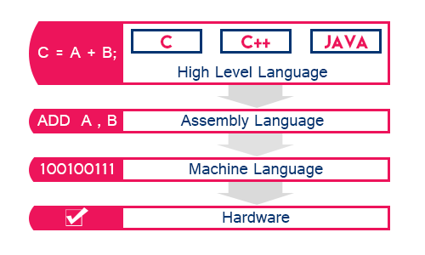

From the above figure, we can observe the following key points...

* The programming languages like C, C++, Java, etc., are written in High-level language which is more comfortable for the developers.
* A high-level language is closer to the users.
* Low-level language is closer to the computer. Computer hardware can understand only the low-level language (Machine Language).
* The program written in the high-level language needs to be converted to low-level language to make communication between the user and the computer.
* Middle-level language is not closer to both user and computer. We can consider it as a combination of both high-level language and low-level language.

INTRODUCTION TO ‘C’ LANGUAGE:

C language facilitates a very efficient approach to the development and implementation of computer programs. The History of C started in 1972 at the Bell Laboratories, USA where Dennis M. Ritchie proposed this language. In 1983 the American National Standards Institute (ANSI) established committee whose goal was to produce “an unambiguous and machine independent definition of the language C “ while still retaining it’s spirit .

C is the programming language most frequently associated with UNIX. Since the 1970s, the bulk of the UNIX operating system and its applications have been written in C. Because the C language does not directly rely on any specific hardware architecture, UNIX was one of the first portable operating systems. In other words, the majority of the code that makes up UNIX does not know and does not care which computer it is actually running on. Machine-specific features are isolated in a few modules within the UNIX kernel, which makes it easy for you to modify them when you are porting to a different hardware architecture.

C was first designed by Dennis Ritchie for use with UNIX on DEC PDP-11 computers. The language evolved from Martin Richard's BCPL, and one of its earlier forms was the B language, which was written by Ken Thompson for the DEC PDP-7.

The first book on C was *The C Programming Language* by Brian Kernighan and Dennis Ritchie, published in 1978.

In 1983, the American National Standards Institute (ANSI) established a committee to standardize the definition of C. The resulting standard is known as *ANSI C,* and it is the recognized standard for the language, grammar, and a core set of libraries. The syntax is slightly different from the original C language, which is frequently called K&R for Kernighan and Ritchie.

There is also an ISO (International Standards Organization) standard that is very similar to the ANSI standard.

It appears that there will be yet another ANSI C standard officially dated 1999 or in the early 2000 years; it is currently known as "C9X."

BASIC STRUCTURE OF C LANGUAGE:

The program written in C language follows this basic structure. The sequence of sections should be as they are in the basic structure. A C program should have one or more sections but the sequence of sections is to be followed.

1. Documentation section

2. Linking section

3. Definition section

4. Global declaration section

5. Main function section

{

Declaration section

Executable section

}

6. Sub program or function section

1. DOCUMENTATION SECTION : comes first and is used to document the use of logic or reasons in your program. It can be used to write the program's objective, developer and logic details. The documentation is done in C language with /* and */ . Whatever is written between these two are called comments.

2. LINKING SECTION : This section tells the compiler to link the certain occurrences of keywords or functions in your program to the header files specified in this section.

e.g. #include <stdio.h>

3. DEFINITION SECTION : It is used to declare some constants and assign them some value.

e.g. #define MAX 25

Here #define is a compiler directive which tells the compiler whenever MAX is found in the program replace it with 25.

4. GLOBAL DECLARATION SECTION : Here the variables which are used through out the program (including main and other functions) are declared so as to make them global(i.e accessible to all parts of program)

e.g. int i; (before main())

5. MAIN FUNCTION SECTION : It tells the compiler where to start the execution from

main()

{

point from execution starts

}

main function has two sections

1. declaration section : In this the variables and their data types are declared.

2. Executable section : This has the part of program which actually performs the task we need.

6. SUB PROGRAM OR FUNCTION SECTION : This has all the sub programs or the functions which our program needs.

SIMPLE ‘C’ PROGRAM:

/* simple program in c */

#include<stdio.h>

main()

{

printf(“welcome to c programming”);

} /

Creating and Running C Program

Generally, the programs created using programming languages like C, C++, Java, etc., are written using a high-level language like English. But, the computer cannot understand the high-level language. It can understand only low-level language. So, the program written in the high-level language needs to be converted into the low-level language to make it understandable for the computer. This conversion is performed using either Interpreter or Compiler.  
  
Popular programming languages like C, C++, Java, etc., use the compiler to convert high-level language instructions into low-level language instructions. A compiler is a program that converts high-level language instructions into low-level language instructions. Generally, the compiler performs two things, first it verifies the program errors, if errors are found, it returns a list of errors otherwise it converts the complete code into the low-level language.  
  
To create and execute C programs in the Windows Operating System, we need to install Dev c++ software. We use the following steps to create and execute C programs in Windows OS…

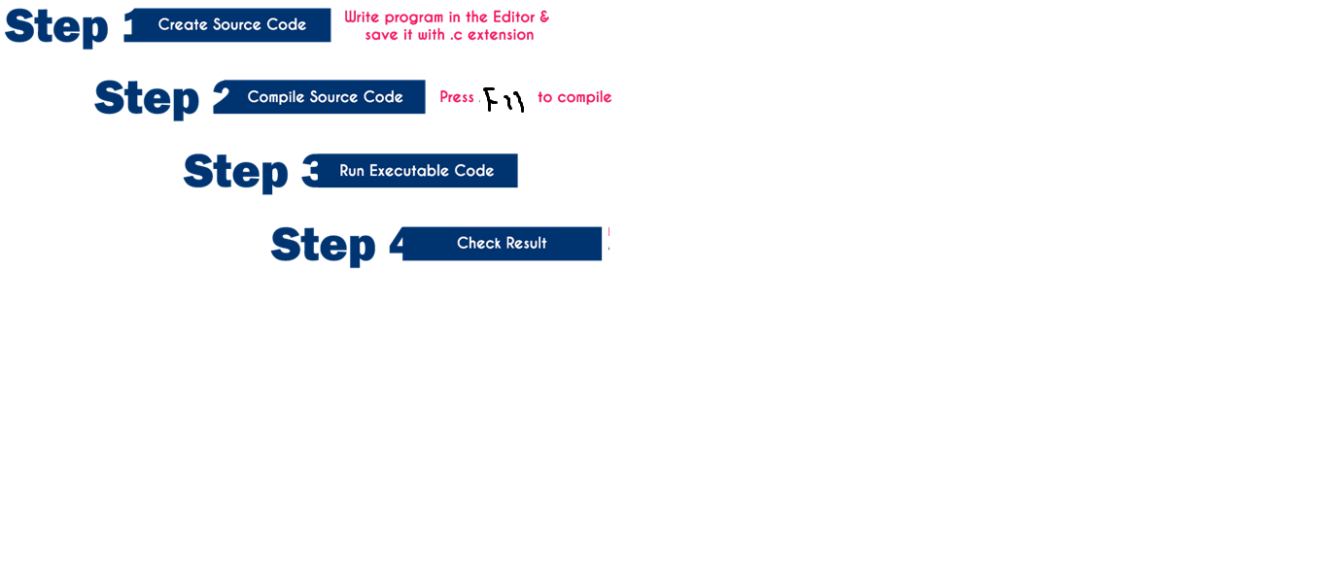

Step 1: Creating a Source Code

Source code is a file with C programming instructions in a high-level language. To create source code, we use any text editor to write the program instructions. The instructions written in the source code must follow the C programming language rules. The following steps are used to create a source code file in Windows OS…

* Click on the Start button
* Select NEW
* Type NAME and SAVE
* Type the program
* Save it as FileName.c (Use shortcut key F2 to save)
* PRESS F11(COMPILE AND EXECUTE)

Step 2: Compile Source Code (F11)

The compilation is the process of converting high-level language instructions into low-level language instructions. We use the shortcut key F11 to compile a C program in Turbo C.

The compilation is the process of converting high-level language instructions into low-level language instructions.

Whenever we press F11, the source file is going to be submitted to the Compiler. On receiving a source file, the compiler first checks for the Errors. If there are any Errors then compiler returns List of Errors, if there are no errors then the source code is converted into object code and stores it as a file with .obj extension. Then the object code is given to the Linker. The Linker combines both the object code and specified header file code and generates an Executable file with a .exe extension.

Step 3: Executing / Running Executable File (F11)

After completing compilation successfully, an executable file is created with a .exe extension. The processor can understand this .exe file content so that it can perform the task specified in the source file.  
  
We use a shortcut key F11 to run a C program. Whenever we pressF11, the .exe file is submitted to the CPU. On receiving .exe file, CPU performs the task according to the instruction written in the file. The result generated from the execution is placed in a window called User Screen.

Step 4: Check Result (f11)

After running the program, the result is placed into User Screen. Just we need to open the User Screen to check the result of the program execution. We use the shortcut key F11 to open the User Screen and check the result.

Execution Process of a C Program

When we execute a C program it undergoes with the following process…

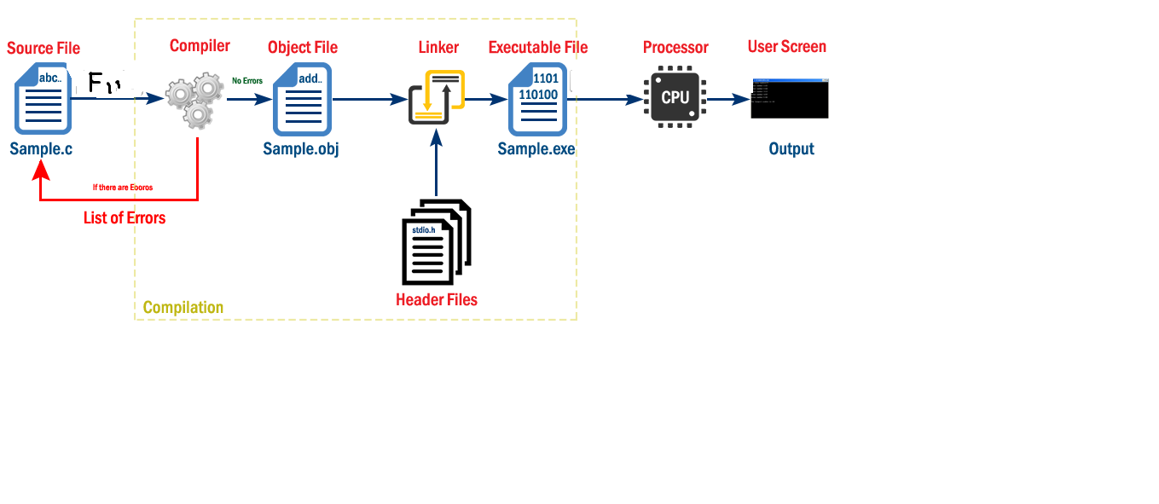

The file which contains c program instructions in a high-level language is said to be source code. Every c program source file is saved with .c extension, for example, Sample.c.  
  
Whenever we press F11 the source file is submitted to the compiler. Compiler checks for the errors, if there are any errors, it returns a list of errors, otherwise generates object code in a file with name Sample.obj and submit it to the linker. The linker combines the code from specified header file into an object file and generates executable file as Sample.exe. With this compilation process completes.  
  
Now, we need to run the executable file (Sample.exe). To run a program we pressF11. When we press F11the executable file is submitted to the CPU. Then CPU performs the task according to the instructions written in that program and place the result into UserScreen.  
  
Then we press F11 to open UserScreen and check the result of the program.

Important Points

* C program file (Source file) must save with .c extension.
* The compiler converts complete program at a time from high-level language to low-level language.
* Input to the compiler is .c file and output from the compiler is .exe file, but it also generates .obj file in this process.
* The compiler converts the file only if there are no errors in the source code.
* CPU places the result in User Screen window.

Overall Process

* Type the program in C editor and save with .c extension (Press F2 to save).
* Press F11 to compile the program.
* If there are errors, correct the errors and recompile the program.
* If there are no errors, then press F11to execute/run the program.
* Press F11 to open User Screen and check the result.

What is a Compiler?

A compiler is a special program that processes statements written in a particular programming language and turns them into machine language or "code" that a computer's processor uses.

Each language(JAVA, C, C++, C# etc.) has its own compiler.

Jobs of a compiler:

Check for all Syntax errors in program.

Compile the complete program into a machine dependent Low level Language called as binary code(0’s and 1’s).

It is slow compared to Interpreters.

* A preprocessor search for the preprocessor directives (special commands) and make substitutions of code. After the preprocessor has prepared the code for compilation, the translator converts the program into machine language and this code is called object code.
* PREPROCESSOR
* Even though the output of the compiler is machine language, it can not be executed. The object code is linked to the library functions using the linker and a executable code is produced. The final executable program is executed in the system.
* LINKER

Even though the output of the compiler is machine language, it can not be executed. The object code is linked to the library functions using the linker and a executable code is produced. The final executable program is executed in the system

* Program execution: To execute your program, use an operating system, load your program in the primary memory and execute it. The program is loaded into the primary memory using a system program called Loader



What is an Algorithm?

Algorithm can be defined as: “A sequence of activities to be processed for getting desired output from a given input.”

Webopedia defines an algorithm as: “A formula or set of steps for solving a particular problem. To be an algorithm, a set of rules must be unambiguous and have a clear stopping point”. There may be more than one way to solve a problem, so there may be more than one algorithm for a problem.

Now, if we take definition of algorithm as: “A sequence of activities to be processed for getting desired output from a given input.” Then we can say that:

1. Getting specified output is essential after algorithm is executed.

2. One will get output only if algorithm stops after finite time.

3. Activities in an algorithm to be clearly defined in other words for it to be unambiguous.

Before writing an algorithm for a problem, one should find out what is/are the inputs to the algorithm and what is/are expected output after running the algorithm. Now let us take some exercises to develop an algorithm for some simple problems: While writing algorithms we will use following symbol for different operations:

‘+’ for Addition

‘-’ for Subtraction

‘*’ for Multiplication

‘/’ for Division and

‘ ’ for assignment. For example A X*3 means A will have a value of X*3.

* To solve any problem a plan is needed. This plan is a procedure to solve the problem in question. The procedure has to be based on definite reasoning and logic to obtain a result.

Computer scientist Niklaus Wirth stated that

Program = Algorithms + Data

* An algorithm is a part of the plan for the computer program. In fact, an algorithm is ‘an effective procedure for solving a problem in a finite number of steps’.

It is effective, which means that an answer is found and it has a finite number of stepslgorithm?

Algorithms may be represented in various ways. There are four ways of stating algorithms.

These are as follows:

1. Step-form

2. Pseudo-code

3. Flowchart

. Step Form Algorithm

In the step-form representation, the procedure of solving a problem is stated with written statements. Each statement solves a part of the problem and these together complete the solution. The step-form uses just normal language to define each procedure. Every statement, that defines an action, is logically related to the preceding statement.

Write an Algorithm to find the sum of any two numbers(Step Form Algorithm)

* Solution: Let the two numbers be A and B and let their sum be equal to C. Then, the desired algorithm is given as follows:
  1. START
  2. PRINT “ENTER TWO NUMBERS”
  3. INPUT A, B
  4. C ¨ A + B Add values assigned to A and B and assign this value to C
  5. PRINT C
  6. STOP
* Explanation: The first step is the starting point of the algorithm.
* The next step requests the programmer to enter the two numbers that have to be added.
* Step 3 takes in the two numbers given by the programmer and keeps them in variables A and B.
* The fourth step adds the two numbers and assigns the resulting value to the variable C.
* The fifth step prints the result stored in C on the output device. The sixth step terminates the procedure.

Write an Algorithm for interchanging the values of two variables

* Solution Let the two variables be A and B. Consider C to be a third variable that is used to store the value of one of the variables during the process of interchanging the values. The algorithm for the given problem is as follows.
  1. START
  2. PRINT “ENTER THE VALUE OF A & B”
  3. INPUT A, B
  4. C <- A
  5. A <- B
  6. B <- C
  7. PRINT A, B
  8. END
* Explanation Like the previous examples, the first step indicates the starting point of the algorithm. The second step is an output message asking for the two values to be entered. Step 3 puts these values into the variables A and B. Now, the value in variable A is copied to variable C in step 4. In fact the value in A is saved in C. In step 5 the value in variable B is assigned to variable A. This means a copy of the value in B is put in A. Next, in step 6 the value in C, saved in it in the earlier step 4 is copied into B. In step 7 the values in A and B are printed on an output device. Step 8 terminates the procedure.
* 1.3.2 Properties of algorithm
* Donald Ervin Knuth has given a list of five properties for a,algorithm, these properties are:
* 1) Finiteness: An algorithm must always terminate after a finite number of steps. It means after every step one reach closer to solution of the problem and after a finite number of steps algorithm reaches to an end point.
* 2) Definiteness: Each step of an algorithm must be precisely defined. It is done by well thought actions to be performed at each step of the algorithm. Also the actions are defined unambiguously for each activity in the algorithm.
* 3) Input: Any operation you perform need some beginning value/quantities associated with different activities in the operation. So the value/quantities are given to the algorithm before it begins.
* 4) Output: One always expects output/result (expected value/quantities) in terms of output from an algorithm. The result may be obtained at different stages of the algorithm. If some result is from the intermediate stage of the operation then it is known as intermediate result and result obtained at the end of algorithm is known as end result. The output is expected value/quantities always have a specified relation to the inputs
* 5) Effectiveness: Algorithms to be developed/written using basic operations. Actually operations should be basic, so that even they can in principle be done exactly and in a finite amount of time by a person, by using paper and pencil only.

1.4 FLOWCHART

The flowchart is a diagram which visually presents the flow of data through processing systems. This means by seeing a flow chart one can know the operations performed and the sequence of these operations in a system. Algorithms are nothing but sequence of steps for solving problems. So a flow chart can be used for representing an algorithm. A flowchart, will describe the operations (and in what sequence) are required to solve a given problem. You can see a flow chart as a blueprint of a design you have made for solving a problem.

* For example suppose you are going for a picnic with your friends then you plan for the activities you will do there. If you have a plan of activities then you know clearly when you will do what activity. Similarly when you have a problem to solve using computer or in other word you need to write a computer program for a problem then it will be good to draw a flowchart prior to writing a computer program. Flowchart is drawn according to defined rules.

1.4.1 Flowchart Symbols

* There are 6 basic symbols commonly used in flowcharting of assembly language Programs: Terminal, Process, input/output, Decision, Connector and Predefined Process. This is not a complete list of all the possible flowcharting symbols, it is the ones used most often in the structure of Assembly language programming.



1.4.2 General Rules for flowcharting

1. All boxes of the flowchart are connected with Arrows. (Not lines)

2. Flowchart symbols have an entry point on the top of the symbol with no other entry points. The exit point for all flowchart symbols is on the bottom except for the Decision symbol.

3. The Decision symbol has two exit points; these can be on the sides or the bottom and one side.

4. Generally a flowchart will flow from top to bottom. However, an upward flow can be shown as long as it does not exceed 3 symbols.

5. Connectors are used to connect breaks in the flowchart. Examples are:

• From one page to another page.

• From the bottom of the page to the top of the same page.

• An upward flow of more then 3 symbols

6. Subroutines and Interrupt programs have their own and independent

flowcharts.

7. All flow charts start with a Terminal or Predefined Process (for interrupt

programs or subroutines) symbol.

8. All flowcharts end with a terminal or a contentious loop.

Flowcharting uses symbols that have been in use for a number of years to represent the type of operations and/or processes being performed. The standardised format provides a common method for people to visualise problems together in the same manner. The use of standardised symbols makes the flow charts easier to interpret, however, standardizing symbols is not as important as the sequence of activities that make up the process.

1.4.4 Some examples of Flowcharts

Now, we will discuss some examples on flowcharting. These examples will help in proper understanding of flowcharting technique. This will help you in program development process in next unit of this block.

*Problem*1: Find the area of a circle of radius r.



*Problem 2*: Convert temperature Fahrenheit to Celsius.



*Problem3*: Flowchart for an algorithm which gets two numbers and prints sum of their value



Pseudocode Algorithm

* Pseudocode is an artificial and informal language that helps programmers develop algorithms. Pseudocode is a "text-based" detail (algorithmic) design tool.
* All statements showing "dependency" are to be indented. These include while, do, for, if, switch. Example:

If student's grade is greater than or equal to 60

Print "passed"

else

Print "failed"

Write pseudocode to compute the area of a rectangle

* Get the length, l, and width, w
* Compute the area = l*w
* Display the area

Write pseudocode to compute the perimeter of a rectangle

* Enter length, l
* Enter width, w
* Compute Perimeter = 2*l + 2*w
* Display Perimeter of a rectangle

Designing a Program(Steps)

1. Identify the outputs needed: This includes the form in which the outputs have to be presented. At the same time, it has to be determined at what intervals and with what precision the output data needs to be given to the user.

2. Identify the input variables available: This activity considers the specific inputs available for this problem, the form in which the input variables would be available, the availability of inputs at different intervals, the ways in which the input would be fed to the transforming process.

3. Identify the major decisions and conditions: This activity looks into the conditions imposed by the need identified and the limitations of the environment in which the algorithm has to be implemented.

4. Identify the processes required to transform inputs into required outputs: This activity identifies the various types of procedures needed to manipulate the inputs, within the bounding conditions and the limitations mentioned in step 3, to produce the needed outputs.

5. Identify the environment available: This activity determines the kind of users and the type of computing machines and software available for implementing the solution through the processes considered in steps.

# C OUTPUT FUNCTIONS

C programming language provides built-in functions to perform output operation. The output operations are used to display data on user screen (output screen) or printer or any file. The c programming language provides the following built-in output functions...

1. printf()

# printf() function

The printf() function is used to print string or data values or a combination of string and data values on the output screen (User screen). The printf() function is built-in function defined in a header file called "**stdio.h**". When we want to use printf() function in our program we need to include the respective header file (stdio.h) using the **#include** statement. The printf() function has the following syntax...

# Syntax:

# printf("message to be display!!!");

# Example Program

#include<stdio.h>

#include<conio.h>

void main(){

printf("Hello! Welcome to btechsmartclass!!!");

}

Output:

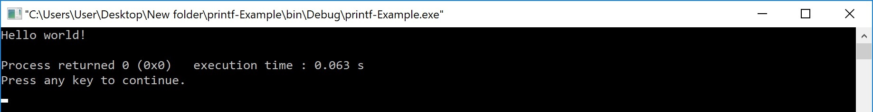

In the above example program, we used the printf() function to print a string on to the output screen.  
  
The printf() function is also used to display data values. When we want to display data values we use **format string** of the data value to be displayed.

# Syntax:

# printf("format string",variableName);

# Example Program

#include<stdio.h>

#include<conio.h>

void main(){

int i = 10;

float x = 5.5;

printf("%d %f",i, x);

}

Output:

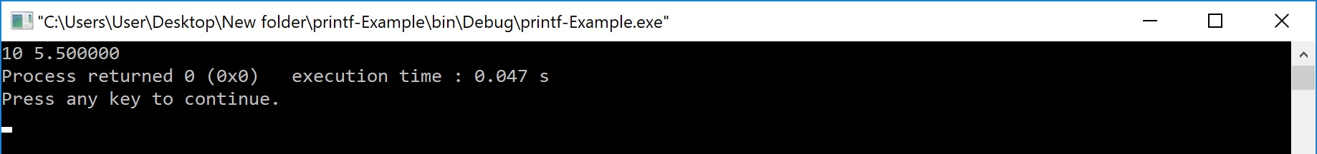

In the above example program, we used the printf() function to print data values of variables i and x on to the output screen. Here i is a an integer variable so we have used format string %d and x is a float variable so we have used format string %f.  
  
The printf() function can also be used to display string along with data values.

# Syntax:

# printf("String format string",variableName);

# Example Program

#include<stdio.h>

#include<conio.h>

void main(){

int i = 10;

float x = 5.5;

printf("Integer value = %d, float value = %f",i, x);

}

Output:

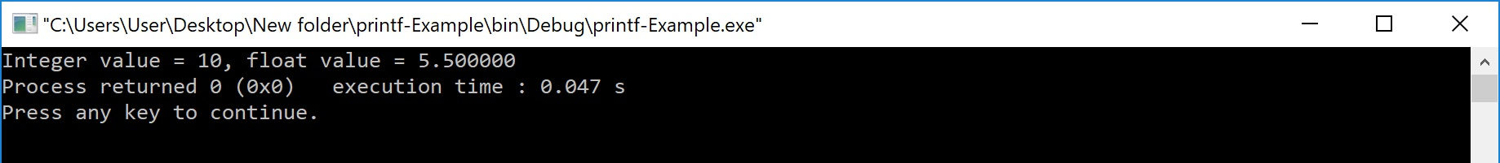

In the above program, we are displaying string along with data values.  
  
Every function in the C programming language must have a return value. The printf() function also have an integer as a return value. The printf() function returns an integer value equivalent to the total number of characters it has printed.

# Example Program

#include<stdio.h>

#include<conio.h>

void main(){

int i;

i = printf("smartclass");

printf(" is %d number of characters.",i);

}

Output:

No of characters :10

In the above program, first printf() function printing "btechsmartclass" which is of 15 characters. So it returns integer value 15 to the variable "i". The value of "i" is printed in the second printf() function.

# Formatted printf() function

Generally, when we write multiple printf() statements the result is displayed in a single line because the printf() function displays the output in a single line. Consider the following example program...

# Example Program

#include<stdio.h>

#include<conio.h>

void main(){

printf("Welcome to c");

printf("welcome to stpeter ");

printf("the perfect place for learning");

}

Output: welcome to c welcome to stpeters the perfect place for learning

In the above program, there are 3 printf() statements written in different lines but the output is displayed in single line only.  
  
To display the output in different lines or as we wish, we use some special characters called **escape sequences**. Escape sequences are special characters with special functionality used in printf() function to format the output according to the user requirement. In the C programming language, we have the following escape sequences...

| Escape sequence | Meaning |
| --- | --- |
| \n | Moves the cursor to New Line |
| \t | Inserts Horizontal Tab (5 characters space) |
| \v | Inserts Vertical Tab (5 lines space) |
| \a | Beep sound |
| \b | Backspace (removes the previous character from its current position) |
| \\ | Inserts Backward slash symbol |
| \? | Inserts Question mark symbol |
| \' | Inserts Single quotation mark symbol |
| \" | Inserts Double quotation mark symbol |

Consider the following example program...

# Example Program

#include<stdio.h>

#include<conio.h>

void main(){

printf("Welcome to c\n");

printf("welcome to stpeter\n ");

printf("the perfect place for learning\n");

}

Output: welcome to c

welcome to stpeters

the perfect place for learning

# C Input Functions

C programming language provides built-in functions to perform input operations. The input operations are used to read user values (input) from the keyboard. The c programming language provides the following built-in input functions.

1. scanf()

# scanf() function

The scanf() function is used to read multiple data values of different data types from the keyboard. The scanf() function is built-in function defined in a header file called "**stdio.h**". When we want to use scanf() function in our program, we need to include the respective header file (stdio.h) using **#include** statement. The scanf() function has the following syntax...

# Syntax:

# scanf("format strings",&variableNames);

# Example Program

#include<stdio.h>

#include<conio.h>

void main(){

int i;

printf("\nEnter any integer value: ");

scanf("%d",&i);

printf("\nYou have entered %d number",i);

}

Output:

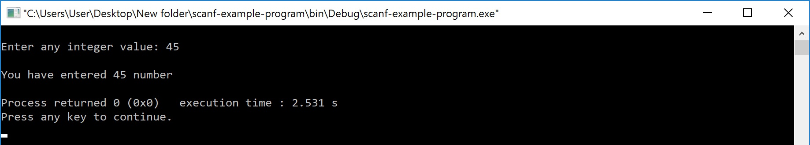

In the above example program, we used the scanf() function to read an integer value from the keyboard and store it into variable 'i'.  
  
The scanf function also used to read multiple data values of different or the same data types. Consider the following example program...

# Example Program

#include<stdio.h>

#include<conio.h>

void main(){

int i;

float x;

printf("\nEnter one integer followed by one float value : ");

scanf("%d%f",&i, &x);

printf("\ninteger = %d, float = %f",i, x);

}

Output:

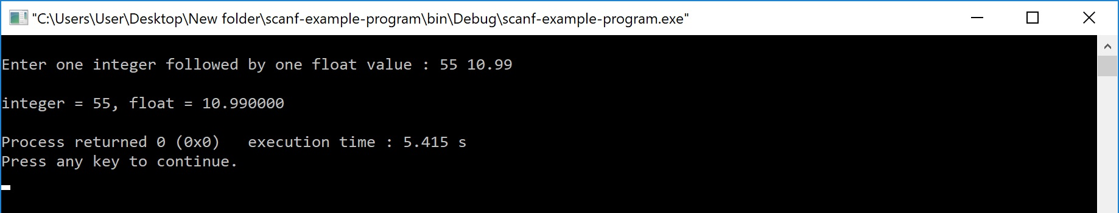

In the above example program, we used the scanf() function to read one integer value and one float value from the keyboard. Here **'i'** is an integer variable so we have used format string %d, and **'x'** is a float variable so we have used format string %f.  
  
The scanf() function returns an integer value equal to the total number of input values read using scanf function.

# Example Program

#include<stdio.h>

#include<conio.h>

void main(){

int i,a,b;

float x;

printf("\nEnter two integers and one float : ");

i = scanf("%d%d%f",&a, &b, &x);

printf("\nTotal inputs read : %d",i);

}

Output:

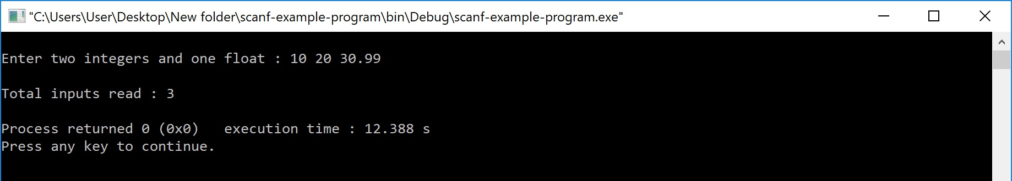

**Number Systems**

• binary number system

• Decimal number system

• Octal number system

• Hexadecimal number system

Number System

• number system in computer ideology is regarded as the method or system of numbering and representing of digits in the computer ‘inner’ system.

• In other words, it is a technique used in representing numbers in the computer system architecture.

• The digital computer represents all kinds of data and information in binary numbers.

•This implies every value/number that you are saving or feeding into/fetching from the computer system memory has a defined number system.

• The value/data feed in/fetch from can includes but not limited to: audio, graphics, video, textfile,numbersetc.

• The total number of digits used in a number system is called its base or radix.

• The base is written after the number as subscript; for instance

10001102(1000110base 2),

❑ 5610(56 to base of 10)

❑ 718(71 base 8) etc

• Computer architecture supports following number systems.

• i. Binary number system(Base 2)

• ii. Octal number system(Base 8)

• iii. Decimal number system(Base 10)

• iv. Hexadecimal number system(Base 16)

**Binary Number**

• 1) A Binary number system has only two digits, which are 0 and 1.

• Every number (value) is represented with 0 and 1 in this number system.

• The base of binary number system is 2, because it has only two digits.

• The easiest way to vary instructions through electric signals is twostate system – on and off. On is represented as 1 and off as 0, though 0 is not actually no signal but signal at a lower voltage. The number system having just these two digits – 0 and 1 – is called binary number system.

• Each binary digit is also called a bit. Binary number system is also positional value system, where each digit has a value expressed in powers of 2, as displayed here.

• In any binary number, the rightmost digit is called least significant bit (LSB) and leftmost digit is called most significant bit (MSB).

• And decimal equivalent of this number is sum of product of each digit with its positional value.

• 110102 = 1×24 + 1×23 + 0×22 + 1×21 + 0×20

• = 16 + 8 + 0 + 2 + 0

• = 2610

• Computer memory is measured in terms of how many bits it can store. Here is a chart for memory capacity conversion.

• 1 byte (B) = 8 bits

• 1 Kilobytes (KB) = 1024 bytes

• 1 Megabyte (MB) = 1024 KB

• 1 Gigabyte (GB) = 1024 MB

• 1 Terabyte (TB) = 1024 GB

• 1 Exabyte (EB) = 1024 PB

• 1 Zettabyte = 1024 EB

• 1 Yottabyte (YB) = 1024 ZB

➢ In a computer, a binary digit representing a binary value (0 or 1) is called a BIT. That is, each digit in a binary number is called a bit, 4 bits form a NIBBLE, 8 bits form a BYTE, two bytes form a WORD and two words form a DOUBLE WORD (rarely used).

➢ An n-bit number can represent 2n different number values, for example, for an 8-bit number, 28 = 256 different values may be represented.

**Octal number system**

• Octal number system has only eight(8) digits from0 to 7.

• The base of octal number system is 8, because it has only 8 digits.

• Every number (value) is represented with

• 0, 1, 2, 3, 4, 5, 6, and 7

• with 0 having the least value and 7 having the greatest value. The number representation in the octal system is done in the same way as in the decimal system, in which the digit on the extreme left represents the most significant digit.

• Ex: (360)8

Octal number system has eight digits – 0, 1, 2, 3, 4, 5, 6 and 7. Octal number system is also a positional value system with where each digit has its value expressed in powers of 8, as shown here −

Decimal equivalent of any octal number is sum of product of each digit with its positional value.

7268 = 7×82 + 2×81 + 6×80

= 448 + 16 + 6

= 47010

**Decimal number system**

• Decimal number system has only ten (10) digits from 0to 9.

• Every number (value) is represented with 0,1,2,3,4,5,6, 7,8 and 9 in this number system.

• The base of decimal number system is 10, because it has only 10 digits.

• Ex:(240)10

Decimal number system is a base 10 number system having 10 digits from 0 to 9. This means that any numerical quantity can be represented using these 10 digits. Decimal number system is also a positional value system. This means that the value of digits will depend on its position. Let us take an example to understand this.

Say we have three numbers – 734, 971 and 207. The value of 7 in all three numbers is different−

• In 734, value of 7 is 7 hundreds or 700 or 7 × 100 or 7 × 102

• In 971, value of 7 is 7 tens or 70 or 7 × 10 or 7 × 101

• In 207, value 0f 7 is 7 units or 7 or 7 × 1 or 7 × 100

The weightage of each position can be represented as follows −

**Hexadecimal number**

• Hexadecimal number system has sixteen (16) alphanumeric values from0 to 9andA to F.

• Every number (value) represents with

0,1,2,3,4,5,6,7,8,9,A,B,C,D,E and F in this number system.

• The base of hexadecimal number system is 16, because it has 16 alphanumeric values.

• Here, we have 0 to 9, representing 0 –9 but from 10, we have A is 10,B is 11,C is 12,D is 13,E is 14andF is 15

• Ex:(F0)16

has 16 symbols – 0 to 9 and A to F where A is equal to 10, B is equal to 11 and so on till F. Hexadecimal number system is also a positional value system with where each digit has its value expressed in powers of 16, as shown here −

Decimal equivalent of any hexadecimal number is sum of product of each digit with its positional value.

27FB16 = 2×163 + 7×162 + 15×161 + 10×160

= 8192 + 1792 + 240 +10

= 1023410

Number System Relationship

The following table depicts the relationship between decimal, binary, octal and hexadecimal number systems.

HEXADECIMAL DECIMAL OCTAL BINARY

0 0 0 0000

1 1 1 0001

2 2 2 0010

3 3 3 0011

4 4 4 0100

5 5 5 0101

6 6 6 0110

7 7 7 0111

8 8 10 1000

9 9 11 1001

A 10 12 1010

B 11 13 1011

C 12 14 1100

D 13 15 1101

E 14 16 1110

F 15 17 1111

**ASCII**

Besides numerical data, computer must be able to handle alphabets, punctuation marks, mathematical operators, special symbols, etc. that form the complete character set of English language. The complete set of characters or symbols are called alphanumeric codes. The complete alphanumeric code typically includes −

• 26 upper case letters

• 26 lower case letters • 10 digits

• 7 punctuation marks

• 20 to 40 special characters

Now a computer understands only numeric values, whatever the number system used. So all characters must have a numeric equivalent called the alphanumeric code. The most widely used alphanumeric code is American Standard Code for Information Interchange (ASCII).

ASCII is a 7-bit code that has 128 (27) possible codes

**Number Systems conversions**

• Decimal conversions

• Binary conversions

• Octal conversions

• Hexadecimal conversions

• As you know decimal, binary, octal and hexadecimal number systems are positional value number systems.

• To convert binary, octal and hexadecimal to decimal number, we just need to add the product of each digit with its positional value.

• Here we are going to learn other conversion among these number systems.

Decimal to Binary

Decimal numbers can be converted to binary by repeated division of the number by 2 while recording the remainder. Let’s take an example to see how this happens.

The remainders are to be read from bottom to top to obtain the binary equivalent.

4310 = 1010112

Decimal to Octal

Decimal numbers can be converted to octal by repeated division of the number by 8 while recording the remainder. Let’s take an example to see how this happens.

Reading the remainders from bottom to top,

47310 = 7318

Decimal to Hexadecimal

Decimal numbers can be converted to octal by repeated division of the number by 16 while recording the remainder. Let’s take an example to see how this happens.

Reading the remainders from bottom to top we get,

42310 = 1A716

**Binary to Decimal Conversion**

• The process of converting binary to decimal is quite simple. The process starts from multiplying the bits of binary number with its corresponding positional weights. And lastly, we add all those products.

• Let's take an example to understand how the conversion is done from binary to decimal.

• Example 1: (10110.001)2

• We multiplied each bit of (10110.001)2 with its respective positional weight, and last we add the products of all the bits with its weight.

• (10110.001)2=(1×24)+(0×23)+(1×22)+(1×21)+(0×20)+

• (0×2-1)+(0×2-2)+(1×2-3)

• (10110.001)2=(1×16)+(0×8)+(1×4)+(1×2)+(0×1)+

• (0×1⁄2)+(0×1⁄4)+(1×1⁄8)

• (10110.001)2=16+0+4+2+0+0+0+0.125

• (10110.001)2=(22.125 )10

• Binary to Octal Conversion

• The base numbers of binary and octal are 2 and 8, respectively. In a binary number, the pair of three bits is equal to one octal digit. There are only two steps to convert a binary number into an octal number which are as follows:

• In the first step, we have to make the pairs of three bits on both sides of the binary point. If there will be one or two bits left in a pair of three bits pair, we add the required number of zeros on extreme sides.

• In the second step, we write the octal digits corresponding to each pair.

• Example 1: (111110101011.0011)2

• 1. Firstly, we make pairs of three bits on both sides of the binary point.

• 111 110 101 011.001 1

• On the right side of the binary point, the last pair has only one bit. To make it a complete pair of three bits, we added two zeros on the extreme side.

• 111 110 101 011.001 100

• 2. Then, we wrote the octal digits, which correspond to each pair.

• (111110101011.0011)2=(7653.14)8

• Binary to Hexadecimal Conversion

• The base numbers of binary and hexadecimal are 2 and 16, respectively. In a binary number, the pair of four bits is equal to one hexadecimal digit. There are also only two steps to convert a binary number into a hexadecimal number which are as follows:

• In the first step, we have to make the pairs of four bits on both sides of the binary point. If there will be one, two, or three bits left in a pair of four bits pair, we add the required number of zeros on extreme sides.

• In the second step, we write the hexadecimal digits corresponding to each pair.

• Example 1: (10110101011.0011)2

• 1. Firstly, we make pairs of four bits on both sides of the binary point.

• 111 1010 1011.0011

• On the left side of the binary point, the first pair has three bits. To make it a complete pair of four bits, add one zero on the extreme side.

• 0111 1010 1011.0011

• 2. Then, we write the hexadecimal digits, which correspond to each pair.

• (011110101011.0011)2=(7AB.3)16

• Octal to other Number System

• Like binary and decimal, the octal number can also be converted into other number systems. The process of converting octal to decimal differs from the remaining one. Let's start understanding how conversion is done.

**Octal to Decimal Conversion**

• The process of converting octal to decimal is the same as binary to decimal. The process starts from multiplying the digits of octal numbers with its corresponding positional weights. And lastly, we add all those products.

• Let's take an example to understand how the conversion is done from octal to decimal.

• Example 1: (152.25)8

• Step 1:

• We multiply each digit of 152.25 with its respective positional weight, and last we add the products of all the bits with its weight.

• (152.25)8=(1×82)+(5×81)+(2×80)+(2×8-1)+(5×8-2)

(152.25)8=64+40+2+(2×1⁄8)+(5×1⁄64)

(152.25)8=64+40+2+0.25+0.078125

(152.25)8=106.328125

• So, the decimal number of the octal number 152.25 is 106.328125

• Octal to Binary Conversion

• The process of converting octal to binary is the reverse process of binary to octal. We write the three bits binary code of each octal number digit.

• Example 1: (152.25)8

• We write the three-bit binary digit for 1, 5, 2, and 5.

• (152.25)8=(001101010.010101)2

• So, the binary number of the octal number 152.25 is (001101010.010101)2

• Octal to hexadecimal conversion

• For converting octal to hexadecimal, there are two steps required to perform, which are as follows:

• In the first step, we will find the binary equivalent of number 25.

• Next, we have to make the pairs of four bits on both sides of the binary point. If there will be one, two, or three bits left in a pair of four bits pair, we add the required number of zeros on extreme sides and write the hexadecimal digits corresponding to each pair. • Example 1: (152.25)8

• Step 1:

• We write the three-bit binary digit for 1, 5, 2, and 5.

• (152.25)8=(001101010.010101)2

• So, the binary number of the octal number 152.25 is (001101010.010101)2

• Step 2:

• 1. Now, we make pairs of four bits on both sides of the binary point.

• 0 0110 1010.0101 01

• On the left side of the binary point, the first pair has only one digit, and on the right side, the last pair has only two-digit. To make them complete pairs of four bits, add zeros on extreme sides.

• 0000 0110 1010.0101 0100

• 2. Now, we write the hexadecimal digits, which correspond to each pair.

• (0000 0110 1010.0101 0100)2=(6A.54)16

**• Hexa-decimal to other Number System**

• Like binary, decimal, and octal, hexadecimal numbers can also be converted into other number systems. The process of converting hexadecimal to decimal differs from the remaining one. Let's start understanding how conversion is done.

• Hexa-decimal to Decimal Conversion

• The process of converting hexadecimal to decimal is the same as binary to decimal. The process starts from multiplying the digits of hexadecimal numbers with its corresponding positional weights. And lastly, we add all those products.

• Let's take an example to understand how the conversion is done from hexadecimal to decimal.

• Example 1: (152A.25)16 • Step 1:

• We multiply each digit of 152A.25 with its respective positional weight, and last we add the products of all the bits with its weight.

• (152A.25)(152A.25)1616=(1×163)+(5×162)+(2×161)+(A×160)+(2×16--11)+(5)+(5××1616--22))

=(1×4096)+(5×256)+(2×16)+(10×1)+(2×16

(152A.25)16=4096+1280+32+10+(2×1⁄16)+(5×1⁄256)

(152A.25)16=5418+0.125+0.125

(152A.25)16=5418.14453125

• So, the decimal number of the hexadecimal number 152A.25 is 5418.14453125

• Hexadecimal to Binary Conversion

• The process of converting hexadecimal to binary is the reverse process of binary to hexadecimal. We write the four bits binary code of each hexadecimal number digit.

• Example 1: (152A.25)16

• We write the four-bit binary digit for 1, 5, A, 2, and 5.

• (152A.25)16=(0001 0101 0010 1010.0010 0101)2

• So, the binary number of the hexadecimal number 152.25 is (1010100101010.00100101)2

• Hexadecimal to Octal Conversion

• For converting hexadecimal to octal, there are two steps required to perform, which are as follows:

• In the first step, we will find the binary equivalent of the hexadecimal number.

• Next, we have to make the pairs of three bits on both sides of the binary point. If there will be one or two bits left in a pair of three bits pair, we add the required number of zeros on extreme sides and write the octal digits corresponding to each pair.

• Example 1: (152A.25)16

• Step 1:

• We write the four-bit binary digit for 1, 5, 2, A, and 5.

• (152A.25)16=(0001 0101 0010 1010.0010 0101)2

• So, the binary number of hexadecimal number 152A.25 is (0011010101010.010101)2

• Step 2:

• 3. Then, we make pairs of three bits on both sides of the binary point.

• 001 010 100 101 010.001 001 010

• 4. Then, we write the octal digit, which corresponds to each pair.

• (001010100101010.001001010)2=(12452.112)8

• So, the octal number of the hexadecimal number 152A.25 is 12452.112

|  |
| --- |
| UNIT 2:  Fundamentals of C: C-Tokens, Data types, Operators, Expressions, Type conversions, Types of Errors , Input and output statements.  Control Statements in C  Decision making and branching, Decision making and Looping statements |

1. **C-TOKENS :**

* Tokens are individual words and punctuations marks in English language sentence. The smallest individual units are known as C tokens.
* A C program can be divided into these tokens. A C program contains minimum 3 c tokens no matter what the size of the program is.

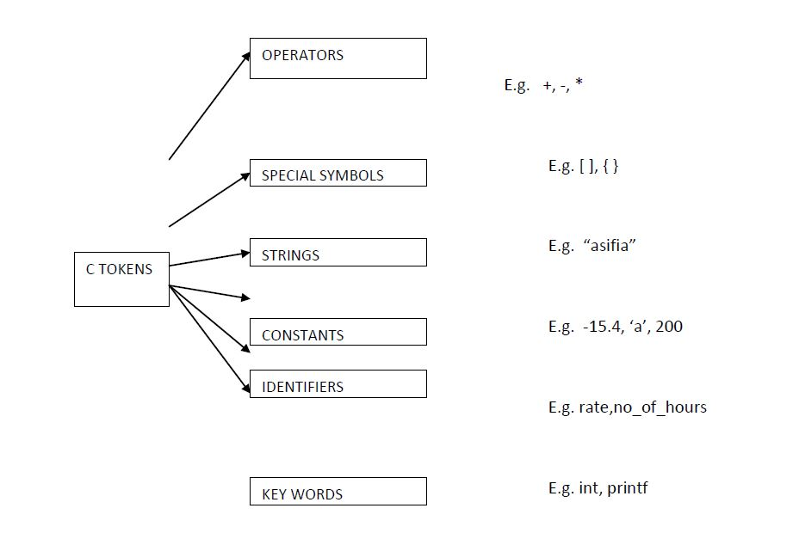

Every C program is a collection of instructions and every instruction is a collection of some individual units. Every smallest individual unit of a c program is called token. Every instruction in a c program is a collection of tokens. Tokens are used to construct c programs and they are said to the basic building blocks of a c program.

In a c program tokens may contain the following...

1. Keywords
2. Identifiers
3. Operators
4. Special Symbols
5. Constants
6. Strings
7. Data values

In a C program, a collection of all the keywords, identifiers, operators, special symbols, constants, strings, and data values are called tokens.

Consider the following C program...

# C program to print all the characters of C character Set

#include<stdio.h>

#include<conio.h>

int main() {

int i;

clrscr();

printf("ASCII ==> Character\n");

for(i = -128; i <= 127; i++)

printf("%d ==> %c\n", i, i);

getch();

return 0;

}

In the above program there are 22 tokens.

# 1.1 C Keywords

As every language has words to construct statements, C programming also has words with a specific meaning which are used to construct c program instructions. In the C programming language, keywords are special words with predefined meaning. Keywords are also known as reserved words in C programming language.  
  
In the C programming language, there are **32 keywords**. All the 32 keywords have their meaning which is already known to the compiler.

Keywords are the reserved words with predefined meaning which already known to the compiler,These keywords are only to be used for their intended purpose and not as identifiers.

Whenever C compiler come across a keyword, automatically it understands its meaning.

# Properties of Keywords

1. All the keywords in C programming language are defined as lowercase letters so they must be used only in lowercase letters
2. Every keyword has a specific meaning, users can not change that meaning.
3. Keywords can not be used as user-defined names like variable, functions, arrays, pointers, etc...
4. Every keyword in C programming language represents something or specifies some kind of action to be performed by the compiler.

The following table specifies all the 32 keywords with their meaning...

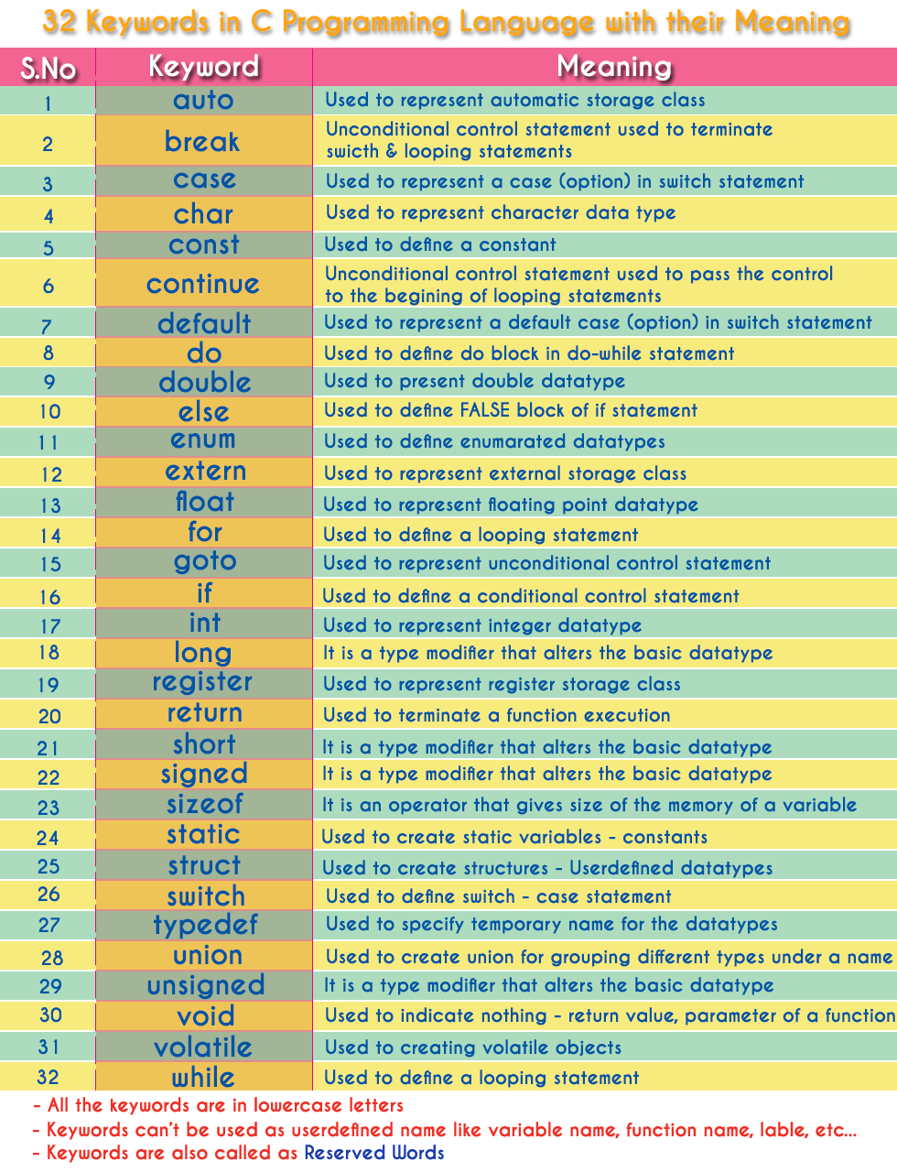

# 1.2 C Identifiers

In C programming language, programmers can specify their name to a variable, array, pointer, function, etc... An identifier is a collection of characters which acts as the name of variable, function, array, pointer, structure, etc... In other words, an identifier can be defined as the user-defined name to identify an entity uniquely in the c programming language that name may be of the variable name, function name, array name, pointer name, structure name or a label.

The identifier is a user-defined name of an entity to identify it uniquely during the program execution

# Example

**int marks;**  
**char studentName[30];**  
  
Here, **marks** and **studentName** are identifiers.

# Rules for Creating Identifiers

1. An identifier can contain **letters** (UPPERCASE and lowercase), **numerics** & **underscore** symbol only.
2. An identifier should not start with a numerical value. It can start with a letter or an underscore.
3. We should not use any special symbols in between the identifier even whitespace. However, the only underscore symbol is allowed.
4. Keywords should not be used as identifiers.
5. There is no limit for the length of an identifier. However, the compiler considers the first 31 characters only.
6. An identifier must be unique in its scope.

# Rules for Creating Identifiers for better programming

The following are the commonly used rules for creating identifiers for better programming...

1. The identifier must be meaningful to describe the entity.
2. Since starting with an underscore may create conflict with system names, so we avoid starting an identifier with an underscore.
3. We start every identifier with a lowercase letter. If an identifier contains more than one word then the first word starts with a lowercase letter and second word onwards first letter is used as an UPPERCASE letter. We can also use an underscore to separate multiple words in an identifier.
4. Identifiers can be named from the combination of A-Z, a-z, 0-9, _(Underscore).
5. The first alphabet of the identifier should be either an alphabet or an underscore. digit are not allowed.
6. It should not be a keyword.

Eg: name,ptr,sum

1. After naming a variable we need to declare it to compiler of what data type it is .

ASSIGNING VALUES

* When we name and declare variables we need to assign value to the variable. In some cases we assign value to the variable directly like

a=10;

* in our program.
* In some cases we need to assign values to variable after the user has given input for that.
* eg we ask user to enter any no and input it

# 1.3 C Identifiers

In C programming language, programmers can specify their name to a variable, array, pointer, function, etc... An identifier is a collection of characters which acts as the name of variable, function, array, pointer, structure, etc... In other words, an identifier can be defined as the user-defined name to identify an entity uniquely in the c programming language that name may be of the variable name, function name, array name, pointer name, structure name or a label.

The identifier is a user-defined name of an entity to identify it uniquely during the program execution

# Example

**int marks;**  
**char studentName[30];**  
  
Here, **marks** and **studentName** are identifiers.

# Rules for Creating Identifiers

1. An identifier can contain **letters** (UPPERCASE and lowercase), **numerics** & **underscore** symbol only.
2. An identifier should not start with a numerical value. It can start with a letter or an underscore.
3. We should not use any special symbols in between the identifier even whitespace. However, the only underscore symbol is allowed.
4. Keywords should not be used as identifiers.
5. There is no limit for the length of an identifier. However, the compiler considers the first 31 characters only.
6. An identifier must be unique in its scope.

# Rules for Creating Identifiers for better programming

The following are the commonly used rules for creating identifiers for better programming...

1. The identifier must be meaningful to describe the entity.
2. Since starting with an underscore may create conflict with system names, so we avoid starting an identifier with an underscore.
3. We start every identifier with a lowercase letter. If an identifier contains more than one word then the first word starts with a lowercase letter and second word onwards first letter is used as an UPPERCASE letter. We can also use an underscore to separate multiple words in an identifier.

# 1.4 C Constants

In C programming language, a constant is similar to the variable but the constant hold only one value during the program execution. That means, once a value is assigned to the constant, that value can't be changed during the program execution. Once the value is assigned to the constant, it is fixed throughout the program. A constant can be defined as follows...

A constant is a named memory location which holds only one value throughout the program execution.

In C programming language, a constant can be of any data type like integer, floating-point, character, string and double, etc.,

# Integer constants

An integer constant can be a decimal integer or octal integer or hexadecimal integer. A decimal integer value is specified as direct integer value whereas octal integer value is prefixed with 'o' and hexadecimal value is prefixed with 'OX'.  
An integer constant can also be unsigned type of integer constant or long type of integer constant. Unsigned integer constant value is suffixed with 'u' and long integer constant value is suffixed with 'l' whereas unsigned long integer constant value is suffixed with 'ul'.

Example

**125 -----> Decimal Integer Constant**  
**O76 -----> Octal Integer Constant**  
**OX3A -----> Hexa Decimal Integer Constant**  
**50u -----> Unsigned Integer Constant**  
**30l -----> Long Integer Constant**  
**100ul -----> Unsigned Long Integer Constant**

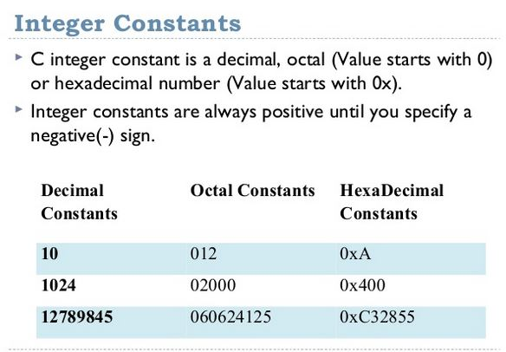

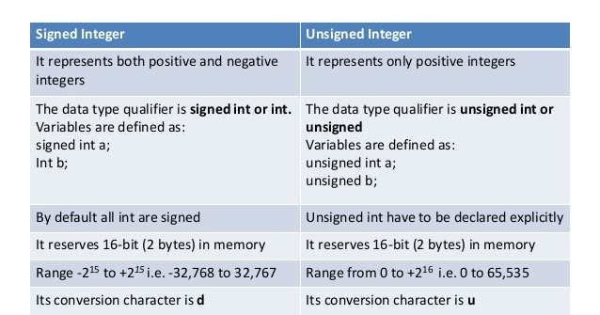

# 

# Floating Point constants

A floating-point constant must contain both integer and decimal parts. Some times it may also contain the exponent part. When a floating-point constant is represented in exponent form, the value must be suffixed with 'e' or 'E'.

Example

The floating-point value **3.14** is represented as **3E-14** in exponent form.

# Character Constants

A character constant is a symbol enclosed in single quotation. A character constant has a maximum length of one character.

Example

**'A'**  
**'2'**  
**'+'**

In the C programming language, there are some predefined character constants called escape sequences. Every escape sequence has its own special functionality and every escape sequence is prefixed with '\' symbol. These escape sequences are used in output function called 'printf()'.

# String Constants

A string constant is a collection of characters, digits, special symbols and escape sequences that are enclosed in double quotations.  
  
We define string constant in a single line as follows...  
**"This is btechsmartclass"**  
  
We can define string constant using multiple lines as follows...  
**" This\**  
**is\**  
**btechsmartclass "**  
  
We can also define string constant by separating it with white space as follows...  
**"This" "is" "btechsmartclass"**  
  
All the above three defines the same string constant.

Enumeration constant:

* There is one another kind of constant i.e Enumeration constant , it is a list of constant integer values.
* Ex.: enum color { RED, Green, BLUE }
* The first name in the enum has the value 0 and the next 1 and so on unless explicit values are specified.
* If not all values specified , unspecified values continue the progression from the last specified value.

For example

* Enum months { JAN=1, FEB,MAR, …, DEC -
* Where the value of FEB is 2 and MAR is 3 and so on.
* Enumerations provide a convenient way to associate constant values with names.

# Creating constants in C

In a c programming language, constants can be created using two concepts...

1. Using the 'const' keyword
2. Using '#define' preprocessor

# Using the 'const' keyword

We create a constant of any datatype using 'const' keyword. To create a constant, we prefix the variable declaration with 'const' keyword.   
The general syntax for creating constant using 'const' keyword is as follows...

const datatype constantName ;

OR

const datatype constantName = value ;

Example

const int x = 10 ;

Here, 'x' is a integer constant with fixed value 10.

# Example Program

#include<stdio.h>

#include<conio.h>

void main(){

int i = 9 ;

const int x = 10 ;

i = 15 ;

x = 100 ; // creates an error

printf("i = %d\nx = %d", i, x ) ;

}

The above program gives an **error** because we are trying to change the constant variable value (x = 100).

# Using '#define' preprocessor

We can also create constants using '#define' preprocessor directive. When we create constant using this preprocessor directive it must be defined at the beginning of the program (because all the preprocessor directives must be written before the global declaration).  
We use the following syntax to create constant using '#define' preprocessor directive...

#define CONSTANTNAME value

Example

#define PI 3.14

Here, **PI** is a constant with value **3.14**

# Example Program

#include<stdio.h>

#include<conio.h>

#defien PI 3.14

void main(){

int r, area ;

printf("Please enter the radius of circle : ") ;

scanf("%d", &r) ;

area = PI * (r * r) ;

printf("Area of the circle = %d", area) ;

}

# 1.6 C Variables

Variables in a c programming language are the named memory locations where the user can store different values of the same datatype during the program execution. That means a variable is a name given to a memory location in which we can store different values of the same data type. In other words, a variable can be defined as a storage container to hold values of the same datatype during the program execution. The formal definition of a data type is as follows...

Variable is a name given to a memory location where we can store different values of the same datatype during the program execution.

Every variable in c programming language must be declared in the declaration section before it is used. Every variable must have a datatype that determines the range and type of values be stored and the size of the memory to be allocated.  
  
A variable name may contain letters, digits and underscore symbol. The following are the rules to specify a variable name...

1. Variable name should not start with a digit.
2. Keywords should not be used as variable names.
3. A variable name should not contain any special symbols except underscore(_).
4. A variable name can be of any length but compiler considers only the first 31 characters of the variable name.

# Declaration of Variable

Declaration of a variable tells the compiler to allocate the required amount of memory with the specified variable name and allows only specified datatype values into that memory location. In C programming language, the declaration can be performed either before the function as global variables or inside any block or function. But it must be at the beginning of block or function.

# Declaration Syntax:

# datatype variableName;

# Example

# int number;

The above declaration tells to the compiler that allocates **2 bytes** of memory with the name **number** and allows only integer values into that memory location.

# 1.2 C DATA TYPES

Data used in c program is classified into different types based on its properties. In the C programming language, a data type can be defined as a set of values with similar characteristics. All the values in a data type have the same properties.  
  
Data types in the c programming language are used to specify what kind of value can be stored in a variable. The memory size and type of the value of a variable are determined by the variable data type. In a c program, each variable or constant or array must have a data type and this data type specifies how much memory is to be allocated and what type of values are to be stored in that variable or constant or array. The formal definition of a data type is as follows...

The Data type is a set of value with predefined characteristics. data types are used to declare variable, constants, arrays, pointers, and functions.

In the c programming language, data types are classified as follows...

1. Primary data types (Basic data types OR Predefined data types)
2. Derived data types (Secondary data types OR User-defined data types)
3. Enumeration data types
4. Void data type

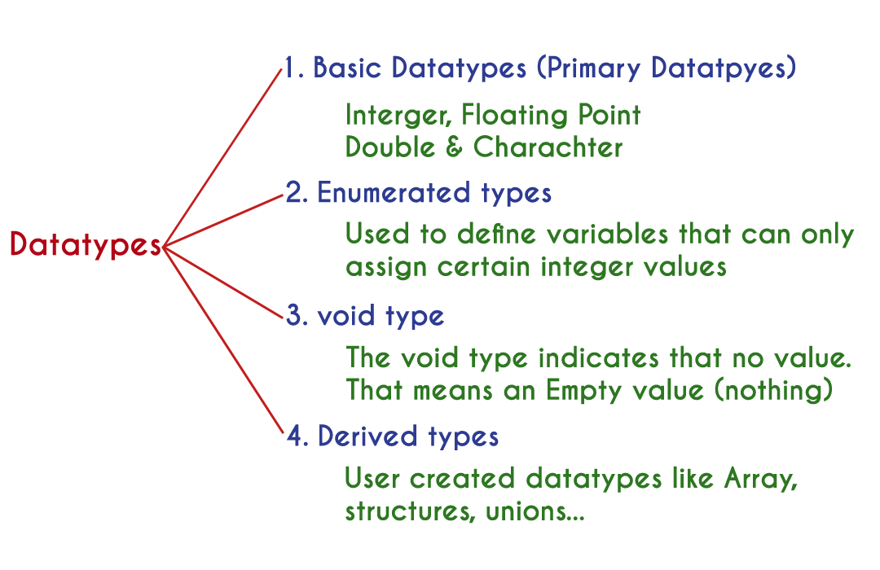

# Primary data types

The primary data types in the C programming language are the basic data types. All the primary data types are already defined in the system. Primary data types are also called as Built-In data types. The following are the primary data types in c programming language...

1. Integer data type
2. Floating Point data type
3. Double data type
4. Character data type

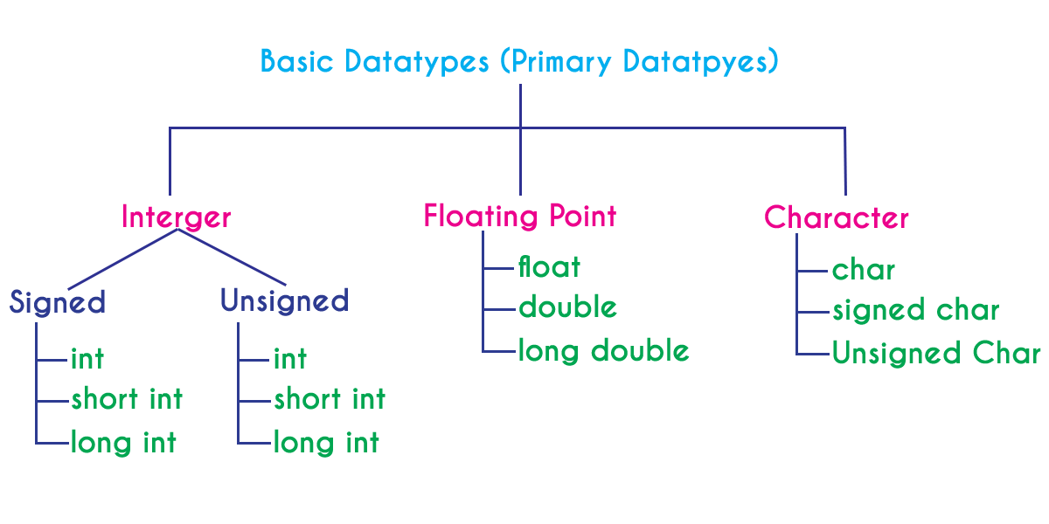

# Integer Data type

The integer data type is a set of whole numbers. Every integer value does not have the decimal value. We use the keyword "**int**" to represent integer data type in c. We use the keyword int to declare the variables and to specify the return type of a function. The integer data type is used with different type modifiers like short, long, signed and unsigned. The following table provides complete details about the integer data type.

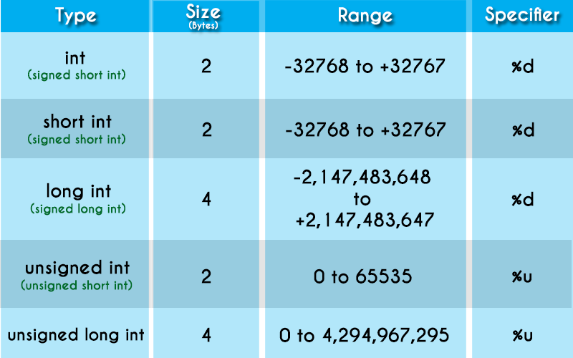

# Floating Point data types

Floating-point data types are a set of numbers with the decimal value. Every floating-point value must contain the decimal value. The floating-point data type has two variants...

* float
* double

We use the keyword "**float**" to represent floating-point data type and "**double**" to represent double data type in c. Both float and double are similar but they differ in the number of decimal places. The float value contains 6 decimal places whereas double value contains 15 or 19 decimal places. The following table provides complete details about floating-point data types.

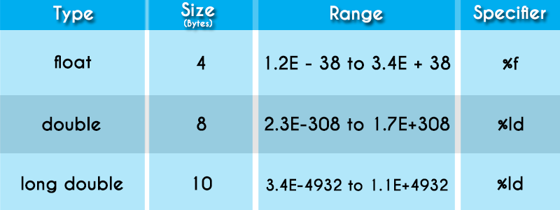

# Character data type

The character data type is a set of characters enclosed in single quotations. The following table provides complete details about the character data type.

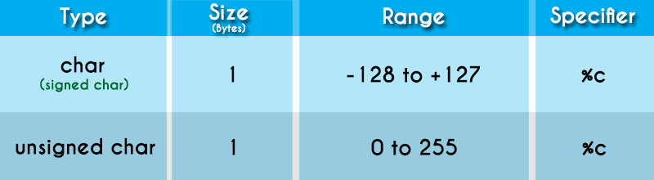

The following table provides complete information about all the data types in c programming language...

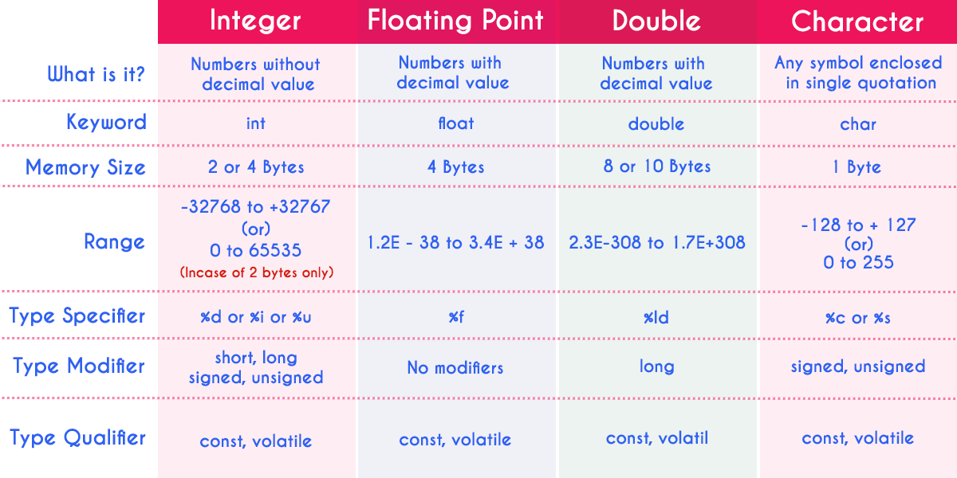

# Derived data types

Derived data types are user-defined data types. The derived data types are also called as user-defined data types or secondary data types. In the c programming language, the derived data types are created using the following concepts...

* Arrays
* Structures
* Unions
* Enumeration

Array

* Same as any other language, Array in C stores multiple values of the same data type. That means we can have an array of integers, chars, floats, doubles, etc
* int numbers[] = ;
* double marks[7];
* float interest[5] = ;

Pointers

* Pointers are considered by many to be complex in C, but that is not the case. Simply put, a pointer is just a variable that stores the address of another variable. A pointer can store the address of variables of any data types. This allows for dynamic memory allocation in C. Pointers also help in passing variables by reference.
* The pointer is defined by using a ‘*’operator. For example –
* int *ptr;

Structs

* A struct is a composite structure that can contain variables of different data types. For example, all the student data that we declared earlier in basic data types can be put under one structure. Instead of having the information scattered, when we give it a structure, it is easier to store information about more students.

typedef struct{

char name[25];

int id;

char group;

float marks[5];

double interest;

}Student;

union

With a union, you can store different data types in the same memory location. The union can have many members, but only one member can have a value at one time. Union, is thus, a special kind of data type in C.

The union is defined in the same way as a structure but with the keyword union.

union Student{

char name[25];

int id;

char group;

float marks[5];

double interest;

}st1, st2;

Enumeration

* Enumeration data types enhance the readability of the code. If you have integer constants in the code that can be reused or clubbed together, we can use enums to define the constants. The most common example of this is the DAYS OF THE WEEK.
* ENUM WEEKDAYS;
* enum weekend;
* Enums are very useful and can be used as flags. They provide flexibility and efficiency in the code.

Void

The void is just an empty data type used as a return type for functions. The absence of any other data type is void. When you declare a function as void, it doesn’t have to return anything. For example –

void swapNumbers(int a, int b)

{//multiple lines of code here}

# 1.4 C OPERATORS

An operator is a symbol used to perform arithmetic and logical operations in a program. That means an operator is a special symbol that tells the compiler to perform mathematical or logical operations. C programming language supports a rich set of operators that are classified as follows.

1. Arithmetic Operators
2. Relational Operators
3. Logical Operators
4. Increment & Decrement Operators
5. Assignment Operators
6. Bitwise Operators
7. Conditional Operator
8. Special Operators

# Arithmetic Operators (+, -, *, /, %)

The arithmetic operators are the symbols that are used to perform basic mathematical operations like addition, subtraction, multiplication, division and percentage modulo. The following table provides information about arithmetic operators.

| Operator | Meaning | Example |
| --- | --- | --- |
| + | Addition | 10 + 5 = 15 |
| - | Subtraction | 10 - 5 = 5 |
| * | Multiplication | 10 * 5 = 50 |
| / | Division | 10 / 5 = 2 |
| % | Remainder of the Division | 5 % 2 = 1 |

**⇒** The addition operator can be used with numerical data types and character data type. When it is used with numerical values, it performs mathematical addition and when it is used with character data type values, it performs concatination (appending).  
  
**⇒** The remainder of the division operator is used with integer data type only.

# Relational Operators (<, >, <=, >=, ==, !=)

The relational operators are the symbols that are used to compare two values. That means the relational operators are used to check the relationship between two values. Every relational operator has two results TRUE or FALSE. In simple words, the relational operators are used to define conditions in a program. The following table provides information about relational operators.

| Operator | Meaning | Example |
| --- | --- | --- |
| < | Returns TRUE if the first value is smaller than second value otherwise returns FALSE | 10 < 5 is FALSE |
| > | Returns TRUE if the first value is larger than second value otherwise returns FALSE | 10 > 5 is TRUE |
| <= | Returns TRUE if the first value is smaller than or equal to second value otherwise returns FALSE | 10 <= 5 is FALSE |
| >= | Returns TRUE if the first value is larger than or equal to second value otherwise returns FALSE | 10 >= 5 is TRUE |
| == | Returns TRUE if both values are equal otherwise returns FALSE | 10 == 5 is FALSE |
| != | Returns TRUE if both values are not equal otherwise returns FALSE | 10 != 5 is TRUE |

# Logical Operators (&&, ||, !)

The logical operators are the symbols that are used to combine multiple conditions into one condition. The following table provides information about logical operators.

| Operator | Meaning | Example |
| --- | --- | --- |
| && | **Logical AND** - Returns TRUE if all conditions are TRUE otherwise returns FALSE | 10 < 5 && 12 > 10 is FALSE |
| || | **Logical OR** - Returns FALSE if all conditions are FALSE otherwise returns TRUE | 10 < 5 || 12 > 10 is TRUE |
| ! | **Logical NOT** - Returns TRUE if condition is FLASE and returns FALSE if it is TRUE | !(10 < 5 && 12 > 10) is TRUE |

**⇒ Logical AND -** Returns TRUE only if all conditions are TRUE, if any of the conditions is FALSE then complete condition becomes FALSE.  
**⇒ Logical OR -** Returns FALSE only if all conditions are FALSE, if any of the conditions is TRUE then complete condition becomes TRUE.

# Increment & Decrement Operators (++ & --)

The increment and decrement operators are called unary operators because both need only one operand. The increment operators adds one to the existing value of the operand and the decrement operator subtracts one from the existing value of the operand. The following table provides information about increment and decrement operators.

| Operator | Meaning | Example |
| --- | --- | --- |
| ++ | **Increment** - Adds one to existing value | int a = 5; a++; ⇒ a = 6 |
| -- | **Decrement** - Subtracts one from existing value | int a = 5; a--; ⇒ a = 4 |

The increment and decrement operators are used infront of the operand (++a) or after the operand (a++). If it is used infront of the operand, we call it as **pre-increment** or **pre-decrement** and if it is used after the operand, we call it as **post-increment** or **post-decrement**.

# Pre-Increment or Pre-Decrement

In the case of pre-increment, the value of the variable is increased by one before the expression evaluation. In the case of pre-decrement, the value of the variable is decreased by one before the expression evaluation. That means, when we use pre-increment or pre-decrement, first the value of the variable is incremented or decremented by one, then the modified value is used in the expression evaluation.

# Example Program

#include<stdio.h>

#include<conio.h>

void main(){

int i = 5,j;

j = ++i; // Pre-Increment

printf("i = %d, j = %d",i,j);

}

Output:

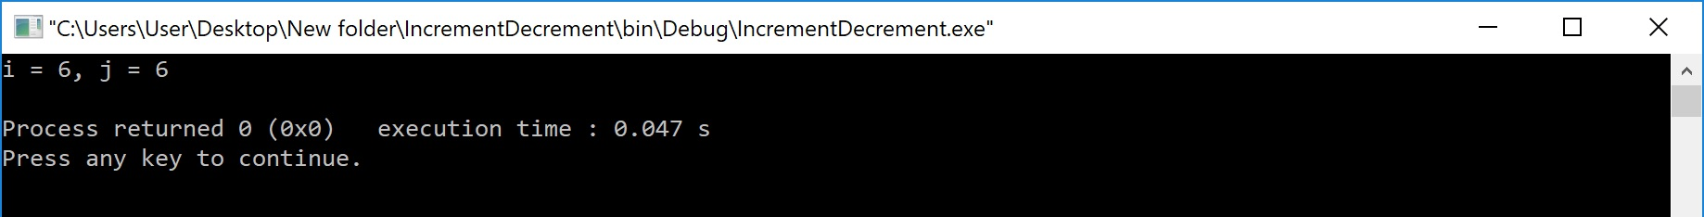

# Post-Increment or Post-Decrement

In the case of post-increment, the value of the variable is increased by one after the expression evaluation. In the case of post-decrement, the value of the variable is decreased by one after the expression evaluation. That means, when we use post-increment or post-decrement, first the expression is evaluated with existing value, then the value of the variable is incremented or decremented by one.

# Example Program

#include<stdio.h>

#include<conio.h>

void main(){

int i = 5,j;

j = i++; // Post-Increment

printf("i = %d, j = %d",i,j);

}

Output:

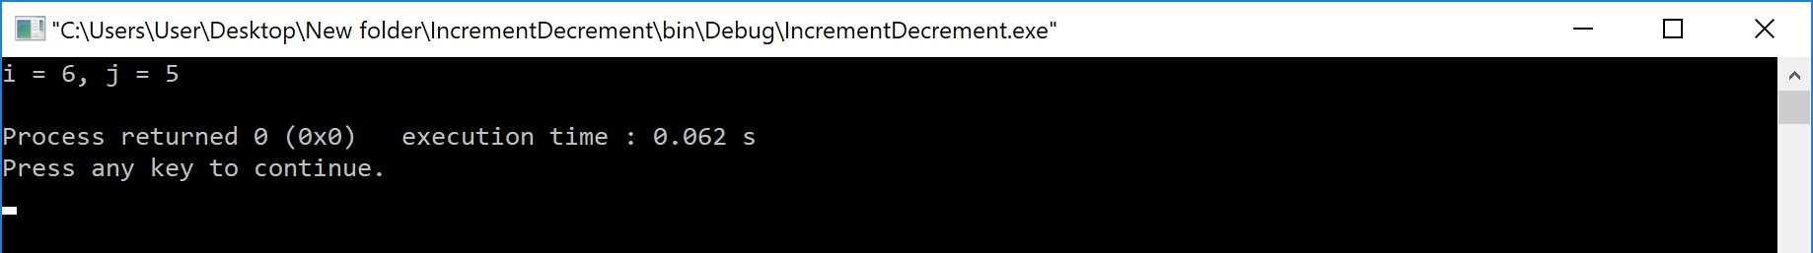

# Assignment Operators (=, +=, -=, *=, /=, %=)

The assignment operators are used to assign right-hand side value (Rvalue) to the left-hand side variable (Lvalue). The assignment operator is used in different variants along with arithmetic operators. The following table describes all the assignment operators in the C programming language.

| Operator | Meaning | Example |
| --- | --- | --- |
| = | Assign the right-hand side value to left-hand side variable | A = 15 |
| += | Add both left and right-hand side values and store the result into left-hand side variable | A += 10 ⇒ A = A+10 |
| -= | Subtract right-hand side value from left-hand side variable value and store the result  into left-hand side variable | A -= B ⇒ A = A-B |
| *= | Multiply right-hand side value with left-hand side variable value and store the result  into left-hand side variable | A *= B ⇒ A = A*B |
| /= | Divide left-hand side variable value with right-hand side variable value and store the result  into the left-hand side variable | A /= B ⇒ A = A/B |
| %= | Divide left-hand side variable value with right-hand side variable value and store the remainder  into the left-hand side variable | A %= B ⇒ A = A%B |

# Bitwise Operators (&, |, ^, ~, >>, <<)

The bitwise operators are used to perform bit-level operations in the c programming language. When we use the bitwise operators, the operations are performed based on the binary values. The following table describes all the bitwise operators in the C programming language.  
Let us consider two variables A and B as A = 25 (11001) and B = 20 (10100).

| Operator | Meaning | Example |
| --- | --- | --- |
| & | the result of Bitwise AND is 1 if all the bits are 1 otherwise it is 0 | A & B ⇒ 16 (10000) |
| | | the result of Bitwise OR is 0 if all the bits are 0 otherwise it is 1 | A | B ⇒ 29 (11101) |
| ^ | the result of Bitwise XOR is 0 if all the bits are same otherwise it is 1 | A ^ B ⇒ 13 (01101) |
| ~ | the result of Bitwise once complement is negation of the bit (Flipping) | ~A ⇒ 6 (00110) |
| << | the Bitwise left shift operator shifts all the bits to the left by the specified number of positions | A << 2 ⇒ 100 (1100100) |
| >> | the Bitwise right shift operator shifts all the bits to the right by the specified number of positions | A >> 2 ⇒ 6 (00110) |

# Conditional Operator (?:)

The conditional operator is also called a **ternary operator** because it requires three operands. This operator is used for decision making. In this operator, first we verify a condition, then we perform one operation out of the two operations based on the condition result. If the condition is TRUE the first option is performed, if the condition is FALSE the second option is performed. The conditional operator is used with the following syntax.

# Condition ? TRUE Part : FALSE Part;

# Example

# A = (10<15)?100:200; ⇒ A value is 100

# Special Operators (sizeof, pointer, comma, dot, etc.)

The following are the special operators in c programming language.

# sizeof operator

This operator is used to find the size of the memory (in bytes) allocated for a variable. This operator is used with the following syntax.

# sizeof(variableName);

# Example

# sizeof(A); ⇒ the result is 2 if A is an integer

# Pointer operator (*)

This operator is used to define pointer variables in c programming language.

# Comma operator (,)

This operator is used to separate variables while they are declaring, separate the expressions in function calls, etc.

# Dot operator (.)

This operator is used to access members of structure or union.

What is an expression?

* In any programming language, if we want to perform any calculation or to frame any condition etc., we use a set of symbols to perform the task. These set of symbols makes an expression.
* In the C programming language, an expression is defined as follows.
* An expression is a collection of operators and operands that represents a specific value.
* In the above definition, an operator is a symbol that performs tasks like arithmetic operations, logical operations, and conditional operations, etc.
* Operands are the values on which the operators perform the task. Here operand can be a direct value or variable or address of memory location.

**What is Operator Precedence?**

* Operator precedence is used to determine the order of operators evaluated in an expression.
* In c programming language every operator has precedence (priority).
* When there is more than one operator in an expression the operator with higher precedence is evaluated first and the operator with the least precedence is evaluated last.
* Precedence of operators
* The precedence of operators determines which operator is executed first if there is more than one operator in an expression.
* Let us consider an example:
* int x = 5 - 17* 6;
* In C, the precedence of * is higher than - and =. Hence, 17 * 6 is evaluated first. Then the expression involving - is evaluated as the precedence of - is higher than that of =.
* Here's a table of operators precedence from higher to lower. The property of associativity will be discussed shortly.

**What is Operator Associativity?**

* Operator associativity is used to determine the order of operators with equal precedence evaluated in an expression.
* In the c programming language, when an expression contains multiple operators with equal precedence, we use associativity to determine the order of evaluation of those operators.
* In c programming language the operator precedence and associativity are as shown in the following table.

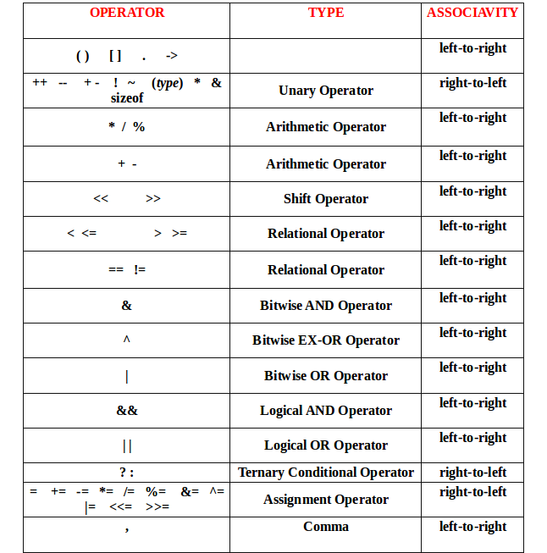

* **1) Associativity is only used when there are two or more operators of same precedence.**
* **2) All operators with the same precedence have same associativity**  
  This is necessary, otherwise, there won’t be any way for the compiler to decide evaluation order of expressions which have two operators of same precedence and different associativity. For example + and – have the same associativity.
* **3) Comma has the least precedence among all operators and should be used carefully** For example consider the following program, the output is 1. See [this](https://www.geeksforgeeks.org/a-comma-operator-question/) and [this](https://www.geeksforgeeks.org/comna-in-c-and-c/) for more details.
* **4) There is no chaining of comparison operators in C**  
  In Python, expression like “c > b > a” is treated as “c > b and b > a”, but this type of chaining doesn’t happen in C.

Associativity

Rules determining how to evaluate expressions containing more than one operator with the same precedence

example: is 5 - 4 - 3 ((5 - 4) - 3) or (5 - (4 - 3))

its important because the values may differ (e.g., -2 or 4 for the above possibilities)

Left associativity: operators are evaluated left to right

Right associativity: evaluated right to left

* The associativity of operators determines the direction in which an expression is evaluated. For example,
* b = a;
* Here, the value of a is assigned to b, and not the other way around. It's because the associativity of the = operator is from right to left.
* Also, if two operators of the same precedence (priority) are present, associativity determines the direction in which they execute.
* Let us consider an example:
* 1 == 2 != 3
* Here, operators == and != have the same precedence. And, their associativity is from left to right. Hence, 1 == 2 is executed first.
* The expression above is equivalent to:
* (1 == 2) != 3

**1.5 TYPE CONVERSIONS IN EXPRESSIONS**

**Type casting** is a way to convert a variable from one data type to another data type.

There are two types of **type casting** in c language that are

Implicit conversions and

Explicit Conversions

* **1. Implicit Type Conversion**
* C permits mixing of constants and variables of different types in an expression. C automatically

converts any intermediate values to the proper type so that the expression can be evaluated without loosing any significance. This automatic conversion is known as implicit type conversion.

* The rule of type conversion: the lower type is automatically converted to the higher type.

**Implicit conversions** do not require any operator for converted. They are automatically performed when a value is copied to a compatible type in the program. output is :20.00000

|  |
| --- |
| #include<stdio.h> |
|  |
| void main() |
| { |
| int i=20; |
| double p; |
| p=i; // implicit conversion |
|  |
| printf(“implicit value is %lf”,p); |
| } |
|  |

* for example,
  + int i, x;
  + f loat f;
  + double d;
  + long int li ;

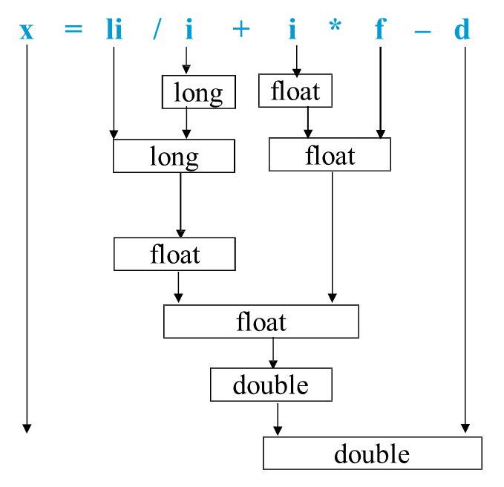

The final result of an expression is converted to the type of the variable on the left of the assignment

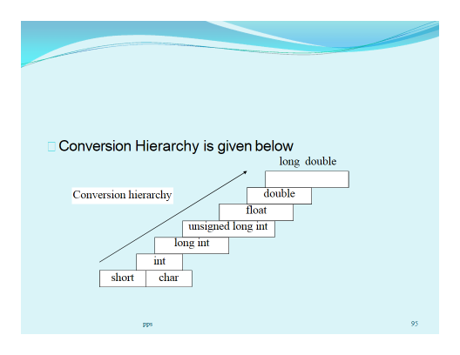

**Explicit conversion**

* We can force a type conversion in a way .
* The general form of explicit conversion is

( type-name ) expression

* for example

— x = ( int ) 7.5 ;

— a = ( int ) 21.3 / (int) 4.5;

— a = ( f loat ) 3 / 2 ;

— a = f loat ( 3 / 2 ) ;

They are not automatically performed**:-**  
output: Explicit value is 20.0000

|  |  |
| --- | --- |
|  | #include<stdio.h> |
|  |  |
| 3 | void main() |
| 4 | { |
| 5 | int i=20; |
| 6 | float p; |
| 7 |  |
| 8 |  |
| 9 | p=(float)i; // explicit conversion |
| 10 |  |
| 11 | printf(“explicit value is %f”,p); |
|  |  |
|  | } |

**1.6 Type of Errors**

* In C we face different kinds of errors. These errors can be categorized into five different types. These are like below −
* Syntax Error
* Run-Time Error
* Linker Error
* Logical Error
* Semantic Error
* **Syntax error**
* This kind of errors are occurred, when it violates the rule of C++ writing techniques or syntaxes. This kind of errors are generally indicated by the compiler before compilation. Sometimes these are known as compile time error.
* In this example, we will see how to get syntax error if we do not put semicolon after one line.
* Example
* #include<stdio.h>
* main() {
* printf("Hello World")
* }
* Output
* Error] expected ';' before '}' token

**Runtime error**

* This kind of errors are occurred, when the program is executing. As this is not compilation error, so the compilation will be successfully done. We can check this error if we try to divide a number with 0.
* Example
* #include<stdio.h>
* main() {
* int x = 52;
* int y = 0;
* printf("Div : %f", x/y);
* }
* Output
* Program crashes during runtime.

**Linker error**

* This kind of errors are occurred, when the program is compiled successfully, and trying to link the different object file with the main object file. When this error is occurred, the executable is not generated, For example some wrong function prototyping, incorrect header file etc. If the main() is written as Main(), this will generate linked error.
* Example
* #include<stdio.h>
* main() {
* int x = 52;
* int y = 0;
* printf("Div : %f", x/y);
* }
* Output
* C:\crossdev\src\mingw-w64-v3-git\mingw-w64-crt\crt\crt0_c.cundefined reference

**Logical error**

* Sometimes, we may not get the desired output. If the syntax and other things are correct, then also, we may not get correct output due to some logical issues. These are called the logical error. Sometimes, we put a semicolon after a loop, that is syntactically correct, but will create one blank loop. In that case, it will show desired output.
* Example
* #include<stdio.h>
* main() {
* int i;
* for(i = 0; i<5; i++);
* {
* printf("Hello World");
* }
* }
* Output
* Here we want the line will be printed five times. But only one time it will be printed for the block of code.

**Semantic error**

* This kind of error occurs when it is syntactically correct but has no meaning. This is like grammatical mistakes. If some expression is given at the left side of assignment operator, this may generate semantic error.
* Example
* #include<stdio.h>
* main() {
* int x, y, z;
* x = 10;
* y = 20;
* x + y = z;
* }
* Output
* [Error] lvalue required as left operand of assignment

# 1.7 C OUTPUT FUNCTIONS

C programming language provides built-in functions to perform output operation. The output operations are used to display data on user screen (output screen) or printer or any file. The c programming language provides the following built-in output functions...

1. printf()
2. putchar()
3. puts()
4. fprintf()

# printf() function

The printf() function is used to print string or data values or a combination of string and data values on the output screen (User screen). The printf() function is built-in function defined in a header file called "**stdio.h**". When we want to use printf() function in our program we need to include the respective header file (stdio.h) using the **#include** statement. The printf() function has the following syntax...

# Syntax:

# printf("message to be display!!!");

# Example Program

#include<stdio.h>

#include<conio.h>

void main(){

printf("Hello! Welcome to btechsmartclass!!!");

}

Output:



In the above example program, we used the printf() function to print a string on to the output screen.  
  
The printf() function is also used to display data values. When we want to display data values we use **format string** of the data value to be displayed.

# Syntax:

# printf("format string",variableName);

# Example Program

#include<stdio.h>

#include<conio.h>

void main(){

int i = 10;

float x = 5.5;

printf("%d %f",i, x);

}

Output:



In the above example program, we used the printf() function to print data values of variables i and x on to the output screen. Here i is a an integer variable so we have used format string %d and x is a float variable so we have used format string %f.  
  
The printf() function can also be used to display string along with data values.

# Syntax:

# printf("String format string",variableName);

# Example Program

#include<stdio.h>

#include<conio.h>

void main(){

int i = 10;

float x = 5.5;

printf("Integer value = %d, float value = %f",i, x);

}

Output:



In the above program, we are displaying string along with data values.  
  
Every function in the C programming language must have a return value. The printf() function also have an integer as a return value. The printf() function returns an integer value equivalent to the total number of characters it has printed.

# Example Program

#include<stdio.h>

#include<conio.h>

void main(){

int i;

i = printf("smartclass");

printf(" is %d number of characters.",i);

}

Output:

No of characters :10

In the above program, first printf() function printing "btechsmartclass" which is of 15 characters. So it returns integer value 15 to the variable "i". The value of "i" is printed in the second printf() function.

# Formatted printf() function

Generally, when we write multiple printf() statements the result is displayed in a single line because the printf() function displays the output in a single line. Consider the following example program...

# Example Program

#include<stdio.h>

#include<conio.h>

void main(){

printf("Welcome to c");

printf("welcome to stpeter ");

printf("the perfect place for learning");

}

Output: welcome to c welcome to stpeters the perfect place for learning

In the above program, there are 3 printf() statements written in different lines but the output is displayed in single line only.  
  
To display the output in different lines or as we wish, we use some special characters called **escape sequences**. Escape sequences are special characters with special functionality used in printf() function to format the output according to the user requirement. In the C programming language, we have the following escape sequences...

| Escape sequence | Meaning |
| --- | --- |
| \n | Moves the cursor to New Line |
| \t | Inserts Horizontal Tab (5 characters space) |
| \v | Inserts Vertical Tab (5 lines space) |
| \a | Beep sound |
| \b | Backspace (removes the previous character from its current position) |
| \\ | Inserts Backward slash symbol |
| \? | Inserts Question mark symbol |
| \' | Inserts Single quotation mark symbol |
| \" | Inserts Double quotation mark symbol |

Consider the following example program...

# Example Program

#include<stdio.h>

#include<conio.h>

void main(){

printf("Welcome to c\n");

printf("welcome to stpeter\n ");

printf("the perfect place for learning\n");

}

Output: welcome to c

welcome to stpeters

the perfect place for learning

# putchar() function

The putchar() function is used to display a single character on the output screen. The putchar() functions prints the character which is passed as a parameter to it and returns the same character as a return value. This function is used to print only a single character. To print multiple characters we need to write multiple times or use a looping statement. Consider the following example program...

# Example Program

#include<stdio.h>

#include<conio.h>

void main(){

char ch = 'A';

putchar(ch);

}

Output:

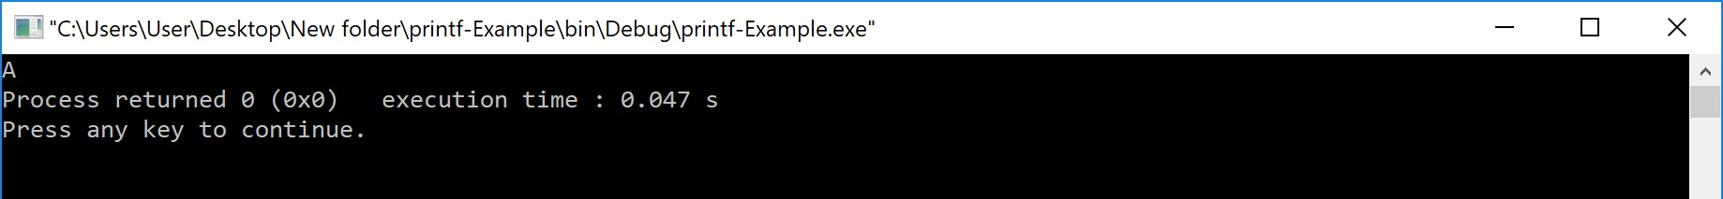

# puts() function

The puts() function is used to display a string on the output screen. The puts() functions prints a string or sequence of characters till the newline. Consider the following example program...

# Example Program

#include<stdio.h>

#include<conio.h>

void main(){

char name[30];

printf("\nEnter your favourite website: ");

gets(name);

puts(name);

}

Output: Enter your favourite website

Stpetershyd.com

# fprintf() function

The fprintf() function is used with the concept of files. The fprintf() function is used to print a line into the file. When you want to use fprintf() function the file must be opened in writting mode.

# C Input Functions

C programming language provides built-in functions to perform input operations. The input operations are used to read user values (input) from the keyboard. The c programming language provides the following built-in input functions.

1. scanf()
2. getchar()
3. getch()
4. gets()
5. fscanf()

# scanf() function

The scanf() function is used to read multiple data values of different data types from the keyboard. The scanf() function is built-in function defined in a header file called "**stdio.h**". When we want to use scanf() function in our program, we need to include the respective header file (stdio.h) using **#include** statement. The scanf() function has the following syntax...

# Syntax:

# scanf("format strings",&variableNames);

# Example Program

#include<stdio.h>

#include<conio.h>

void main(){

int i;

printf("\nEnter any integer value: ");

scanf("%d",&i);

printf("\nYou have entered %d number",i);

}

Output:



In the above example program, we used the scanf() function to read an integer value from the keyboard and store it into variable 'i'.  
  
The scanf function also used to read multiple data values of different or the same data types. Consider the following example program...

# Example Program

#include<stdio.h>

#include<conio.h>

void main(){

int i;

float x;

printf("\nEnter one integer followed by one float value : ");

scanf("%d%f",&i, &x);

printf("\ninteger = %d, float = %f",i, x);

}

Output:



In the above example program, we used the scanf() function to read one integer value and one float value from the keyboard. Here **'i'** is an integer variable so we have used format string %d, and **'x'** is a float variable so we have used format string %f.  
  
The scanf() function returns an integer value equal to the total number of input values read using scanf function.

# Example Program

#include<stdio.h>

#include<conio.h>

void main(){

int i,a,b;

float x;

printf("\nEnter two integers and one float : ");

i = scanf("%d%d%f",&a, &b, &x);

printf("\nTotal inputs read : %d",i);

}

Output:



# getchar() function

The getchar() function is used to read a character from the keyboard and return it to the program. This function is used to read a single character. To read multiple characters we need to write multiple times or use a looping statement. Consider the following example program...

# Example Program

#include<stdio.h>

#include<conio.h>

void main(){

char ch;

printf("\nEnter any character : ");

ch = getchar();

printf("\nYou have entered : %c\n",ch);

}

Output:

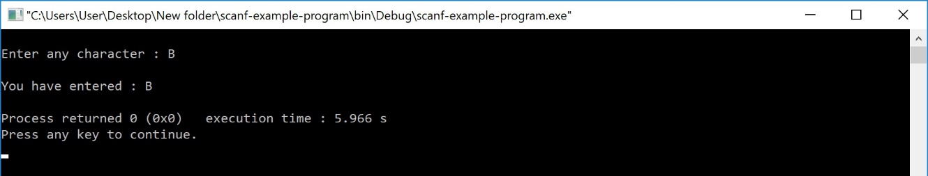

# getch() function

The getch() function is similar to getchar function. The getch() function is used to read a character from the keyboard and return it to the program. This function is used to read a single character. To read multiple characters we need to write multiple times or use a looping statement. Consider the following example program...

# Example Program

#include<stdio.h>

#include<conio.h>

void main(){

char ch;

printf("\nEnter any character : ");

ch = getch();

printf("\nYou have entered : %c",ch);

}

Output:

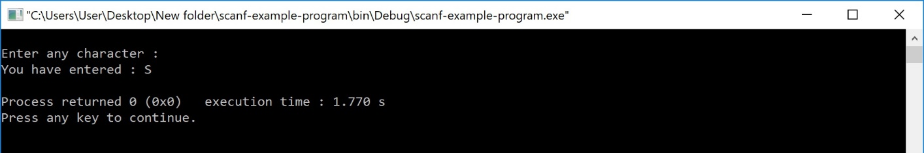

# gets() function

The gets() function is used to read a line of string and stores it into a character array. The gets() function reads a line of string or sequence of characters till a newline symbol enters. Consider the following example program...

# Example Program

#include<stdio.h>

#include<conio.h>

void main(){

char name[30];

printf("\nEnter your favourite website: ");

gets(name);

printf("%s",name);

}

Output: Enter your favourite website:stpeterhyd.com

# fscanf() function

The fscanf() function is used with the concept of files. The fscanf() function is used to read data values from a file. When you want to use fscanf() function the file must be opened in reading mode.

# Unit –II

|  |  |
| --- | --- |
| **Unit-2** | |
| Statement | A statement is a syntactic unit of an imperative programming language that expresses some action to be carried out |
| Iteration Statement | Iteration statements cause statements (or compound statements) to be executed zero or more times, subject to some loop-termination criteria. |

Concepts:

1. CONTROL STATEMENTS IN C PROGRAMMING LANGUAGE:

To control the flow of program execution c programming languages uses control statements. C provides two sytles of flow control:

* Branching (or) Selectional statements
* Looping ( or ) Iterative statements

Branching is deciding what actions to take and looping is deciding how many times to take a certain action.

Selectional statement are used to make one-time decisions in C Programming, that is, to execute some code/s and ignore some code/s depending upon the test expression.

## IF STATEMENT

if (test expression)

{

statement/s to be executed if test expression is true;

}

if statement checks whether the text expression inside parenthesis () is true or not. If the test expression is true, statement/s inside the body of if statement is executed but if test is false, statement/s inside body of if is ignored.

### Flowchart of if statement

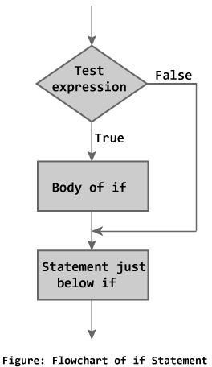

### Example of if statement

#include <stdio.h>

int main()

{

int x = 20;

int y = 22;

if (x<y)

{

printf("Variable x is less than y");

}

return 0;

}

**Output:**

Variable x is less than y

* 1. C IF...ELSE STATEMENT

The if...else statement is used if the programmer wants to execute some statement/s when the test expression is true and execute some other statement/s if the test expression is false.

Syntax of if...else

if (test expression) {

statements to be executed if test expression is true;

}

else {

statements to be executed if test expression is false;

}

Flowchart of if...else statement

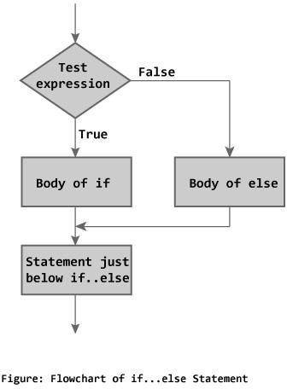

### Example of if else statement

In this program user is asked to enter the age and based on the input, the if..else statement checks whether the entered age is greater than or equal to 18. If this condition meet then display message “You are eligible for voting”, however if the condition doesn’t meet then display a different message “You are not eligible for voting”.

#include <stdio.h>

int main()

{

int age;

printf("Enter your age:");

scanf("%d",&age);

if(age >=18)

{

/* This statement will only execute if the

* above condition (age>=18) returns true

*/

printf("You are eligible for voting");

}

else

{

/* This statement will only execute if the

* condition specified in the "if" returns false.

*/

printf("You are not eligible for voting");

}

return 0;

}

Output:

Enter your age:14

You are not eligible for voting

# Nested if...else statement (if...elseif else Statement)

The nested if else statement is used when program requires more than one test expression.

Syntax of nested if. else statement.

if (test expression1){

statement/s to be executed if test expression1 is true;

}

else if(test expression2) {

statement/s to be executed if test expression1 is false and 2 is true;

}

else if (test expression 3) {

statement/s to be executed if text expression1 and 2 are false and 3 is true;

}

.

.

.

else {

statements to be executed if all test expressions are false;

}

### How else if ladder.. works?

The nested if...else statement has more than one test expression. If the first test expression is true, it executes the code inside the braces{ } just below it. But if the first test expression is false, it checks the second test expression. If the second test expression true, it executes the statement/s inside the braces{ } just below it. This process continues. If all the test expression are false, code/s inside else is executed and the control of program jumps below the nested if...else

The ANSI standard specifies that 15 levels of nesting may be continued.

### Example of nested if..else

### #include <stdio.h>

int main()

{

int var1, var2;

printf("Input the value of var1:");

scanf("%d", &var1);

printf("Input the value of var2:");

scanf("%d",&var2);

if (var1 !=var2)

{

printf("var1 is not equal to var2\n");

}

else if (var1 > var2)

{

printf("var1 is greater than var2\n");

}

else if (var2 > var1)

{

printf("var2 is greater than var1\n");

}

else

{

printf("var1 is equal to var2\n");

}

return 0;

}

Output:

Input the value of var1:12

Input the value of var2:21

var1 is not equal to var2

As you can see that only the statements inside the body of “if” are executed. This is because in this statement as soon as a condition is satisfied, the statements inside that block are executed and rest of the blocks are ignored.

Important Points:  
1. else and else..if are optional statements, a program having only “if” statement would run fine.  
2. else and else..if cannot be used without the “if”.  
3. There can be any number of else..if statement in a if else..if block.  
4. If none of the conditions are met then the statements in else block gets executed.  
5. Just like relational operators, we can also use logical operators such as AND (&&), OR(||) and NOT(!).

# C PROGRAMMING LOOPS

Loops cause program to execute the certain block of code repeatedly until test condition is false. Loops are used in performing repetitive task in programming. Consider these scenarios:

1. You want to execute some code/s 100 times.
2. You want to execute some code/s certain number of times depending upon input from user.

These types of task can be solved in programming using loops. There are 3 types of loops in C programming:

1. for loop
2. while loop
3. do...while loop

### 2.1 for Loop Syntax

for(initialization statement; test expression; update statement) { code/s to be executed;

}

### How for loop works in C programming?

The initialization statement is executed only once at the beginning of the for loop. Then the test expression is checked by the program. If the test expression is false, for loop is terminated. But if test expression is true then the code/s inside body of for loop is executed and then update expression is updated. This process repeats until test expression is false.

This flowchart describes the working of for loop in C programming.

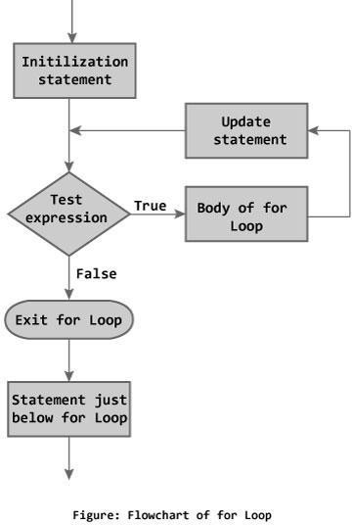

### Example of For loop

#include <stdio.h>

int main()

{

int i;

for (i=1; i<=3; i++)

{

printf("%d\n", i);

}

return 0;

}

Output:

1

2

3

### Nested For Loop in C

Nesting of loop is also possible. Lets take an example to understand this:

#include <stdio.h>

int main()

{

for (int i=0; i<2; i++)

{

for (int j=0; j<4; j++)

{

printf("%d, %d\n",i ,j);

}

}

return 0;

}

Output:

0, 0

0, 1

0, 2

0, 3

1, 0

1, 1

1, 2

1, 3

## Multiple initialization inside for Loop in C

We can have multiple initialization in the for loop as shown below.

for (i=1,j=1;i<10 && j<10; i++, j++)

**What’s the difference between above for loop and a simple for loop?**  
1. It is initializing two variables. Note: both are separated by comma (,).  
2. It has two test conditions joined together using AND (&&) logical operator. Note: You cannot use multiple test conditions separated by comma, you must use logical operator such as && or || to join conditions.  
3. It has two variables in increment part. **Note:** Should be separated by comma.

### Example of for loop with multiple test conditions

#include <stdio.h>

int main()

{

int i,j;

for (i=1,j=1 ; i<3 || j<5; i++,j++)

{

printf("%d, %d\n",i ,j);

}

return 0;

}

2.2 WHILE LOOP STATEMENT:

Syntax of while loop while (test xpression) {

statement/s to be executed.

}

The while loop checks whether the test expression is true or not. If it is true, code/s inside the body of while loop is executed,that is, code/s inside the braces { } are executed. Then again the test expression is checked whether test expression is true or not. This process continues until the test expression becomes false.

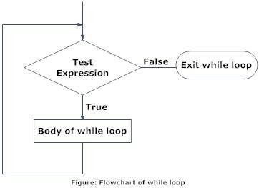

### Example of while loop

#include <stdio.h>

int main()

{

int count=1;

while (count <= 4)

{

printf("%d ", count);

count++;

}

return 0;

}

Output:

1 2 3 4

**step1:** The variable count is initialized with value 1 and then it has been tested for thecondition.  
**step2:** If the condition returns true then the statements inside the body of while loop are executed else control comes out of the loop.  
**step3:** The value of count is incremented using ++ operator then it has been tested again for the loop condition.

## Use of Logical operators in while loop

Just like relational operators (<, >, >=, <=, ! =, ==), we can also use logical operators in while loop. The following scenarios are valid :

while(num1<=10 && num2<=10)

-using AND(&&) operator, which means both the conditions should be true.

while(num1<=10||num2<=10)

– OR(||) operator, this loop will run until both conditions return false.

while(num1!=num2 &&num1 <=num2)

– Here we are using two logical operators NOT (!) and AND(&&).

while(num1!=10 ||num2>=num1)

### Example of while loop using logical operator

In this example we are testing multiple conditions using logical operator inside while loop.

#include <stdio.h>

int main()

{

int i=1, j=1;

while (i <= 4 || j <= 3)

{

printf("%d %d\n",i, j);

i++;

j++;

}

return 0;

}

Output:

1 1

2 2

3 3

4 4

# 2.3 Do...while loop

In C, do...while loop is very similar to while loop. Only difference between these two loops is that, in while loops, test expression is checked at first but, in do...while loop code is executed at first then the condition is checked. So, the code are executed at least once in do...while loops.

Syntax of do...while loops do {

some code/s;

}

while (test expression);

At first codes inside body of do is executed. Then, the test expression is checked. If it is true, code/s inside body of do are executed again and the process continues until test expression becomes false(zero).

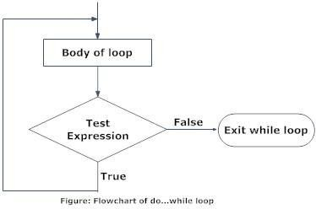Notice, there is semicolon in the end of while (); in do...while loop.

### Example of do while loop

#include <stdio.h>

int main()

{

int j=0;

do

{

printf("Value of variable j is: %d\n", j);

j++;

}while (j<=3);

return 0;

}

**Output:**

Value of variable j is: 0

Value of variable j is: 1

Value of variable j is: 2

Value of variable j is: 3

## 2.4 While vs do..while loop in C

**Using while loop:**

#include <stdio.h>

int main()

{

int i=0;

while(i==1)

{

printf("while vs do-while");

}

printf("Out of loop");

}

**Output:**

Out of loop

**Same example using do-while loop**

#include <stdio.h>

int main()

{

int i=0;

do

{

printf("while vs do-while\n");

}while(i==1);

printf("Out of loop");

}

**Output:**

while vs do-while

Out of loop

# BREAK & CONTINUE STATEMENT:

There are two statements built in C programming, break; and continue; to alter the normal flow of a program. Loops perform a set of repetitive task until text expression becomes false but it is sometimes desirable to skip some statement/s inside loop or terminate the loop immediately without checking the test expression. In such cases, break and continue statements are used. The break;statement is also used in switch statement to exit switch statement.

### 3.1 break Statement

In C programming, break is used in terminating the loop immediately after it is encountered. The break statement is used with conditional if statement.

Syntax of break statement break;

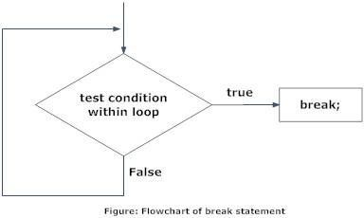The break statement can be used in terminating all three loops for, while and do...while loops.

The figure below explains the working of break statement in all three type of loops.

### Example – Use of break in a while loop

#include <stdio.h>

int main()

{

int num =0;

while(num<=100)

{

printf("value of variable num is: %d\n", num);

if (num==2)

{

break;

}

num++;

}

printf("Out of while-loop");

return 0;

}

**Output:**

value of variable num is: 0

value of variable num is: 1

value of variable num is: 2

Out of while-loop

### Example – Use of break in a for loop

#include <stdio.h>

int main()

{

int var;

for (var =100; var>=10; var --)

{

printf("var: %d\n", var);

if (var==99)

{

break;

}

}

printf("Out of for-loop");

return 0;

}

**Output:**

var: 100

var: 99

Out of for-loop

### Example – Use of break statement in switch-case

#include <stdio.h>

int main()

{

int num;

printf("Enter value of num:");

scanf("%d",&num);

switch (num)

{

case 1:

printf("You have entered value 1\n");

break;

case 2:

printf("You have entered value 2\n");

break;

case 3:

printf("You have entered value 3\n");

break;

default:

printf("Input value is other than 1,2 & 3 ");

}

return 0;

}

Output:

Enter value of num:2

You have entered value 2

You would always want to use break statement in a switch case block, otherwise once a case block is executed, the rest of the subsequent case blocks will execute. For example, if we don’t use the break statement after every case block then the output of this program would be:

Enter value of num:2

You have entered value 2

You have entered value 3

Input value is other than 1,2 & 3

# 3.2 CONTINUE STATEMENT

It is sometimes desirable to skip some statements inside the loop. In such cases, continue statements are used.

Syntax of continue Statement continue;

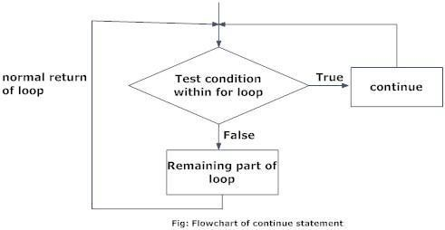Just like break, continue is also used with conditional if statement.

#include <stdio.h>

int main()

{

for (int j=0; j<=8; j++)

{

if (j==4)

{

/* The continue statement is encountered when

* the value of j is equal to 4.

*/

continue;

}

/* This print statement would not execute for the

* loop iteration where j ==4 because in that case

* this statement would be skipped.

*/

printf("%d ", j);

}

return 0;

}

Output:

0 1 2 3 5 6 7 8

Value 4 is missing in the output, why? When the value of variable j is 4, the program encountered a continue statement, which makes the control to jump at the beginning of the for loop for next iteration, skipping the statements for current iteration (that’s the reason printf didn’t execute when j is equal to 4).

### Example: Use of continue in While loop

In this example we are using continue inside while loop. When using while or do-while loop you need to place an increment or decrement statement just above the continue so that the counter value is changed for the next iteration. For example, if we do not place counter– statement in the body of “if” then the value of counter would remain 7 indefinitely.

#include <stdio.h>

int main()

{

int counter=10;

while (counter >=0)

{

if (counter==7)

{

counter--;

continue;

}

printf("%d  ", counter);

counter--;

}

return 0;

}

Output:

10 9 8 6 5 4 3 2 1 0

The print statement is skipped when counter value was 7.

### Another Example of continue in do-While loop

#include <stdio.h>

int main()

{

int j=0;

do

{

if (j==7)

{

j++;

continue;

}

printf("%d ", j);

j++;

}while(j<10);

return 0;

}

Output:

0 1 2 3 4 5 6 8 9

# SWITCH CASE STATEMENT:

Decision making are needed when, the program encounters the situation to choose a particular statement among many statements. If a programmer has to choose one block of statement among many alternatives, nested if...else can be used but, this makes programming logic complex. This type of problem can be handled in C programming using switch statement.

Syntax of switch...case switch (*n*) {

case constant1:

code/s to be executed if *n* equals to *constant1*; break;

case *constant2*:

code/s to be executed if *n* equals to *constant2*; break;

.

.

.

default:

code/s to be executed if *n* doesn't match to any cases;

}

The value of *n* is either an integer or a character in above syntax. If the value of *n* matches constant in case, the relevant codes are executed and control moves out of the switch statement. If the *n* doesn't matches any of the constant in case, then the default codes are executed and control moves out of switch statement.

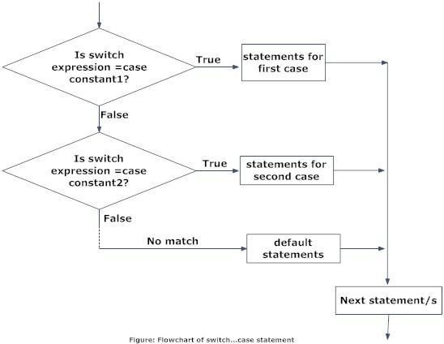

### Example of Switch Case in C

Let’s take a simple example to understand the working of a switch case statement in C program.

#include <stdio.h>

int main()

{

int num=2;

switch(num+2)

{

case 1:

printf("Case1: Value is: %d", num);

case 2:

printf("Case1: Value is: %d", num);

case 3:

printf("Case1: Value is: %d", num);

default:

printf("Default: Value is: %d", num);

}

return 0;

}

**Output:**

Default: value is: 2

**Explanation:** In switch I gave an expression, you can give variable also. I gave num+2, where num value is 2 and after addition the expression resulted 4. Since there is no case defined with value 4 the default case is executed.

### – Introducing Break statement

Before we discuss more about [break statement](https://beginnersbook.com/2014/01/c-break-statement/), guess the output of this C program.

#include <stdio.h>

int main()

{

int i=2;

switch (i)

{

case 1:

printf("Case1 ");

case 2:

printf("Case2 ");

case 3:

printf("Case3 ");

case 4:

printf("Case4 ");

default:

printf("Default ");

}

return 0;

}

**Output:**

Case2 Case3 Case4 Default

We passed a variable to switch, the value of the variable is 2 so the control jumped to the case 2, However there are no such statements in the above program which could break the flow after the execution of case 2. That’s the reason after case 2, all the subsequent cases and default statements got executed.

**How to avoid this situation?**  
We can use break statement to break the flow of control after every case block.

### Break statement in Switch Case

Break statements are useful when you want your program-flow to come out of the switch body. Whenever a break statement is encountered in the switch body, the control comes out of the switch case statement.

**Example of Switch Case with break**  
I’m taking the same above that we have seen above but this time we are using break.

#include <stdio.h>

int main()

{

int i=2;

switch (i)

{

case 1:

printf("Case1 ");

break;

case 2:

printf("Case2 ");

break;

case 3:

printf("Case3 ");

break;

case 4:

printf("Case4 ");

break;

default:

printf("Default ");

}

return 0;

}

**Output:**

Case 2

**Why didn’t I use break statement after default?**  
The control would itself come out of the switch after default so I didn’t use it, however if you want to use the break after default then you can use it, there is no harm in doing that.

## Few Important points regarding Switch Case

1) Case doesn’t always need to have order 1, 2, 3 and so on. They can have any integer value after case keyword. Also, case doesn’t need to be in an ascending order always, you can specify them in any order as per the need of the program.

2) You can also use characters in switch case. for example –

#include <stdio.h>

int main()

{

char ch='b';

switch (ch)

{

case 'd':

printf("CaseD ");

break;

case 'b':

printf("CaseB");

break;

case 'c':

printf("CaseC");

break;

case 'z':

printf("CaseZ ");

break;

default:

printf("Default ");

}

return 0;

}

Output:

CaseB

3) The expression provided in the switch should result in a constant value otherwise it would not be valid.  
For example:  
**Valid expressions for switch –**

switch(1+2+23)

switch(1*2+3%4)

**Invalid switch expressions –**

switch(ab+cd)

switch(a+b+c)

4) Nesting of switch statements are allowed, which means you can have switch statements inside another switch. However nested switch statements should be avoided as it makes program more complex and less readable.  
5) Duplicate case values are not allowed. For example, the following program is incorrect:  
This program is **wrong** because we have two case ‘A’ here which is wrong as we cannot have duplicate case values.

#include <stdio.h>

int main()

{

char ch='B';

switch (ch)

{

case 'A':

printf("CaseA");

break;

case 'A':

printf("CaseA");

break;

case 'B':

printf("CaseB");

break;

case 'C':

printf("CaseC ");

break;

default:

printf("Default ");

}

return 0;

}

6) The **default** statement is optional, if you don’t have a default in the program, it would run just fine without any issues. However it is a good practice to have a default statement so that the default executes if no case is matched. This is especially useful when we are taking input from user for the case choices, since user can sometime enter wrong value, we can remind the user with a proper error message that we can set in the default statement.

# GOTO STATEMENT:

In C programming, goto statement is used for altering the normal sequence of program execution by transferring control to some other part of the program.

Syntax of goto statement goto label;

.............

.............

.............

label:

statement;

In this syntax, label is an identifier. When, the control of program reaches to goto statement, the control of the program will jump to the label: and executes the code below it.

Example:

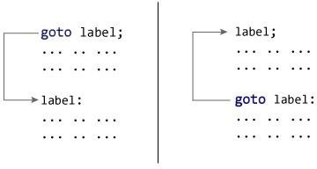

### Reasons to avoid goto statement

Though, using goto statement give power to jump to any part of program, using goto statement makes the logic of the program complex and tangled. In modern programming, goto statement is considered a harmful construct and a bad programming practice.

The goto statement can be replaced in most of C program with the use of break and continue statements. In fact, any program in C programming can be perfectly written without the use of goto statement. All programmer should try to avoid goto statement as possible as they can.

### Example of goto statement

#include <stdio.h>

int main()

{

int sum=0;

for(int i = 0; i<=10; i++){

sum = sum+i;

if(i==5){

goto addition;

}

}

addition:

printf("%d", sum);

return 0;

}

Output:

15

**Explanation:** In this example, we have a label addition and when the value of i (inside loop) is equal to 5 then we are jumping to this label using goto. This is reason the sum is displaying the sum of numbers till 5 even though the loop is set to run from 0 to 10.

**UNIT – III**

**Structured Programming :** Functions: Syntax, Steps ,Types and Category of Functions, parameter passing mechanism. Recursion and Storage Classes

**Dynamic memory allocation:** malloc(), calloc(), realloc(), free() with example

1. **Introduction to structured programming**

Software engineering is a discipline that is concerned with the construction of robust and reliable computer programs. Just as civil engineers use tried and tested methods for the construction of buildings, software engineers use accepted methods for analyzing a problem to be solved, a blueprint or plan for the design of the solution and a construction method that minimizes the risk of error.

The structured programming approach to program design was based on the following method.

i. To solve a large problem, break the problem into several pieces and work on each piece separately.

ii. To solve each piece, treat it as a new problem that can itself be broken down into smaller problems;

iii. Repeat the process with each new piece until each can be solved directly, without further decomposition.

**2. Functions - Basics**

In programming, a function is a segment that groups code to perform a specific task. A C program has at least one function main().Without main() function, there is technically no C program.

**Types of C functions**

There are two types of functions in C programming:

1. Library functions

2. User defined functions

**1 Library functions**

Library functions are the in-built function in C programming system.

For example:

main() - The execution of every C program starts form this main() function.

printf() – is used for displaying output in C.

scanf() – is used for taking input in C.

**2 User defined functions**

C allows programmer to define their own function according to their requirement. These types of functions are known as user- defined functions. Suppose, a programmer wants to find factorial of a number and check whether it is prime or not in same program. Then, he /she can create tow separate user-defined functions in that program: one for finding factorial and other for checking whether it is prime or not.

How user-defined function works in C Programming?

#include<stdio.h>

voidfunction_name(){

……………….

……………….

}

int main(){

……………….

……………….

function_name();

……………….

……………….

}

As mentioned earlier, every C program begins form main() and program starts executing the codes inside main() function. When the control of program reaches to function_name() inside main() function. The Control of program jumps to void function_name() and executes the codes inside it. When all the codes inside that user-defined function are executed, control of the program jumps to the statement just after function_name() from where it is called. Analyze the figure below for understanding the concept of function in C programming. Visit this page to learn in detail about user-defined functions.

Remember, the function name is an identifier and should be unique.

**Advantages of user defined functions**

1. User defined functions helps to decompose the large program into small segments which makes programmer easy to understand, maintain and debug.

2. If repeated code occurs in a program. Function can be used to include those codes and execute when needed by calling that function.

3. Programmer working on large project can divide the workload by making different functions.

**3. C Programming User-defined functions**

**Example of user-defined function**

Write a C program to add two integers. Make a function **add** to add integers and display sum

int**main()** function.

/* program to demonstrate the working of user defined function*/

#include<stdio.h>

#include<conio.h>

int add(int a, int b); /* Function Declaration */

int main()

{

int num1,num2,sum;

clrscr();

printf(“enter two numbers : \n ”);

scanf(“%d %d”,&num1,&num2);

sum=add(num1,num2); /* Function Call*/

printf(“\n sum is : %d”,sum);

getch();

}

int add(inta,int b) /* Function Definition */

{

int add;

add=a+b;

return add;

}

**3.1 Function Declaration**

Every function in C programming should be declared before they are used. These type of declaration are also called function prototype. Function prototype gives compiler information about function name, type of arguments to be passed and return type.

**Syntax:**

return_typefunction_name(type(1) argument(1),....,type(n) argument(n));

In the above example,int add(int a, int b); is a function prototype which provides following information to the compiler:name of the function is add()

1. return type of the function is int.

2. two arguments of type int are passed to function.

Function prototype are not needed if user-definition function is written before main() function.

**3.2 Function call**

Control of the program cannot be transferred to user-defined function unless it is called invoked.

**Syntax:**

function_name(argument(1),....argument(n));

In the above example, function call is made using statement add(num1,num2); from main(). This make the control of program jump from that statement to function definition and executes the codes inside that function.

**3.3 Function Definition:**

Function definition contains programming codes to perform specific task.

**Syntax:**

return_typefunction_name(type(1) argument(1),..,type(n) argument(n))

{

//body of function

}

Function definition has two major components:

**3.3.1Function declarator or function header**

Function declarator is the first line of function definition. When a function is called, control of the program is transferred to functiondeclarator.

**Syntax**

return_typefunction_name(type(1) argument(1),....,type(n) argument(n))

Syntax of function declaration and declarator are almost same except, there is no semicolon at the end of declarator and function declarator is followed by function body.

In above example, intadd(inta,int b) in line 12 is a function declarator.

**3.3.2 Function body**

Function declarator is followed by body of function inside braces.

**3.4 Passing Arguments to functions**

In programming, argument(parameter) refers to data this is passed to function(function definition) while calling function.

In above example two variable, num1 and num2 are passed to function during function call and these arguments are accepted by arguments a and b in function definition.

Arguments that are passed in function call and arguments that are accepted in function definition should have same data type. For example:

If argument *num1* was of int type and *num2* was of float type then, argument variable *a* should be of type int and b should be of type float,i.e., type of argument during function call and function definition should be same.

A function can be called with or without an argument.

**3.5 Return Statement**

Return statement is used for returning a value from function definition to calling function.

**Syntax:**

return (expression);

For example:

return a;

returna+b;

In above example, value of variable add in add() function is returned and that value is stored in variable *sum* in main() function. The data type of expression in return statement should also match the return type of function.

**4. Inter Function communication**

The Calling and called function are two separate entities, they need to communicate to exchange data. The data flow between the calling and called functions can be divided into three strategies

DOWNWARD FLOW UPWARD FLOW BI-DIRECTIONAL FLOW

Downward Flow:

In downward communication, the calling function sends data to the called function. No data flows in the opposite direction. In this strategy, copies of the data items are passed from the calling function to the called function. The called function may change the values passed, but the original values in the calling function remain untouched.

Example: **call-by-value**

#include<stdio.h>

void main()

{ int x=2,y=3,z=0;

add(x,y);

}

void add(intx,int y)

{ int z;

z=x+y;

printf(“%d”,z);

}

Upward Flow:

Upward communication occurs when the called function sends data back to the called function without receiving any data from it.

Example: **call-by-reference**

#include<stdio.h>

void main()

{

int x=2,y=3,z=0;

modify(&x, &y);

printf((“%d%d”,x,y);

}

void modify(int *x,int *y)

{

*x=10;

*y=20;

}

Bi-directional Flow:

The strategy described for the upward direction can easily be augmented to allow the communication in both directions. The only difference is that the indirect reference must be used in both sides of the assignment variable.

#include<stdio.h>

void main()

{

int x=2,y=3,z=0;

modify(&x, &y);

printf((“%d%d”,x,y);

}

void modify(int *x,int *y)

{

*x=*x+10;

*y=*y+20;

}

**5. Storage classes – auto, register, static, extern**

The concept of storage class modifiers is used for the purpose of efficient utilization of variables and economisation of variables. These are used to tell the compiler how the variable that follows should be stored.

The General declaration form is

*Storage-specifier Data type variable name;*

There are four storage class specifiers supported by C. They are

1) Auto

2) Register

3) Static

4) Extern

**auto**: The variables generally declared in any function are called automatic variables. Even if the storage class is not specified they become auto by default.

For example :inta,b,c; is equal to auto inta,b,c;

The scope of these variables is that they are active only within the function in which they are declared. These are also called as „Local Variables‟.

Ex Pgm: #include<stdio.h>

void main()

{

autoint x=2;

printf(“%d”,x);

}

**static**: The variables that are declared and initialized in a function are normally initializing the variables for every function call and process further, but if we expect the function should initialize only once and process further then we go to the declaration of variable to be static.

Example: static int x;

The scope of these variables is within the function in which they are declared.

Ex pgm: : #include<stdio.h>

void main()

{

add();

add();

}

void add()

{ staticint x=0;

x++;

Printf(“%d”,x);

}

Output: 1 2 3

**register:** The variables generally declared in functions normally allocate the memory in the RAM type of memory. The variables declared using register allocate the memory in a „register‟ type of memory. The speed of register type of memory is more than the speed of RAM type of memory. The declaration looks like this.

Example: register inta,b,c;

The scope of these variables is that they are active only within the functions in which they are declared.

Example Program: #include<stdio.h>

void main()

{

Register int x=2;

printf(“%d”,x);

}

**extern:** The variables declared in a file are to be referenced by the variables in another files then such kind of variables can be accessed among the files by declaring the variable to be extern;

Example program:

First.c second.h

#include<stdio.h> int m;

#include<second.h> void add()

Extern int m; {

void main() printf(“%d”, m);

{ }

int m=2;

add();

}

**6. Recursion**

Recursion is a repetitive process in which a function calls itself. The process of repetition can be done in two ways using programming. They are

➢ Iterative Definition

➢ Recursive Definition

**Iterative Definition:**

Repeating a set of statements using loops is referred as Iteration.

**Recursive Definition:**

A repetitive function is defined recursively whenever the function appears within the definition itself. The recursive function has two elements : each call either solves one part of the problem or it reduces the size of the problem. The statement that solves the problem is known as the **base case**. The rest of the function is known as the **general case**. Each recursive function must have a base case.

**Example:** Finding Factorial of a number using recursive function.

Let the number be 4, then

4! =4x3x2x1

If n is the number then

n!=nx(n-1)x(n-2)x(n-3)x(n-4)……x(n-n)

or

n!=nx(n-1)!

(n-1)!=(n-1) x (n-2)!

(n-2)!=(n-2)x(n-3)!

………………………………………

(n-n)!=1

4!=4x3! n=nx(n-1)! If n=4

3!=3x2! n=nx(n-1)! If n=3

2!=2x1! n=nx(n-1)! If n=2

1!=1x0! n=nx(n-1)! if n=1

0!=1 n1=1 if n=0

In the above example ,

n=nx(n-1)! Is considered as general case as it is valid for all n values

n!=1 is considered as base case as the value of 0! and 1! are 1 with which calculating the factorial terminates.

Base case: factorial(0)

General case: nxfactorial(n-1).

The execution order is as follows

4! = 4x3! (4x6=24)

3! = 3x2! (3x2=6)

2! = 2!x1 (2x1=2)

1! = 1x0! (1x1=1)

0!=1 (1=1)

The following are the rules for designing a recursive function:

1. First, determine the base case

2. Then, determine the general case

3. Finally, combine the base case and general case into a function

In combining the base and general cases into a function, we must pay careful attention to the logic. The base case, when reached, must terminate without a call to the recursive function; that is, it must execute a return.

Program:

#include<stdio.h>

int factorial(int );

void main()

{

Intn,result;

Printf(“enter the number”);

Scanf(“%d”,&n);

Result=factorial(n);

Printf(“%d”,result);

}

Intfactorial(int n)

{

if(n==0)

Return 1;

else

Return(nxfactorial(n-1));

}

Limitations of Recursion:

1. Recursive solutions may involve extensive overhead because they use function calls.

2. Each time you make a call, you use up some of your memory allocation.



#include<stdio.h>

#include<conio.h> void TOH(intn,char x, char y, char z);

void main()

{

int n;

printf(“\n enter the number of plates :”);

scanf(“%d”,&n);

TOH(n-1,‟A‟,‟B‟,‟C‟);

getch();

}

void TOH(int n, char x, char y, char z)

{

if(n>0)

{

TOH(n-1,x,z,y);

printf(“\n %c -> %c”,x,y);

TOH(n-1,z,y,x);

}

}

**7. Passing Arrays to Functions:**

An entire array can be transferred to a function as a parameter. To transfer an array to a function, the array name is enough without subscripts as an actual parameters within the function call.The corresponding formal parameters are written in same fashion, and must be declared as an array in formal parameters declaration.

**Syntax:**

voidfunccall(int,int[]);

main() void funccall(x,arr[])

{ {

int a[10],n;

…… }

funccall(n,a);

…..

}

Example Program demonstrating passing an array of 5 elements to function printarray;

#include<stdio.h>

void main()

{

inti,a[5];

Printf(“enter the elements”);

For(i=0;i<5;i++)

Scanf(“%d”,&a[i]);

Printarray(a);

}

voidprintarray(intarr[5])

{

For(i=0;i<5;i++)

printf(“%d”,arr[i]);

}

**8. Strings - Basics**

Strings are actually one-dimensional array of characters terminated by a **null**character '\0'. Thus a null-terminated string contains the characters that comprise the string followed by a **null**.

The following declaration and initialization create a string consisting of the word "Hello". To hold the null character at the end of the array, the size of the character array containing the string is one more than the number of characters in the word "Hello."

char greeting[6]={ 'H', 'e', 'l', 'l', 'o', '\0'};

If you follow the rule of array initialization then you can write the above statement as follows char greeting[] = "Hello";

Following is the memory presentation of the above defined string in C/C++

Actually, you do not place the *null* character at the end of a string constant. The C compiler automatically places the '\0' at the end of the string when it initializes the array. Let us try to print the above mentioned string –

#include<stdio.h>

#include<conio.h>

int main()

{

char greeting[6]=”Hello”;

printf(“\n Greeting Message : %s \n”,greeting);

getch();

}

When the above code is compiled and executed, it produces the following result –

Greeting message: Hello

**9. String input /output functions**

C programming language provides many of the built-in functions to read given input and write data on screen, printer or in any file.

**i. scanf() and printf() functions**

#include<stdio.h>

#include<conio.h>

void main()

{

int i;

printf(“\n Enter a value :”);

scanf(“%d”,&i);

printf(“\n You entered : %d”,i);

getch();

}

When you will compile the above code, it will ask you to enter a value. When you will enter the value, it will display the value you have entered.

**NOTE :** printf() function returns the number of characters printed by it, and scanf() returns the number of characters read by it.

int i = printf("studytonight");

In this program i will get 12 as value, because studytonight has 12 characters.

**ii. getchar() &putchar() functions**

The getchar()function reads a character from the terminal and returns it as an integer. This function reads only single character at a time. You can use this method in the loop in case you want to read more than one characters. Theputchar()function prints the character passed to it on the screen and returns the same character. This function puts only single character at a time. In case you want to display more than one characters, use putchar() method in the loop.

#include<stdio.h>

#include<conio.h>

void main()

{

int c;

printf(“Enter a character :”);

c=getchar();

putchar(c);

getch();

}

When you will compile the above code,it will ask you to enter a value. When you will enter the value, it will display the value you have entered.

**iii. gets() & puts() functions**

The gets() function reads a line from **stdin** into the buffer pointed to by **s** until either a terminating newline or EOF (end of file). The puts() function writes the string **s** and a trailing newline to stdout.

#include<stdio.h>

#include<conio.h>

void main()

{

charstr[100];

printf(“Enter a String :”);

gets(str);

puts(str);

getch();

}

When you will compile the above code,it will ask you to enter a string. When you will enter the string, it will display the value you have entered.

**Difference between scanf() and gets() functions**

The main difference between these two functions is that scanf() stops reading characters when it encounters a space, but gets() reads space as character too.

If you enter name as **Study Tonight** using scanf() it will only read and store **Study** and will leave the part after space. But gets() function will read it complete.

**10. String handling functions:**

|  |  |
| --- | --- |
|  |  |
|  |  |
| The following example uses some of the above-mentioned functions –  **/* Write C program to reverse a string */**  #include<stdio.h>  #include<conio.h>  #include<string.h>  void main()  {  intn,i,j=0;  char str1[10],str2[10];  clrscr();  printf("\n Enter the string :");  gets(str1);  n=strlen(str1)-1;  for(i=n;i>=0;i--)  {  str2[j]=str1[i];  j++;  }  str2[j]=’\0’;  printf("\n reverse of the string is : %s",str2);  getch();  }  **/* Write a C program copying from one string to another string */**  #include<stdio.h>  #include<conio.h>  void main()  {  char str1[20],str2[20];  clrscr();  printf("\n enter the string : ");  scanf("%s",str1);  strcpy(str2,str1);  printf("\n The string after copying is : ");  printf("\n %s",str2);  getch();  }  **/* Write a C program to get the sub string from the given string by using index values */**  #include<stdio.h>  #include<conio.h>  #include<string.h>  void main()  {  intn,start,end,i=0;  char str1[10],str2[10];  clrscr();  printf("\n enter the string :");  gets(str1);  printf("\n enter the starting index and ending index value : ");  scanf("%d %d",&start,&end);  for(n=start;n<=end;n++)  {  str2[i]=str1[n];  i++;  }  str2[i]='\0';  printf("sub string is %s",str2);  getch();  }  **/* Write a C program to concatenating two strings**  #include<stdio.h>  #include<conio.h>  #include<string.h>  void main()  {  char str1[10],str2[10],c;  clrscr();  printf("enter the first string :");  scanf("%s",str1);  printf("enter the second string :");  scanf("%s",str2);  strcat(str1,str2);  printf("\n The string after concatenation is : %s ",str1);  getch();  }  **11. Strings to functions**  String can be passed to functions in similar manner as arrays as, string is also an array.  Example:  #inlcude<stdio.h> #include<conio.h>  void display(char ch[]);  void main()  {  char c[50];  printf(“Enter the string :”);  gets(c);  display(c);  }  void display(char ch[])  {  printf(“\n String is : ”);  puts(ch);  }  Here string c is passed from main() function to user-defined function display(). In function declaration, ch[] is the formal argument. |  |
|  |  |
|  |  |
|  |  |
|  |  |

**Dynamic Memory Allocation in C using malloc(), calloc(), free() and realloc()**

Since C is a structured language, it has some fixed rules for programming. One of it includes changing the size of an array. An array is collection of items stored at continuous memory locations.  
[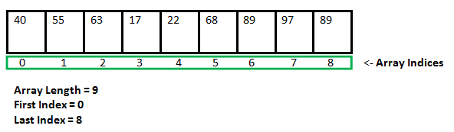](https://media.geeksforgeeks.org/wp-content/cdn-uploads/gq/2015/05/Arrays.png)

As it can be seen that the length (size) of the array above made is 9. But what if there is a requirement to change this length (size). For Example,

* If there is a situation where only 5 elements are needed to be entered in this array. In this case, the remaining 4 indices are just wasting memory in this array. So there is a requirement to lessen the length (size) of the array from 9 to 5.
* Take another situation. In this, there is an array of 9 elements with all 9 indices filled. But there is a need to enter 3 more elements in this array. In this case 3 indices more are required. So the length (size) of the array needs to be changed from 9 to 12.

This procedure is referred to as **Dynamic Memory Allocation in C**.

Therefore, C **Dynamic Memory Allocation** can be defined as a procedure in which the size of a data structure (like Array) is changed during the runtime.

C provides some functions to achieve these tasks. There are 4 library functions provided by C defined under **<stdlib.h>** header file to facilitate dynamic memory allocation in C programming. They are:

1. malloc()
2. calloc()
3. free()
4. realloc()

Let’s look at each of them in greater detail.

### C malloc() method

**“malloc”** or **“memory allocation”** method in C is used to dynamically allocate a single large block of memory with the specified size. It returns a pointer of type void which can be cast into a pointer of any form. It initializes each block with default garbage value.

**Syntax:**

ptr = (cast-type*) malloc(byte-size)

**For Example:**

***ptr = (int*) malloc(100 * sizeof(int));***

*Since the size of int is 4 bytes, this statement will allocate 400 bytes of memory. And, the pointer ptr holds the address of the first byte in the allocated memory.*

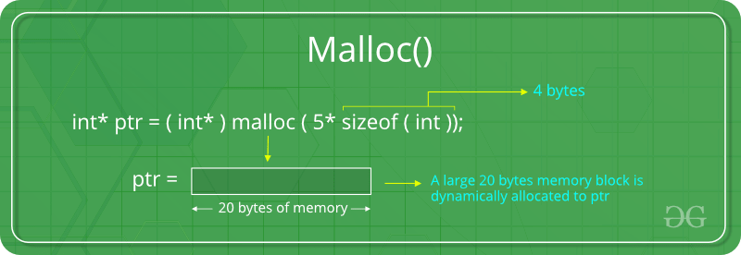

If space is insufficient, allocation fails and returns a NULL pointer.

**Example:**

|  |
| --- |
| #include <stdio.h>  #include <stdlib.h>    int main()  {        // This pointer will hold the      // base address of the block created      int* ptr;      int n, i;        // Get the number of elements for the array      n = 5;      printf("Enter number of elements: %d\n", n);        // Dynamically allocate memory using malloc()      ptr = (int*)malloc(n * sizeof(int));        // Check if the memory has been successfully      // allocated by malloc or not      if (ptr == NULL) {          printf("Memory not allocated.\n");          exit(0);      }      else {            // Memory has been successfully allocated          printf("Memory successfully allocated using malloc.\n");            // Get the elements of the array          for (i = 0; i < n; ++i) {              ptr[i] = i + 1;          }            // Print the elements of the array          printf("The elements of the array are: ");          for (i = 0; i < n; ++i) {              printf("%d, ", ptr[i]);          }      }        return 0;  } |

**Output:**

Enter number of elements: 5

Memory successfully allocated using malloc.

The elements of the array are: 1, 2, 3, 4, 5,

### C calloc() method

**“calloc”** or **“contiguous allocation”** method in C is used to dynamically allocate the specified number of blocks of memory of the specified type. It initializes each block with a default value ‘0’.

**Syntax:**

ptr = (cast-type*)calloc(n, element-size);

**For Example:**

***ptr = (float*) calloc(25, sizeof(float));***

*This statement allocates contiguous space in memory for 25 elements each with the size of the float.*

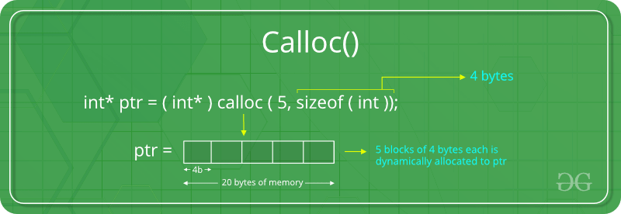

If space is insufficient, allocation fails and returns a NULL pointer.

**Example:**

|  |
| --- |
| #include <stdio.h>  #include <stdlib.h>    int main()  {        // This pointer will hold the      // base address of the block created      int* ptr;      int n, i;        // Get the number of elements for the array      n = 5;      printf("Enter number of elements: %d\n", n);        // Dynamically allocate memory using calloc()      ptr = (int*)calloc(n, sizeof(int));        // Check if the memory has been successfully      // allocated by calloc or not      if (ptr == NULL) {          printf("Memory not allocated.\n");          exit(0);      }      else {            // Memory has been successfully allocated          printf("Memory successfully allocated using calloc.\n");            // Get the elements of the array          for (i = 0; i < n; ++i) {              ptr[i] = i + 1;          }            // Print the elements of the array          printf("The elements of the array are: ");          for (i = 0; i < n; ++i) {              printf("%d, ", ptr[i]);          }      }        return 0;  } |

**Output:**

Enter number of elements: 5

Memory successfully allocated using calloc.

The elements of the array are: 1, 2, 3, 4, 5,

### C free() method

**“free”** method in C is used to dynamically **de-allocate** the memory. The memory allocated using functions malloc() and calloc() is not de-allocated on their own. Hence the free() method is used, whenever the dynamic memory allocation takes place. It helps to reduce wastage of memory by freeing it.

**Syntax:**

free(ptr);

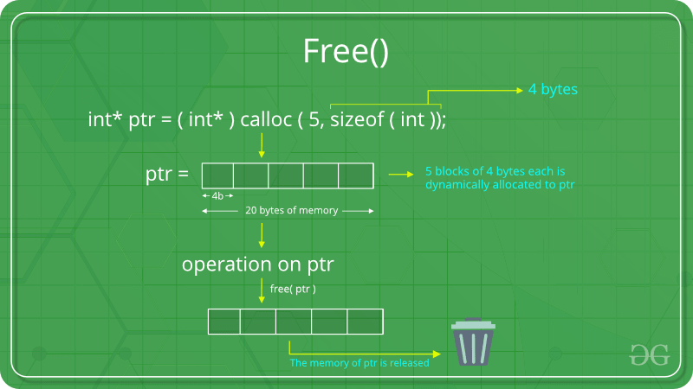

**Example:**

|  |
| --- |
| #include <stdio.h>  #include <stdlib.h>    int main()  {        // This pointer will hold the      // base address of the block created      int *ptr, *ptr1;      int n, i;        // Get the number of elements for the array      n = 5;      printf("Enter number of elements: %d\n", n);        // Dynamically allocate memory using malloc()      ptr = (int*)malloc(n * sizeof(int));        // Dynamically allocate memory using calloc()      ptr1 = (int*)calloc(n, sizeof(int));        // Check if the memory has been successfully      // allocated by malloc or not      if (ptr == NULL || ptr1 == NULL) {          printf("Memory not allocated.\n");          exit(0);      }      else {            // Memory has been successfully allocated          printf("Memory successfully allocated using malloc.\n");            // Free the memory          free(ptr);          printf("Malloc Memory successfully freed.\n");            // Memory has been successfully allocated          printf("\nMemory successfully allocated using calloc.\n");            // Free the memory          free(ptr1);          printf("Calloc Memory successfully freed.\n");      }        return 0;  } |

**Output:**

Enter number of elements: 5

Memory successfully allocated using malloc.

Malloc Memory successfully freed.

Memory successfully allocated using calloc.

Calloc Memory successfully freed.

### C realloc() method

**“realloc”** or **“re-allocation”** method in C is used to dynamically change the memory allocation of a previously allocated memory. In other words, if the memory previously allocated with the help of malloc or calloc is insufficient, realloc can be used to **dynamically re-allocate memory**. re-allocation of memory maintains the already present value and new blocks will be initialized with default garbage value.

**Syntax:**

ptr = realloc(ptr, newSize);

where ptr is reallocated with new size 'newSize'.

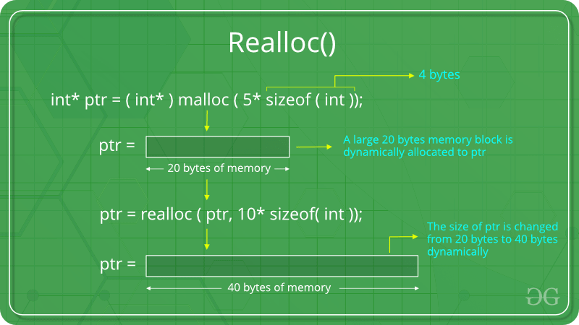

If space is insufficient, allocation fails and returns a NULL pointer.

**Example:**

|  |
| --- |
| #include <stdio.h>  #include <stdlib.h>    int main()  {        // This pointer will hold the      // base address of the block created      int* ptr;      int n, i;        // Get the number of elements for the array      n = 5;      printf("Enter number of elements: %d\n", n);        // Dynamically allocate memory using calloc()      ptr = (int*)calloc(n, sizeof(int));        // Check if the memory has been successfully      // allocated by malloc or not      if (ptr == NULL) {          printf("Memory not allocated.\n");          exit(0);      }      else {            // Memory has been successfully allocated          printf("Memory successfully allocated using calloc.\n");            // Get the elements of the array          for (i = 0; i < n; ++i) {              ptr[i] = i + 1;          }            // Print the elements of the array          printf("The elements of the array are: ");          for (i = 0; i < n; ++i) {              printf("%d, ", ptr[i]);          }            // Get the new size for the array          n = 10;          printf("\n\nEnter the new size of the array: %d\n", n);            // Dynamically re-allocate memory using realloc()          ptr = realloc(ptr, n * sizeof(int));            // Memory has been successfully allocated          printf("Memory successfully re-allocated using realloc.\n");            // Get the new elements of the array          for (i = 5; i < n; ++i) {              ptr[i] = i + 1;          }            // Print the elements of the array          printf("The elements of the array are: ");          for (i = 0; i < n; ++i) {              printf("%d, ", ptr[i]);          }            free(ptr);      }        return 0;  } |

**Output:**

Enter number of elements: 5

Memory successfully allocated using calloc.

The elements of the array are: 1, 2, 3, 4, 5,

Enter the new size of the array: 10

Memory successfully re-allocated using realloc.

The elements of the array are: 1, 2, 3, 4, 5, 6, 7, 8, 9, 10,

**UNIT - IV**

**Arrays & Strings:** Declaration , Initialization and Accessing Elements, String handling functions, Array of Strings.

**Structures and Unions:** Defining structures, initializing structures, unions, Array of structures, self referential structures.

**Pointers:** Types of Pointers Use of Pointers, Dereferencing operations, Examples

ARRAYS

*Arrays:*

These are the collection of elements which are of similar data type.

Syntax: datatype name of array [ size ];

Example: int a1[5];

Note: Size should be an integer value only.

The elements are going to be stored in a continuous memory location.

Example:

0 1 2 3 4

|  |  |  |  |  |
| --- | --- | --- | --- | --- |
|  |  |  |  |  |

2 bytes 2 bytes 2 bytes 2 bytes 2 bytes

size of ( a1[3]) ; 🡪 2 bytes

size of (a1); 🡪 10 bytes

size of ( a1 [5]) ; 🡪 none (since, no value is there i.e., no 6th element)

*Declaration of an array:*

Syntax:

datatype name of array [ size ];

The datatype may be int, float or char.

The name of the array is a valid identifier.

Size: It indicates the number of elements in an array, which are of the given data type and they are going to be called with same name (name of the array) followed by subscript of individual elements.

Example: int a1 [5];

The above declaration tells that ‘a1’is the name of the array, ‘int’ is the data type, ‘[5]’ is the number of elements of integer data type and all the elements are going to be called with name followed by individual element subscript value.

Defining the array:

int a[5] = {1,2,3,4,5};

a[0]=11; a[1]=12; a[2]=13; a[3]=14; a[4]=15;

int b[] = { 1,2,3,4,5 };

int a[4];

for ( i=0; i<5; i++ )

scanf(“%d”,&a[i]);

For FLOAT:

float a1 [5]; a1[5 ] = { 1.1,2.2,3.3,4.4,5.5 };

Note :

If the array is partially defined then the undefined positions of array will be filled with zero.

For CHAR:

char ch1 [5];

ch1 [5] = { ‘a’, ‘b’, ‘c’, ‘d’, ‘e’ }; (or)

ch1[5]={ ‘1’, ‘2’, ‘3’, ‘4’, ‘5’ };

To display the array element or to read data from array,.

1. For individual element subscript is followed along array name.

Example: if ( %d”, a[2]); 🡪prints 3rd element or an element at position 2.

1. For total array element we must use for loop.

Example: for (i=0; i<5; i++)

Printf(“%d”, a[i]);

Collection of integer elements is called integer array

Example: int x[5];

[5] = { 1,2,3,4,5 }

Collection of float elements is called float array

Example: float x[5];

x[5] = { 1.1, 3.4, 5.2, 6.3, 2.3 }

Collection of character elements is called character array/strings

Example: char x1[5];

X1[5] = { ‘T’, ‘S’, ‘I’, ‘O’,’ H’ };

An array element without any subscript gives address,

i.e., printf (“ %d”, x1) 🡪65512 (address)

printf (“%d”, &x1[0]) 🡪65512.

Note: If we assign a string to an array, the size of the array should be +1 of the number of characters of the string.

Char name[16]=”upendar gandham”;

In the above example, the number of characters in string 15, the size of array is 16 i.e., +1 of the actual number of characters of the string.

Example: int x1 [4];

x1 [4] = { 1, 20, 33 };

printf(“%d”, x1[3]);

OUTPUT: ‘0’.

The number of elements entering into the array exceeds its specified size, the system will accept the data, without giving any error by compiler at the time of execution the system will terminate unexpectedly.

Note: The subscript values should be integer values only.

*Single dimensional array*

If the name is followed by a single subscript then it is called as single dimensional array.

**E**xample: int m[5];

1. Write a program for entering 5 characters into an array and to display.

#include<stdio.h>

Output:

a 1 $ 2 b

#include<conio.h>

void main()

{

int i;

char ch [5] = { ‘a’. ‘1’, ‘$’, ‘2’, ‘b’ };

for (i=0; i<5; i++)

printf (“%c”, ch [i]);

}

2. Write a program for adding the elements in an array.

#include<stdio.h>

#include<conio.h>

void main()

{

Output:

Enter five values

11 22 33 44 55

the sum of array elements is 165

int s=0, a[5],i;

printf (“Enter five values”);

for (i=0;i<5;i++)

scanf (“%d”, & a[i]);

for ( i=0; i<5; i++ )

{

s = s + a[i];

}

printf (“\n the sum of array elements is %d”, s);

}

3. Write a program for searching an element in an array list.

#include<stdio.h>

#include<conio.h>

void main()

Enter five values

11 22 33 44 55

Enter the element to be searched

33

Element is found in the list

{

int a[5] ,i,find,count=0;

printf (“Enter five values”);

for (i=0;i<5;i++)

scanf (“%d”, & a[i]);

printf(“enter the element to be searched”);

scanf(“%d”,&find);

for (i=0; i<5; i++)

{

if (m == a[i])

{

count=1;

}

}

if(count==1)

printf(“element is found in list”);

else

{

printf (“element is not found in the list”);

}

}

4. Write a program for sorting array elements.

void main()

{

Output:

The sorted list is

2 3 10 13 15 28

int i, j, t, a[6], = { 10, 15, 2, 28, 3, 13 };

for ( i=0; i<6; i++)

{

for ( j=i+1; j<6; j++)

{

if (a[i] > a[j])

{

t = a[i];

a[i] = a[j];

a[j] = t;

}

}

}

printf(“the sorted list is”\n”);

for(i=0;i<6;i++)

printf(“%d “,a[i]);

}

*Double dimensional array (2D array):*

An array name followed by 2 subscripts is called double dimensional array and each subscript must have its own square brackets.

**S**yntax: data_type name_of_the_array[row_size][column_size];

**E**xample: a1[3][3] valid

a1[ 3 3 ] invalid

**I**nitialization of 2D array:

1. float fp1 [2][2] = { 1.2, 1.3, 1.4, 1.5 };
2. float fp1 [2][2] = { 1.2, 1.3 }, { 1.4, 1.5 } };
3. int a[3][3];

for ( i=0; i<row size; i++ )

{

for ( j=0; j<column size; j++ )

scanf (“%d”, &a[i][j]);

}

To display the array element or to read data from array:

1. To display specific element

printf (“%d”, a[i][j]); it displays ith row and jth column value in 2D array.

1. To see all the array elements:

for(i=0;i<rowsize;i++)

for(j=0;j<columnsize;j++)

printf(“%d”,a[i][j]);

1. Write a program for entering the data into 2D array and for displaying.

void main()

{

int i, j, a1[3][3];

printf (“Enter array elements”);

for ( i=0; i<3; i++ )

Output:

Enter array elements

11 22 33 44 55 66 77 88 99

The array elements are

11 22 33

44 55 66

77 88 99

{

for ( j=0; j<3; j++ )

scanf (“%d”, &a[i][j]);

}

printf(“the array elements”);

for ( i=0; i<3; i++ )

{

for ( j=0; j<3; j++ )

{

printf (“%d\t”, a[i][j]);

}

printf (“\n”);

}

}

1. Write a c program to add two matrices?

#include<stdio.h>

void main()

{

int A[10][10],B[10][10],C[10][10],i,j,m,n,p,q;

clrscr();

printf("enter row and column for matrix A");

scanf("%d%d",&m,&n);

printf("\nenter row and column for matrix B");

scanf("%d%d",&p,&q);

printf("\nenter array elements in matrix A");

enter row and column for matrix A

2

3

enter row and column for matrix B

2

3

enter array elements in matrix A

1 0 0

0 0 1

enter array elements in matrix B

0 1 1

1 1 0

matrix addition result is

1 1 1

1 1 1

for(i=0;i<m;i++)

{

for(j=0;j<n;j++)

scanf("%d",&A[i][j]);

}

printf("enter array elements in matrix B");

for(i=0;i<p;i++)

{

for(j=0;j<q;j++)

scanf("%d",&B[i][j]);

}

if(m==p && n==q)

{

printf("\n matrix addition result is\n");

for(i=0;i<m;i++)

{

for(j=0;j<n;j++)

{

C[i][j]=A[i][j]+B[i][j];

printf("%d ",C[i][j]);

}

printf("\n");

}

}

else

{

printf("addition of matrices is not possible");

}

}

1. Write a c program to multiply two matrices?

#include<stdio.h>

#include<conio.h>

void main()

{

enter row and column for matrix A

2

3

enter row and column for matrix B

3

2

enter array elements in matrix A

1 0 0

0 0 1

enter array elements in matrix B

0 1

1 0

1 1

matrix multiplication result is

0 1

1 1

int A[10][10],B[10][10],C[10][10],m,n,p,q,i,j,k;

clrscr();

printf("enter row and column for matrix A");

scanf("%d%d",&m,&n);

printf("enter row and column for matrix B");

scanf("%d%d",&p,&q);

printf("enter array elements in matrix A");

for(i=0;i<m;i++)

for(j=0;j<n;j++)

scanf("%d",&A[i][j]);

printf("enter array elements in matrix B");

for(j=0;j<p;j++)

for(k=0;k<q;k++)

scanf("%d",&B[j][k]);

if(n==p)

{

printf("\n");

for(i=0;i<m;i++)

{

for(k=0;k<q;k++)

{

C[i][k]=0;

for(j=0;j<n;j++)

{

C[i][k]=C[i][k]+A[i][j]*B[j][k];

}

}

}

printf("matrix multiplication result is\n\n\n");

for(i=0;i<m;i++)

{

for(k=0;k<q;k++)

printf("%d ",C[i][k]);

printf("\n");

}

}

else

{

printf("matrix multiplication is not possible");

}

}

*Multi dimensional array (or) N-dimensional array:*

Declaration:

Array name follows more than 3 subscripts then it is treated as multi dimensional array or N-dimensional array.

Syntax:

for 3D array declaration

Datatype array_name[tablesize][rowsize][columnsize];

Example: int mdarray[4][4][5];

The array indicates there are 4 tables each table contains 4 rows and 5 column matrix.

To declare and define a 3D array:

int arry[4][4][5],i,j,k;

printf(“enter the elements int o 3d array”);

for(i=0;i<4;i++)

{

for(j=0;j<4;j++)

{

for(k=0;k<5;k++)

{

scanf(“%d”,&arry[i][j][k]);

}

}

}

To read or display elements from 3D array:

for(i=0;i<4;i++)

{

for(j=0;j<4;j++)

{

for(k=0;k<5;k++)

{

printf(“%d”,arry[i][j][k]);

}

}

}

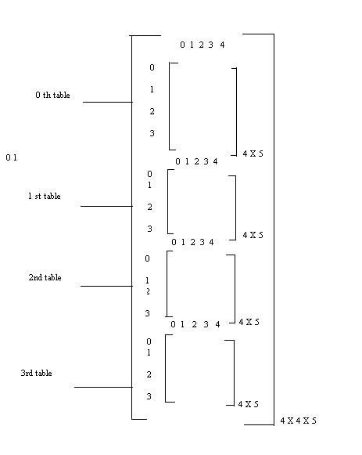

Fig: 3 dimensional array representation

Write a c program to insert and to read data from 3D array?

void main()

{

int arry[4][4][5],i,j,k;

printf(“enter the elements int o 3d array”);

for(i=0;i<4;i++)

for(j=0;j<4;j++)

for(k=0;k<5;k++)

scanf(“%d”,&arry[i][j][k]);

printf(“the elements of 3D array are”);

for(i=0;i<4;i++)

{

for(j=0;j<4;j++)

{

for(k=0;k<5;k++)

{

printf(“%d”,arry[i][j][k]);

}

printf(“\n”);

}

printf(“\n”);

}

*Advantages of arrays:*

## 1. Stores Elements of Same Data Type.

## 2. Array Used for maintaining multiple variable names using single name

## 3. Array can be used for Sorting Elements

## 4. Array Can Perform Matrix Operation

## 5. Array can be used in CPU Scheduling

## 6. Array can be used in Recursive Function

## *Disadvantages*:

## 1. Sometimes it's not easy to operate with many index arrays. 2. C environment doesn't have checking mechanism for array sizes. 3. An array uses reference mechanism to work with memory which can cause unstable behavior of operating system.

## 4. The size is fixed at compile time (you can't make them bigger if you need more space)

## 5. Using an array index that is beyond the bounds of an array is a frequent programming error that leads to program failure (segmentation faults) and can have serious security implications.

**CHARACTER ARRaYS (StringS) :**

A String is an array of characters. Any group of characters (except double quote sign) defined between double quotes is a constant string.

Ex: “C is a great programming language”.

If we want to include double quotes.

Ex: “\”C is great \” is norm of programmers “.

Declaring and initializing strings :-

A string variable is any valid C variable name and is always declared as an array.

char string name [size];

size determines number of characters in the string name. When the compiler assigns a character string to a character array, it automatically supplies a null character (‘\0’) at end of String. Therefore, size should be equal to maximum number of character in String plus one.

String can be initialized when declared as

char city[g]= “NEW YORK’;

char city[g]= {‘N’,’E’,’W’,’ ‘,’Y’,’O’,’R’,’K’,’/0’};

C also permits us to initializing a String without specifying size.

Ex:- char Strings[ ]= {‘G’,’O’,’O’,’D’,’\0’};

READING STRINGS FROM USER:

%s format with scanf can be used for reading String.

char address[15];

scanf(“%s”,address);

The problem with scanf function is that it terminates its input on first white space it finds. So scanf works fine as long as there are no spaces in between the text.

Reading a line of text:

If we are required to read a line of text we use getchar(). Which reads a single characters. Repeatedly to read successive single characters from input and place in character array.

/* Program to read String using scanf & getchar */

#include<stdio.h>

main()

{

char line[80],ano_line[80],character;

int c;

c=0;

printf(“Enter String using scanf to read \n”);

scanf(“%s”, line);

printf(“Using getchar enter new line\n”);

do

{

character = getchar();

ano_line[c] = character;

c++;

} while(character !=’\n’);

c=c-1;

ano_line[c]=’\0’;

}

String input/output functions:

C provides two basic ways to read and write strings.First we can read and write strings with the formatted input/output functions,scanf/fscanf and prinf/fprinf.Second we can use a special set of strin only functions ,get string(gets/fgets)and put string(puts/fputs).

Formatted string Input/Output:

Formatted String Input:scanf/fscanf:

Declarations:

int fscanf(FILE *stream, const char *format, ...);  
int scanf(const char *format, ...);

The scanf functions provide a means to input formatted information from a stream

|  |  |
| --- | --- |
| fscanf | reads formatted input from a stream |
| scanf | reads formatted input from stdin |

These functions take input in a manner that is specified by the format argument and store each input field into the following arguments in a left to right fashion. Each input field is specified in the format string with a conversion specifier which specifies how the input is to be stored in the appropriate variable. Other characters in the format string specify characters that must be matched from the input, but are not stored in any of the following arguments. If the input does not match then the function stops scanning and returns. A whitespace character may match with any whitespace character (space, tab, carriage return, new line, vertical tab, or formfeed) or the next incompatible character.

INPUT CONVERSION SPECIFICATION:

FLAG:

There is only one flag for input formatting, The assignment suppression flag(*). The assignment suppression flag tells scanf that the next input field is to be read but not stored. It is discarded.

Example:

scanf(“%d%*c%f”, &x,&y);

Width:

The width specifies the maximum width of the input(in characters).This allows us to break out a code that may be stored in the input without spaces.

SIZE:

A size specification is a modifier for the conversion code. Used in combination with the conversion code, specifies the type of the associative variable.

Conversion codes:

*Integer*(d): The decimal (d) format code accepts a value from the input stream and formats it in to the specified variables. It reads only decimal digits and an optional plus or minus sign is the first character of the value.

*Integer*(i): The integer format code (i) allows the user to create decimal ,octal or hexadecimal numbers. Numbers starting with any digit other than zero are read and stored as decimal values. Numbers starting with zero are interpretes as octal values and are converted to decimal and stored. Hexadecimal numbers must be prefixed with 0x (or) 0X, The hexadecimal value is converted to decimal and stored.

*Octal and hexadecimal*(o,x): The octal (o) and hexadecimal (x) conversion codes perform unsigned conversion. For octal only valid input digits are 0…7. For Hexadecimal input valid digits are 0…9, a…f and A…F.

*Scientific notation* (e,g,a): The C languages uses three real format codes for scientific notation. In scientific notation the significand and exponent are specify separately. The significant part is a floating point number that contains as many significant digits as possible.

*Count*(n): To verify the number of input characters we use the n-conversion code. The code requires a matching variable address in to which scanf places the count of the characters input.

*The Common Input Format Mistakes*: Two common mistakes while formatting input stream, They are

Invalid Address

Datatype conflict

*Invalid address*: The common mistake is to use a data value rather than an address for the input parameter

*Data type conflict*: It is conflict between the format stream and the input stream. It occurs, For example when the format string calls for a numeric value and the input stream contains alphabetic character then scanf operation aborts.

FORMATTED STRING OUTPUT: *printf/fprintf*:

Declarations:

int fprintf(FILE *stream, const char *format, ...);  
int printf(const char *format, ...);

The printf functions provide a means to output formatted information to a stream.

|  |  |
| --- | --- |
| fprintf | sends formatted output to a stream |
| printf | sends formatted output to stdout |

These functions take the format string specified by the format argument and apply each following argument to the format specifiers in the string in a left to right fashion. Each character in the format string is copied to the stream except for conversion characters which specify a format specifier.

Flags:

|  |  |
| --- | --- |
| - | Value is left justified (default is right justified). Overrides the 0 flag. |
| + | Forces the sign (+ or -) to always be shown. Default is to just show the - sign.  Overrides the space flag. |

Width:

The width of the field is specified here with a decimal value. If the value is not large enough to fill the width, then the rest of the field is padded with spaces (unless the 0 flag is specified). If the value overflows the width of the field, then the field is expanded to fit the value. If a * is used in place of the width specifer, then the next argument (which must be an int type) specifies the width of the field. Note: when using the * with the width and/or precision specifier, the width argument comes first, then the precision argument, then the value to be converted.

Precision:

The precision begins with a dot (.) to distinguish itself from the width specifier. The precision can be given as a decimal value or as an asterisk (*). If a * is used, then the next argument (which is an int type) specifies the precision. Note: when using the * with the width and/or precision specifier, the width argument comes first, then the precision argument, then the value to be converted. Precision does not affect the c type.

String Input/Output

In addition to the Formatted string functions,C has two sets of string functions that read and write strings without reformatting any data.These functions convert text file lines to strings and strings to text file lines.

Line to String:

gets():

Declaration:

char *gets(char *str);

Reads a line from stdin and stores it into the string pointed to by str. It stops when either the newline character is read or when the end-of-file is reached, whichever comes first. The newline character is not copied to the string. A null character is appended to the end of the string.

On success a pointer to the string is returned. On error a null pointer is returned. If the end-of-file occurs before any characters have been read, the string remains unchanged.

fgets():

Declaration:

char *fgets(char *str, int n, FILE *stream);

Reads a line from the specified stream and stores it into the string pointed to by str. It stops when either (n-1) characters are read, the newline character is read, or the end-of-file is reached, whichever comes first. The newline character is copied to the string. A null character is appended to the end of the string.

On success a pointer to the string is returned. On error a null pointer is returned. If the end-of-file occurs before any characters have been read, the string remains unchanged.

String to Line:

puts:

Declaration:

int puts(const char *str);

Writes a string to stdout up to but not including the null character. A newline character is appended to the output.

On success a nonnegative value is returned. On error EOF is returned.

fputs():

Declaration:

int fputs(const char *str, FILE *stream);

Writes a string to the specified stream up to but not including the null character.

On success a nonnegative value is returned. On error EOF is returned.

ARRAY OF STRINGS:

Arrays of strings (arrays of character arrays) can be declared and handled in a similar manner to that described for 2-D arrays.

Consider the following example:

#include< stdio.h>

void main(void)

{

char names[2][8] = {"Frans", "Coenen"};

/* Output */

printf("names = %s, %s\n",names[0],names[1]);

printf("names = %s\n",names);

/* Output initials */

printf("Initials = %c. %c.\n",names[0][0],names[1][0]);

}

Here we declare a 2-D character array comprising two "roes" and 8 "columns". We then initialise this array with two character strings. The output the array we need to index into each row --- using the 2-D array name on its own (strings) as a pointer cause only the first element ("row") to be produced. Note that we can still index to individual elements using index pairs. The output from the above will be:

names = Frans, Coenen

names = Frans

Initials = F. C.

ARRAYS OF STRINGS AS POINTER ARRAYS

The declaration of an array of character pointers is an extremely useful extension to single string pointer declarations.For example:

char *names[2];

Creates a two element array of character pointers (i.e. each element is a pointer to a character). As individual pointers each can be assigned to point to a string using a normal assignment statement:

names[0] = "Frans";

names[1] = "Coenen";

Alternatively we can initialise the names array as shown in the following programs:

#include< stdio.h>

void main(void)

{

char *names[2] = {"Frans", "Coenen"};

/* Output */

printf("names = %s, %s\n",names[0],names[1]);

/* New assignments */

names[0] = "Ray";

names[1] = "Paton";

/* Output */

printf("names = %s, %s\n",names[0],names[1]);

}

In the above the declaration of names both creates an array of pointers and initilises the pointers with appropriate addresses. Once addresses have been assigned to the pointers, each pointer can be used to access its corresponding string. The output from the above is as follows:

names = Frans, Coenen

names = Ray, Paton

STRING/DATA CONVERSION:

String to Data Conversion:

sscanf():

The string scan function is called sscanf. The sscanf function accepts a string from which to read input, then, in a manner similar to printf and related functions, it accepts a template string and a series of related arguments. It tries to match the template string to the string from which it is reading input, using conversion specifier like those of printf.

The sscanf function is just like the deprecated parent scanf function, except that the first argument of sscanf specifies a string from which to read, whereas scanf can only read from standard input. Reaching the end of the string is treated as an end-of-file condition.

ret = sscanf( s, format [, p1, p2, ...] );

const char *s;

points to the string which is to be read.

const char *format;

is a format string similar to that for "scanf".

p1, p2, p3, ... are pointers to various data types.

int ret;

is the number of matching data items that were read in. This may be zero if the first data item found does not match the type that was expected. If an error or end of string occurs before the first item could be read in, EOF is returned.

Description:

"sscanf" reads input from the string "s" and assigns it to the areas of memory pointed to by the pointers "p1", "p2", and so on. The "format" string indicates how to interpret the characters being read in.

Important difference between sscanf and printf is that the arguments to sscanf must be pointers; this allows sscanf to return values in the variables they point to. If you forget to pass pointers to sscanf, you may receive some strange errors, and it is easy to forget to do so; therefore, this is one of the first things you should check if code containing a call to sscanf begins to go awry.

A sscanf template string can contain any number of any number of whitespace characters, any number of ordinary, non-whitespace characters, and any number of conversion specifiers starting with %. A whitespace character in the template string matches zero or more whitespace characters in the input string. Ordinary, non-whitespace characters must correspond exactly in the template string and the input stream; otherwise, a matching error occurs. Thus, the template string " foo " matches "foo" and " foo ", but not " food ".

Data to String Conversion:

The string print function,sprintf. Returns a string formatted by the usual printf() conventions of the C library function sprintf().

i = sprintf( s, control [, arg1, arg2, ...] );

char *s;

is the string to which the output should be written.

const char *control;

is a "printf" control string.

arg1, arg2, ...

are the values to be output.

int i;

is the number of characters that were output. If a write error occurred, a negative number is returned.

Description:

"sprintf" writes to the string "s". "sprintf" converts, formats, and prints its arguments under control of the string "control.

STRING HANDLING FUNCTIONS:

strcat( ) Concatenates two Strings

strcmp( ) Compares two Strings

strcpy( ) Copies one String Over another

strlen( ) Finds length of String

strcat() :

This function yours two strings together.

strcat(string1,string2);

string1 = VERY

string2 = FOOLISH

strcat(string1,string2);

string1=VERY FOOLISH

string2 = FOOLISH

strcmp() function :

This function compares two strings identified by arguments and has a value 0 if they are equal. If they are not, it has the numeric difference between the first non-matching characters in the Strings.

strcmp(string1,string2);

Ex:- strcmp(name1,name2);

strcmp(name1,”John”);

strcmp(“ROM”,”Ram”);

strcpy() function :

It works almost as a string assignment operators. It takes the form

strcpy(string1,string2);

string2 can be array or a constant.

strlen() function :

Counts and returns the number of characters in a string.

n= strlen(string);

n🡪 integer variable which receives the value of length of string.

/* Illustration of string-handling */

#include<stdio.h>

#include<string.h>

main()

{

char s1[20],s2[20],s3[20];

int X,L1,L2,L3;

printf(“Enter two string constants\n”);

scanf(“%s %s”,s1,s2);

X=strcmp(s1,s2);

if (X!=0)

{

printf(“Strings are not equal\n”);

strcat(s1,s2);

}

else

printf(“Strings are equal \n”);

strcpy(s3,s1);

L1=strlen(s1);

L2=strlen(s2);

L3=strlen(s3);

printf(“s1=%s\t length=%d chars \n”,s1,L1);

printf(“s2=%s\t length=%d chars \n”,s2,L2);

printf(“s3=%s\t length=%d chars \n”,s3,L3);

}

**POINTERS:**

One of the powerful features of C is ability to access the memory variables by their memory address. This can be done by using Pointers. The real power of C lies in the proper use of Pointers.

A pointer is a variable that can store an address of a variable (i.e., 112300).We say that a pointer points to a variable that is stored at that address. A pointer itself usually occupies 4 bytes of memory (then it can address cells from 0 to 232-1).

Advantages of Pointers:

* A pointer enables us to access a variable that is defined out side the function.
* Pointers are more efficient in handling the data tables.
* Pointers reduce the length and complexity of a program.
* They increase the execution speed.

Definition:

A variable that holds a physical memory address is called a pointer variable or Pointer.

Declaration:

Datatype * Variable-name;

Eg:- int *ad; /* pointer to int */

char *s; /* pointer to char */

float *fp; /* pointer to float */

char **s; /* pointer to variable that is a pointer to char */

A pointer is a variable that contains an address which is a location of another variable in memory.

Consider the Statement

p=&I;

Here ‘&’ is called address of a variable.

‘p’ contains the address of a variable i.

The operator & returns the memory address of variable on which it is operated, this is called Referencing. The * operator is called an indirection operator or dereferencing operator which is used to display the contents of the Pointer Variable.

Consider the following Statements:

int *p,x;

x =5;

p= &x;

Assume that x is stored at the memory address 2000. Then the output for the following printf statements is:

Output

Printf(“The Value of x is %d”,x); 5

Printf(“The Address of x is %u”,&x); 2000

Printf(“The Address of x is %u”,p); 2000

Printf(“The Value of x is %d”,*p); 5

Printf(“The Value of x is %d”,*(&x)); 5

Pointer Function Arguments

Function arguments in C are strictly pass-by-value. However, we can simulate pass-by-reference by passing a pointer. This is very useful when you need to Support in/out(bi-directional) parameters (e.g. swap, find replace) Return multiple outputs (one return value isn’t enough) Pass around large objects (arrays and structures).

/* Example of swapping a function can’t change parameters */

void bad_swap(int x, int y)

{

int temp;

temp = x;

x = y;

y = temp;

}

/* Example of swapping – a function can’t change parameters, but if a parameter is a pointer it can change the value it points to */

void good_swap(int *px, int *py)

{

int temp;

temp = *px;

*px = *py;

*py = temp;

}

#include <stdio.h>

void bad_swap(int x, int y);

void good_swap(int *p1, int *p2);

main() {

int a = 1, b = 999;

printf(“a = %d, b = %d\n”, a, b);

bad_swap(a, b);

printf(“a = %d, b = %d\n”, a, b);

good_swap(&a, &b);

printf(“a = %d, b = %d\n”, a, b);

}

Pointers and Arrays:

When an array is declared, elements of array are stored in contiguous locations. The address of the first element of an array is called its base address.

Consider the array

|  |  |  |  |  |
| --- | --- | --- | --- | --- |
| 2000 | 2002 | 2004 | 2006 | 2008 |
|  |  |  |  |  |
| a[0] | a[1] | a[2] | a[3] | a[4] |

The name of the array is called its base address.

i.e., a and k& a[20] are equal.

Now both a and a[0] points to location 2000. If we declare p as an integer pointer, then we can make the pointer P to point to the array a by following assignment

P = a;

We can access every value of array a by moving P from one element to another.

i.e., P points to 0th element

P+1 points to 1st element

P+2 points to 2nd element

P+3 points to 3rd element

P +4 points to 4th element

Reading and Printing an array using Pointers :

main()

{

int *a,I;

printf(“Enter five elements:”);

for (i=0;i<5;i++)

scanf(“%d”,a+i);

printf(“The array elements are:”);

for (i=o;i<5;i++)

printf(“%d”, *(a+i));

}

In one dimensional array,

a[i] element is referred by

(a+i) is the address of ith element.

* (a+i) is the value at the ith element.

In two-dimensional array, a[i][j] element is represented as

*(*(a+i)+j)

Pointers and Functions:

Parameter passing mechanism in ‘C’ is of two types.

* Call by Value
* Call by Reference.

The process of passing the actual value of variables is known as Call by Value.The process of calling a function using pointers to pass the addresses of variables is known as Call by Reference. The function which is called by reference can change the value of the variable used in the call.

Example of Call by Value:

#include <stdio.h>

void swap(int,int);

main()

{

int a,b;

printf(“Enter the Values of a and b:”);

scanf(“%d%d”,&a,&b);

printf(“Before Swapping \n”);

printf(“a = %d \t b = %d”, a,b);

swap(a,b);

printf(“After Swapping \n”);

printf(“a = %d \t b = %d”, a,b);

}

void swap(int a, int b)

{

int temp;

temp = a;

a = b;

b = temp;

}

Example of Call by Reference:

#include<stdio.h>

main()

{

int a,b;

a = 10;

b = 20;

swap (&a, &b);

printf(“After Swapping \n”);

printf(“a = %d \t b = %d”, a,b);

}

void swap(int *x, int *y)

{

int temp;

temp = *x;

*x = *y;

*y = temp;

}

ADDRESS ARITHIMETIC:

Incrementing/Decrementing a pointer variable ,adding and subtracting an integer from pointer variable are all legal and known as pointer arithmetic. Pointers are valid operands in arithmetic expressions ,assignment expressions ,and comparison expressions. However not all the operators normally used in these expressions are valid in conjunction with pointer variable.

A limited set of arithmetic operations may be performed on pointers. A pointer may be incremented (+ +) or decremented(--) ,an integer may be added to a pointer. (+ or +=),an integer may be subtracted from a pointer(- or -=),or one pointer may be subtracted from another.

We can add and subtract integers to/from pointers – the result is a pointer to another element of this type

Ex : int *pa; char *s;

s-1 →points to char before s (1 subtracted)

pa+1→ points to next int (4 added!)

s+9 →points to 9th char after s (9 added)

++pa→ increments pa to point to next int

NULL Pointer:

‘Zero’ is a special value we can assign to a pointer which does not point to anything most frequently; a symbolic constant NULL is used. It is guaranteed, that no valid address is equal to 0.The bit pattern of the NULL pointer does not have to contain all zeros usually it does or it depends on the processor architecture. On many machines, dereferencing a NULL pointer causes a segmentation violation.

NULL ptr is not the same as an EMPTY string.

Const char* psz1 = 0;

const char* psz2 = “”;

assert(psz1 != psz2);

Always check for NULL before dereferencing a pointer.

If (psz1)

/* use psz1 */

sizeof(psz1)

// doesn’t give you the number of elements in psz1. Need additional size variable.

Void pointer :

In C ,an additional type void *(void pointer) is defined as a proper type for generic pointer. Any pointer to an object may be converted to type void * without loss of information. If the result is converted back to the original type ,the original pointer is recovered .

Ex:

main()

{

void *a;

int n=2,*m;

double d=2.3,*c;

a=&n;

m=a;

printf(“\n%d %d %d”,a,*m,m);

a=&d;

c=a;

printf(“\n%d %3.1f %d”,a,*c,c);

}

In the above program a is declared as a pointer to void which is used to carry the address of an int(a=&n)and to carry the address of a double(a=&d) and the original pointers are recovered with out any loss of information.

POINTERS TO POINTERS :

So far ,all pointers have been pointing directely to data.It is possible and with advanced data structures often necessary to use pointers to that point to other pointers.

For example,we can have a pointer pointing to a pointer to an integer.This two level indirection is seen as below:

//Local declarations

int a;

int* p;

int **q;

q p a

Ex:

234560

287650

58

397870 234560 287650

pointer to pointer to integer pointer to integer integer variable

//statements

a=58;

p=&a;

q=&p;

printf(“%3d”,a);

printf(“%3d”,*p);

printf(“%3d”,**q);

There is no limit as to how many level of indirection we can use but practically we seldom use morethan two.Each level of pointer indirection requires a separate indirection operator when it is dereferenced .

In the above figure to refer to ‘a’ using the pointer ‘p’, we have to dereference it as shown below.

*p

To refer to the variable ‘a’ using the pointer ‘q’ ,we have to dereference it twice toget to the integer ‘a’ because there are two levels of indirection(pointers) involved.If we dereference it only once we are referring ‘p’ which is a pointer to an integer .Another way to say this is that ‘q’ is a pointer to a pointer to an integer.The doule dereference is shown below:

**q

In above example all the three references in the printf statement refer to the variable ‘a’.

The first printf statement prints the value of the variable ‘a’ directly,second uses the pointer ‘p’,third uses the pointer ‘q’.The result is the value 58 printed 3 times as below

58 58 58

**STRUCTURES:**

A Structure is a collection of elements of dissimilar data types. Structures provide the ability to create user defined data types and also to represent real world data.

Suppose if we want to store the information about a book, we need to store its name (String), its price (float) and number of pages in it (int). We have to store the above three items as a group then we can use a structure variable which collectively store the information as a book.

Structures can be used to store the real world data like employee, student, person etc.

Declaration:

The declaration of the Structure starts with a Key Word called struct and ends with semicolon. The Structure elements can be any built in types.

struct <Structure name>

{

Structure element 1;

Structure element 2;

-

-

-

Structure element n;

};

Then the Structure Variables are declared as

struct < Structure name > <Var1,Var2>;

Eg:-

struct emp

{

int empno.

char ename[20];

float sal;

};

struct emp e1,e2,e3;

The above Structure can also be declared as :

struct emp

{

int empno;

char ename[20];

float sal;

}e1,e2,e3;

Initialization:

Structure Variables can also be initialised where they are declared.

struct emp

{

int empno; char ename[20]; float sal;

};

struct emp e1 = { 123,”Kumar”,5000.00};

To access the Structure elements we use the dot (.) operator.

To refer empno we should use e1.empno

To refer sal we would use e1.sal

Structure elements are stored in contiguous memory locations as shown below. The above Structure occupies totally 26 bytes.

|  |  |  |
| --- | --- | --- |
| e1.empno | E1.ename | E1.sal |
| 123 | Kumar | 5000.00 |
| 2000 | 2002 | 2022 |

/* Program to illustrate the usage of a Structure.*/

main()

{

struct emp

{

int empno;

char ename[20];

float sal;

};

struct emp e;

printf (“ Enter Employee number: \n”);

scanf(“%d”,&e.empno);

printf (“ Enter Employee Name: \n”);

scanf(“%s”,&e.empname);

printf (“ Enter the Salary: \n”);

scanf(“%f”,&e.sal);

printf (“ Employee No = %d”, e.empno);

printf (“\n Emp Name = %s”, e.empname);

printf (“\n Salary = %f”, e.sal);

}

NESTING OF STRUCTURES:

One Structure can be enclosed in another Structure. The Structure which is to be nested must be declared before it is used. We can nest a Structure within a Structure, which is in still another Structure and so on. Nesting of Structure can be done to any number of levels. The elements of the nested Structure are accessed by using one more dot (.) operator.

Eg:-

struct date

{

int dd, mm, yy;

};

struct student

{

int rno;

char sname[15];

struct date dob;

};

struct student s;

Here, dob is the Nested Structure. To access this we use s.dob.dd or s.dob.mm or s.dob.yy.

/* Program to read Student Details and Calculate total and average using structures */

#include<stdio.h>

main()

{

struct stud

{

int rno;

char sname[20];

int m1,m2,m3;

};

struct stud s; int tot;

float avg;

printf(“Enter the student roll number: \n”);

scanf(“%d”,&s.rno);

printf(“Enter the student name: \n”);

scanf(“%s”,&s.sname);

printf(“Enter the three subjects marks: \n”); scanf(“%d%d%d”,&s.m1,&s.m2,&s.m3);

tot = s.m1 + s.m2 +s.m3; avg = tot/3.0;

printf(“Roll Number : %d\n”,s.rno); printf(“Student Name: %s\n”,s.sname); printf(“Total Marks : %d\n”,tot); printf(“Average : %f\n”,avg);

}

/* Program to read Item Details and Calculate Total Amount of Items*/

#include<stdio.h>

main()

{

struct item

{

int itemno;

char itemname[20];

float rate;

int qty;

};

struct item i;

float tot_amt;

printf(“Enter the Item Number \n”);

scanf(“%d”,&i.itemno);

printf(“Enter the Item Name \n”);

scanf(“%s”,&i.itemname);

printf(“Enter the Rate of the Item \n”);

scanf(“%f”,&i.rate);

printf(“Enter the number of %s purchased ”,i.itemname);

scanf(“%d”,&i.qty);

tot_amt = i.rate * i.qty;

printf(“Item Number: %d\n”,i.itemno);

printf(“Item Name: %s\n”,i.itemname);

printf(“Rate: %f\n”,i.rate);

printf(“Number of Items: %d\n”,i.qty);

printf(“Total Amount: %f”,tot_amt);

}

/*Program to illustrate the use of Nested Structures */

#include<stdio.h>

main()

{

struct date

{

int dd, mm, yy;

};

struct stud

{

int rno;

char sname[15];

struct date dob;

int tot;

};

struct stud s;

printf(“Enter the student roll number: \n”);

scanf(“%d”,&s.rno);

printf(“Enter the student name: \n”);

scanf(“%s”,&s.sname);

printf(“Enter the date of birth of student(dd/mm/yy): \n”); scanf(“%d%d%d”,&s.dob.dd,&s.dob.mm,&s.dob.yy);

printf(“Roll Number : %d\n”,s.rno); printf(“Student Name: %s\n”,s.sname);

printf(“Date of Birth: %d/%d/%d\n”, s.dob.dd, s.dob.mm, s.dob.yy);

printf(“Total Marks : %f\n”,s.tot);

}

ARRAYS OF STRUCTURES:

To store more number of Structures, we can use array of Structures. In array of Structures all elements of the array are stored in adjacent memory location.

/* Program to illustrate the usage of array of Structures.

main()

{

struct book

{

char name[20]; float price;

int pages;

};

struct book b[10];

int i;

for (i=0;i<10;i++)

{

print(“\n Enter Name, Price and Pages”); scanf(“%s%f%d”, b[i].name,&b[i].price,&b[i].pages);

}

for (i i=0;i<10;i++)

printf(“ \n%s%f%d”, b[i].name,b[i].price,b[i].pages);

}

STRUCTURES WITH FUNCTIONS:

The entire Structure can be passed to a function at once. Whenever a Structure is passed to a function the Structure should be declared outside the main(), otherwise it will not be known to all the functions in the program.

/*Program to illustrate the use of Structures with functions.*/

struct stud

{

int rno;

char name[20]; int tot;

};

main()

{

struct stud s = { 111, “Ramoo”,500}; display(s);

}

display(struct stud s)

{

printf(“Roll Number: %d\n”, s.rno); printf(“Student Name: %s\n”, s.name); printf(“Total Marks: %d\n”, s.tot);

}

STRUCTURE POINTER:

A Pointer pointing to a struct is called Structure Poniter. A Structure Pointer can be used to store the address of a Structure Variable. An arrow operator ( ) is used to refer the Structure elements when a pointer is used with a Structure.

/* Program to illustrate the usage of Structures with Pointer */

struct emp

{

int empno;

char ename[20]; float sal;

};

main()

{

struct emp e;

reademp(&e);

displayemp(&e);

}

reademp(struct emp *e)

{

printf(“Enter Emp Details:”);

scanf(“\n%d%s%f”, &e empno, e ename, &e sal);

}

display emp(struct emp *e)

{

printf(“empno:%d\tename:%s\tSalary=%f”,e empno, ename,e sal);

}

SELF REFERENTIAL STRUCTURES:

A Self referential Structure is one that includes within its structure at least one member which is a pointer to the same structure type. With self referential structures we can create very useful data structures such as linked lists, trees etc.

Ex:

Struct tag

{

char name[40];

struct emp*next;

};

A structure contains two members a 40 element character array called name,and a pointer to another structure of the same called next.

APPLICATIONS OF STRUCTURES:

Structures can be used for a Variety of Applications like:

1. Database Management.

(To maintain data about employees in an organisation, book in a library,

items in a Store etc)

1. Changing the size of the Cursor.
2. Clearing the contents of the Screen.
3. Placing the Cursor at appropriate position on Screen.
4. Drawing any graphics Shape on the Screen.
5. Receiving a Key from the Keyboard.
6. Checking the memory size of the Computer.
7. Finding the list of equipment attached to the Computer.
8. Formatting a Floppy.
9. Hiding a file from the Directory.
10. Displaying the Directory of a Disk.
11. Sending the Output to Printer.
12. Interacting with the Mouse.

UNIONS:

Union, similar to Structures, are collection of elements of different data types. However, the members within a union all share the same storage area within the computer’s memory, here as each member within a Structure is assigned its own unique Storage area.

Structure enables us to treat a member of different variables stored at different places in memory; a union enables us to treat the same space in memory as a number of different variables. That is, a union offers a way for a section of memory to be treated as a variable of one type on one occasion and as a different variable of a different type on another occasion.

Unions are used to conserve memory. Unions are useful for applications involving multiple members, where values need not be assigned to all of the members at any given time. An attempt to access the wrong type of information will produce meaningless results.

The union elements are accessed exactly the same way in which the structure elements are accessed using dot (.) operator.

The difference between the structure and union in the memory representation is as follows.

struct cx

{

int i;

char ch[2];

};

struct cx s1;

The Variable s1 will occupy 4 bytes in memory and is represented as

|  |  |  |  |  |  |  |
| --- | --- | --- | --- | --- | --- | --- |
| <----------- s.i -----------> | | | |  | s.ch[0] | s.ch[1] |
|  | |  | | |  |  |
| 4002 |  | | 4003 |  | 4004 | 4005 |

The above datatype, if declared as union then

union ex

{

int i;

char ch[2];

}

union ex u;

|  |  |  |  |  |  |
| --- | --- | --- | --- | --- | --- |
| u.ch[0] | u.ch[1] | | | |  |
| <----------- s.i -----------> | | | | |  |
|  | | |  | | |
| 4002 | |  | | 4003 |  |

/* Program to illustrate the use of unions */

main()

{

union example

{

int i;

char ch[2];

};

union example u;

u.i = 412;

print(“\n u.i = %d”,u.i);

print(“\n u.ch[0] = %d”,u.ch[0]);

print(“\n u.ch[1] = %d”,u.ch[1]);

u.ch[0] = 50; /* Assign a new value */

print(“\n\n u.i = %d”,u.i);

print(“\n u.ch[0] = %d”,u.ch[0]);

print(“\n u.ch[1] = %d”,u.ch[1]);

}

Output:

u.i = 412

u.ch[0] = 0

u.ch[1] =2

u.i = 562

u.ch[0] = 50

u.ch[1] =2

A union may be a member of a structure, and a structure may be a member of a union. And also structures and unions may be freely mixed with arrays.

/* Program to illustrate union with in a Structure */

main()

{

union id

{

char color;  
int size;

};

struct

{

char supplier[20]; float cost;

union id desc;

}pant, shirt;

printf(“%d\n”, sizeof(union id));

shirt.desc.color = ‘w’;

printf(“%c %d\n”, shirt.desc.color, shirt.desc.size);

shirt.desc.size = 12;

printf(“%c %d\n”, shirt.desc.color, shirt.desc.size);

}

/* Program to raise a number to a power */

#include <stdio.h>

#include <math.h>

typedef union

{

float fexp; /* float exponent */

int nexp; /* integer exponent */

}nvals;

typedef struct

{

float x; /* value to raised to a power */

char flag; /* ‘f’ if exponent is float ‘i’ if exponent is integer */

nvals exp; /* union containing exponent */

}values;

float power (values a ) /* function calculations power */

{

int i;

float y = a.x;

if (a.flag = = ‘i’)

{

/* integer exponent */

if (a.exp.nexp = = 0) /* zero exponent*/

y = 1.0;

else

{

for (i = 1;i<abs(a.exp.nexp);++i)

y * = a.x;

if (a.exp.nexp<0)

y = 1.0/y; /* negative integer exponent */

}

}

else

y = exp(a.exp.fexp*log(a.x)); /* floating point exponent */

return(y);

}

main()

{

values a ;

int i;

float n,y;

printf(“Enter the value for X”);

scanf(“%f”,&a.x);

printf(“Enter the value for n”);

scanf(“%f”,&n);

/* determine type of exponent */

i = (int)n;

a.flag = (i = = n) ? ‘i’ : ‘f’ 3

if((a.flag = = ‘i’)

a.exp.nexp = i;

else

a.exp.fexp = n;

/* raise X to the power */

if(a.flag = = ‘f’ && a.x <= 0.0)

printf(“ERROR, can’t raise negative no to floating point power”);

else

{

y = power(a);

printf(“\n y = % .4f”,y);

}

}

TYPEDEF:

typedef is used to create new datatype. The statement typedef is used while defining the new data type.

Syntax:

typedef type dataname;

Here, type is the data type and dataname is the user defined name for that type.

typedef int hours;

Here, hours is another name for int and now we can use hours instead of int in the program as follows:

/* Example to demonstrate typedefinition */

#define H 60 main()

{

typedef int hours;

hours hrs;

clrscr();

printf(“Enter hours\n”);

scanf(“%d”,&hrs);

printf(“minutes=%d”,hrs*H);

printf(“\nseconds=%d”,hrs*H*H);

}

Output**:**

Enter hours: 2

Minutes=120

Seconds=7200

Explanation of program:

In the above example with typedef we had declared hours as an integer data type. Immediately after the typedef statement hrs is a variable of hours datatype which is similar to int. further the program calculates minuter and seconds using hrs variable.

BITFIELDS**:**

A bitfield allows structures to be subdivided into groups of bits. This process allows multiple variables to be packed into a single block of memory.

Syntax**:**

type_name <variable_name> : number_of_bits

The type can be char, short, int, or int64 (unsigned or signed) or any of the equivalent types. If the variable name is omitted, the given number of bits will be skipped.

For example:

int alpha : 5;

int : 12;

int beta : 15;

would pack alpha and beta into one 32-bit value, but skip 12 bits in the middle.

Example**:**

Suppose we want to store the following data about an employee. Eachemployee can:

1. be male or female
2. be single, married, divorced or widowed
3. have one of the eight different hobbies
4. Can choose from any of the fifteen different schemes proposed by the company to pursue his/her hobby.

This means one bit is needed to store gender, two bits to store marital status, three for hobby and four for scheme i.e there is a need for ten bits altogether which means we can pack all this information in to a single integer since an integer is 16 bits long.

To do this using bit fields we declare the following structure:

struct employee

{

unsigned gender:1;

unsigned mat_stat:2;

unsigned hobby:3;

unsigned scheme:4;

};

The colon in the above declaration tells the compiler that we are talking about bit fields and the number after it tells how many bits to allot for the field. Once we have established a bit field, we can reference it just like any other structure element as shown in the program given below:

Program:

#include <stdio.h>

#define MALE 0

#define FEMALE 1

#define SINGLE 0

#define MARRIED 1

#define DIVORCED 2

#define WIDOWED 3

void main()

{

struct employee

{

unsigned gender:1;

unsigned mar_stat:2;

unsigned hobby:3;

unsigned scheme:4;

};

struct employee e;

e.gender=MALE;

e.mar_status=DIVORCED;

e.hobby=5;

e.scheme=9;

printf(“\nGender=%d”,e.gender); printf(“\nMarital status=%d”,e.mar_ status); printf(“\nBytes occupied by e=%d”, sizeof(e));

}

Output**:**

Gender=0

Marital status=2

Bytes occupied by e=2

Two special bitfield modes that determine how the bits are packed into variables is:

1. Padded bitfields
2. Unpadded bitfields.

PADDED BITFIELDS:

With padded bitfields (the default), how the bits are packed into a variable depends upon the current endianness. By default, bits are packed right-to-left for little endian files, and left-to-right for big endian files. For example, for the bitfields:

ushort a : 4; ushort b : 7; ushort c : 5;

In little endian mode, this structure would be stored as the bits:

cccccbbb bbbbaaaa

(and stored on disk as bbbbaaaa cccccbbb). In big endian mode, this structure would be stored as the bits:

aaaabbbb bbbccccc

(and stored on disk as aaaabbbb bbbccccc). Whether the bits are packed left-to-right or right-to-left can be controlled by the functions BitfieldLeftToRight, and BitfieldRightToLeft.

In this mode, the program will automatically add padding bits when needed. If the size of the type being defined changes, padding will be added so the bitfield will be defined on the next variable boundary. Also, if the specified bitfield would step across the boundary of a variable, padding is added so the bitfield starts at the next variable.

For example:

int apple : 10;

int orange : 20;

int banana : 10;

int peach : 12;

short grape : 4;

The bitfields apple and orange would be packed into one 32 bit value. However, banana steps over the variable boundary, so 2 bits of padding are added so that it starts at the next 32 bit value. Banana and peach are packed into another 32-bit value, but because the size of the type changes with grape, an extra 10 bits of padding is added before grape is defined.

UNPADDED BITFIELDS:

Unpadded bitfield mode treats the file as one long bit stream. No padding bits are added if the variable type changes or if the bits cannot be packed into a single variable.

The unpadded mode can be entered by calling the function BitfieldDisablePadding (padding can be turned back on by calling BitfieldEnablePadding).

In unpadded bitfield mode, each variable defined reads some bits from the bitstream.

For example:

BitfieldDisablePadding();

short a : 10;

int b : 20;

short c : 10;

Here a reads the first 10 bits from the file, b reads the next 20 bits from the file, and so on.

If the bitfields are defined as reading from right to left (this is the default for little endian data and can enabled using the function BitfieldRightToLeft), the variables would be stored as the bits:

aaaaaaaa bbbbbbaa bbbbbbbb ccbbbbbb cccccccc

If the bitfields are defined as reading from left to right (this is the default for big endian data and can enabled using the function BitfieldLeftToRight), the variables would be stored as the bits:

aaaaaaaa aabbbbbb bbbbbbbb bbbbbbcc cccccccc

Note:

When declaring structures containing unpadded bitfields, no extra padding bitsare added between the structures. (Note that internally, any unpadded right-to-left bitfield is forced to be declared in little endian mode and any unpadded left-to-right bitfield is forced to be declared in big endian mode.)

ENUMERATED DATA TYPES

In computer programming, an enumerated type (also called enumeration or enum) is a data type consisting of a set of named values called elements, members or enumerators of the type. The enumerator names are usually identifiers that behave as constants in the language. A variable that has been declared as having an enumerated type can be assigned any of the enumerators as a value.

Enumerated data type variables can only assume values which have been previously declared.

enum month { jan = 1, feb, mar, apr, may, jun, jul, aug, sep, oct, nov, dec }; enum month this_month;

this_month = feb;

In the above declaration, *month* is declared as an enumerated data type. It consists of a set of values, jan to dec. Numerically, jan is given the value 1, feb the value 2, and so on. The variable *this_month* is declared to be of the same type as month, and then is assigned the value associated with feb. this_month cannot be assigned any values outside those specified in the initialization list for the declaration of month.

#include <stdio.h>

main()

{

char *pwest = "west",*pnorth = "north", *peast="east",*psouth="south";

enum location { east=1, west=2, south=3, north=4};

enum location direction;

direction = east;

if( direction == east )

printf("Cannot go %s\n", peast);

}

The variables defined in the enumerated variable *location* should be assigned initial values.

**UNIT - V**

**Numerical methods**: Roots, Integration and Differentiation Methods, Examples

**Linked List:** Definition, Types, Implementation Using Self referential Structures:

**Files:** (only if time is available, otherwise should be done as part of the lab)

**FILE INPUT AND OUTPUT**

A program is a data processor. It accepts input data, processes it and creates output data. Handling input /output is a complex task, because of the variety of devices and data formats. Data may come from many different sources and may go to different destinations.

FILES:

Files are used to store the information permanently and to access information whenever necessary. Files are stored in the Secondary Storage Devices like Floppy Disks, Hard Disks etc. Unlike other programming languages, C does not distinguish between sequential and direct access (random access) files.

There are two different types of files in C. They are Stream – Oriented (or Standard) files and System-Oriented (or Low-Level) files.

STREAMS:

All input and output operations in C is performed with streams. Stream is a sequence of characters organized into lines (text stream), each line consists of 0 or more characters and ends with the newline character ‘\n’.

Streams provide communications channels between files and programs. A stream can be connected to a file by opening it and the connection is broken by closing the stream.

When program execution begins, three files and their associated streams are connected to the program automatically. They are

1. the standard input stream
2. the standard output stream
3. the standard error stream

Standard input:

It is connected to the keyboard & it enables a program to read datafrom the keyboard.

Standard output:

It is connected to the screen & it enables a program to write data to the screen.

Standard error:

It is+ connected to the screen & all error messages are output to standard error.

Operating systems often allow these streams to be redirected to other devices, Standard input, standard output and standard error are manipulated with file pointers stdin, stdout and stderr.

BINARY FILES:

Binary files contain fixed length records, They are in binary format (machine readable) not a human readable format like text files, Binary files can be accessed directly (i.e. random access).

The record structure for a binary file is created using structures, they are more efficient than text files as conversion from ASCII to binary (reading) and vice versa for writing does not have to occur, they cannot be read easily by other non-C programs. Binary files are appropriate for online transaction processing systems.

Ex:Airline reservation, Order processing, Banking systems.

FWRITE:

The function fwrite is used to write to a binary file.

Syntax:

size_t fwrite (void *ptr, size_t size, size_t n, FILE *fptr);

fwrite writes from array ptr, n objects of size to file pointed to by fptr

fwrite returns the no. of objects written which is less than n if an error occurs

FREAD:

The function fread is used to read from a binary file.

Syntax:

size_t fread (void *ptr, size_t size,size_t n, FILE *fptr);

fread reads n objects of size size from a file pointed to by fptr, and places them in array ptr

fread returns the number of objects read which may be less than the number requested

call to feof() is necessary to distinguish EOF and error condition.

TEXT FILES:

Text files are classified in to two types.These are:

1. Formatted Text files
2. Unformatted Text files

FORMATTED TEXT FILES:

Formatted Text files contain variable length records must be accessed sequentially, processing all records from the start of file to access a particular record.

For formatted input and output to files we use fprintf and fscanf functions. These functions are the same as printf and scanf except that the output is directed to the stream accessed by the file pointer, fptr.

FPRINTF:

fprintf is used to write a record to the file.

Syntax:

int fprintf (FILE *fptr, const char* fmt,...)

Ex: fprintf (fptr,"%d %s %.2f\n",accNo,name,balance);

fprintf returns the number of characters written or negative if an error occurs.

FSCANF :

fscanf is used toRead a record from the file.

Syntax :

int fscanf (FILE *fptr, const char* fmt, ... )

Ex :fscanf (fptr,"%d %20s %f",&accNo,name, &balance);

fscanf returns the number of input items assigned or EOF if an error or EOF occurs before any characters are input.Rewind(FILE* ptr) - resets the current file position to the start of the file.

SEARCHING THE FILE:

Accessing a particular record(s) requires

* 1. a sequential read from the start of the file
  2. testing each record to see is it being searched for
  3. reset the file pointer to the start of the file ready for the next search.

UPDATING RECORDS:

Records cannot be updated , To update a text file the entire file is rewritten.

UNFORMATTED TEXT FILES:

stdio.h provides many functions for reading and writing to unformatted text files.

FGETC:

This function is used to read the next character from the stream,This is similar to getchar().

Syntax :

int fgetc (FILE *stream)

It returns the character (as an integer) or **EOF** if end of file or an error occurs.

FPUTC:

This function is used to write the character **c** to the stream.This is similar to putchar(int).

Syntax :

int fputc (int c, FILE *stream)

It returns the character or **EOF** for error.

FGETS:

This function reads at most the next n-1 characters from the stream into the array s. Reading stops after an EOF or a newline. If a newline is read, it is stored into the buffer. A '\0' is stored after the last character in the buffer. This is similar to gets(char* ).

Syntax:

char* fgets (char *s,int n,FILE *stream)

It returns s or NULL if EOF or error occurs

FPUTS:

This is used to write the string **s** to the stream. This is similar to puts(const char*).

Syntax :

int fputs (const char *s, FILE *stream)

It returns EOF for error.

These file handling functions can be used instead of reading and writing characters and strings from the keyboard and to the screen.

Positioning the File Pointer:

fseek is used to position the file pointer at the appropriate record in the file before reading or writing a record. The function fseek sets the file position for a stream. Subsequent reads and writes will access data in the file beginning at the new position

Syntax:

int fseek (FILE *fp, long offset,int origin)

The position is set to the offset from the origin. fseek returns non zero on error

fseek takes 3 arguments

1. fp the file pointer for the file in question
2. offset is an offset in a file we want to seek to
3. origin is the position that the file pointer is set to origin can be either
   1. SEEK_SET - beginning of file
   2. SEEK_CUR - current position in file
   3. SEEK_END - end of file

It may be necessary when performing a number of different types of access to a single file to reset the file pointer in certain instances.

Ex:

Searching for a particular record in a file may leave the file pointer in the middle ofthe file. To write a new record to this file the pointer should be reset to point to the end of file.

REWIND:

The function rewind resets the file pointer back to the start of file.

Syntax:

void rewind (FILE *fp)

rewind(fp) is equivalent to fseek(fp,0,SEEK_SET).

FEOF:

The function feof tests for end of file.

Syntax:

int feof(FILE *fptr)

Feof accepts a pointer to a FILE, It returns non-zero if EOF and zero otherwise. It is used when reading a file to check whether the EOF has been reached

These are three main areas where text and binary mode files are different.

HANDLING OF NEW LINES:

In Text Mode, a newline character is connected into the carriage return –linefeed combination before being written to the disk. Likewise, the carriage return-linefeed combination on the disk is converted back into a newline when the file is read by a C program. In Binary Mode, these conversions will not take place.

END OF FILE:

In Text Mode, a special character, whose ascii value is 26, is inserted after the last character in the file to mark the end of file. If this character is detected at any point in the file, the read function would return the EOF signal to the program.

In Binary Mode, there is no such special character present in the binary mode files to mark the end of file. The Binary Mode files keep track of the end of file from the number of characters present in the directory entry of the file.

The file that has been written in text mode is read back only in text mode. Similarly, the file that has been written in binary mode must be read back only in binary mode.

STORAGE OF NUMBERS:

In Text Mode, numbers are stored as strings of characters. Thus 1234 even though occupies two bytes in memory, when transferred to the disk would occupy four bytes, one byte per character.

In Binary Mode, the number will be stored in Binary format. Each number would occupy same number of bytes on disk as it occupies in memory.

STEPS IN WORKING WITH FILES:

1. Establish a Buffer Area
2. Opening a File
3. Reading from a File or Writing to a File
4. Closing a File.
5. Establish a Buffer Area :

The first step is to establish a buffer area, where the information is temporarily stored while being transferred between the computers memory and the file.

The Buffer Area is established by writing

FILE *ptrvar;

FILE is a Structure which has been defined in the header file “stdio.h” (Standard input/output header file), which is a link between the Operating System and Program. It is necessary to include the header file “stdio.h”. The FILE Structure contain information about the file being used, such as its current size, its location in memory etc. This buffer area allows information to be read from or written to file more fastly.

*prtvar is a pointer variable, which contains address of the Structure FILE.

1. Opening a File :

A File must be opened before it can be created or processed. This association the file name with the buffer area. It also specifies how the file will be utilized i.e. read-only file, write-only file, or read/write file. We use the library function fopen() for opening a file.

ptrvar = fopen(filename, mode)

Where filename and mode are strings. Filename represent the name of the file, mode represents how the file opened i.e., read only, write only etc.

The fopen() function returns a pointer to the begins of the buffer area associated with the file. A NULL value is returned if the file cannot be created or when existing file cannot be found.

The different file opening modes area listed below.

|  |  |
| --- | --- |
| Mode | Meaning |
| “r” | Open an existing file for reading only |
| “w” | Open a new file for writing only. If the file exists, its contents are |
|  | over written. |
| “a” | Open an existing file for appending (i.e., for adding new information |
|  | at the end of the file). A new file will be created if the file does not |
|  | exists. |
| “r+” | Open an existing file for both reading and writing. |
| “w+” | Open a new file for both reading and writing. If the file exists, the |
|  | contents are over written |
| “a+” | Open an existing file for both reading and appending. A new file |
|  | will be created if the file does not exists |

To open the file in Binary file mention the mode along with a extra letter ‘b’ as “rb”, “wb”, “rb+” and so on.

1. Reading /Writing form/to a File :
2. After opening the file we can read the characters from a file or write the characters into the file by using the two library functions fgetc() and fputc(). fgetc() reach a character from the current position and advances the pointer position to the next character, and returns the character that is read.

Eg:- ch = fgetc(ptrvar)

fputc() Writes a character into the file.

Eg:- fputc(ch,ptrvar)

1. fscanf() and fprintf() are two functions used for formatted reading and writing of characters, Strings, integers and floats.
2. fread() and fwrite():

These are two functions to read and write structures with file in binary mode.

The Syntax is as follows:

fwrite(&record, sizeof(record),no of records, fileptr);

fread(&record, sizeof(record),no of records, fileptr);

The first argument is the address and the structure.

The second argument is the size of the structure in bytes.

The third argument is the number of structures to read or write. The last argument is pointer to the file.

1. Closing the File :

Finally, the file must be closed at the end of the program. This can be done by using the function fclose().

fclose(ptrvar);

It is good programming practice to close a file explicitly, even though C compiler will automatically close the file.

/* Program to Create a File */

main()

{

FILE *fp; char ch;

fp = fopen(“chars”,’w’);

printf(“Enter the characters(enter * to stop)\n”); while((ch=getchar())!=’*’)

putc(ch,fp); printf(“File Created”); fclose(fp);

}

/* Program to Create a read an Existing File */

#include<stdio.h>

main()

{

FILE *fp; char ch;

fp = fopen(“chars”,’r’);

printf(“The contents of the file are:\n”);

while((ch=fgetc(fp))!=EOF)

printf(“%c”,ch);

fclose(fp);

}

/* Program to Copy One File to Another File */

#include<stdio.h>

main()

{

FILE fs**,**ft; char ch;

fs = fopen(“source”,’r’); if(fs = =NULL)

{

puts(“Cannot open source file”); exist();

}

fr = fopen(“target”,’w’); if(ft = =NULL)

{

puts(“Cannot open target file”); fclose(fs);

exist();

}

while((ch=fgetc(fs))!=EOF)

putc(ch,ft);

printf(“File Copied”);

fclose(fs);

fclose(ft);

}

/* Program to illustrate the use of fprintf() */

#include<stdio.h>

main()

{

FILE *fp;

char itemname[20]; int qty;

float rate;

char choice = ‘y’;

fp = fopen (“Item”,”w”);

while (choice = = ‘y’)

{

printf(“Enter Item Name, Quantity and Rate \n”); scanf(“%s%d%f”,itemname,&qty,&rate);

fprintf(fp, “%s%d%f\n”,itemname, age,rate); printf(“Do you want to Continue (y/n)”); fflush(stdin);

choice = getch();

}

fclose(fp);

}

/* Program to illustrate the use of fscanf() */

#include<stdio.h>

main()

{

FILE *fp;

char itemname[20]; int qty;

float rate;

fp = fopen (“Item”,”r”);

while (fscanf(fp,“%s%d%f”,itemname,&qty,&rate)!=EOF)

{

printf(“Item Name : %s\n”,itemname); printf(“Quantity =%d\n”,qty); printf(“Rate = %f\n”,rate);

}

fclose(fp);

}

Till now, we have seen examples of writing individual items into the file. Now we see how to write a record into a file and read a record from the file by using fprintf() and fscanf() respectively.

/* Program for writing records into a file using Structures */

#include<stdio.h>

main()

{

FILE *fp;

char choice = ‘y’;

struct emp

{

char name[40];

int age;

float bs;

};

struct emp e;

fp = fopen(“emp.dat”, “w”);

if(fp = = NULL)

{

puts(“Cannot open file”);

exit();

}

while (choice = =’y’)

{

printf(“Enter Name, age and Basic Salary”); scanf(“%s%d%f”, e.name, &e.age, &e.bs);

fprintf(fp, “%s%d%f\n”,e.name,e.age,e.bs);

printf(“Do you want to add one more record (y/n)”);

fflush(stdin);

choice =getch();

}

fclose(fp);

}

/* Program to read records from file using Structures */

#include<stdio.h>

main()

{

FILE *fp;

struct emp

{

char name[40];

int age;

float bs;

};

struct emp e;

fp = fopen(“emp.dat”, “r”);

if(fp = = NULL)

{

puts(“Cannot open file”); exit();

}

while (fscanf(fp,“%s%d%f”, e.name, &e.age, &e.bs)!=EOF)

{

printf(“\n Employee Name : %s\n”,e.name);

printf(“\n Employee Age:%d”,e.age);

printf(“\nBasic Salary = %f”,e.bs);

}

fclose(fp);

}

In the above programs the Structure elements are handled individually. Since the above program is opened in text mode it would occupy more number of bytes.

If the number of fields in the Structure increases, writing Structures using fprintf(), or reading them using fscanf() becomes complex.

So overcome these disadvantages we open the file in binary mode and also handle the structures collectively as a single one by using fread() and fwrite() function.

/* Writing records into file in Binary Mode */

#include<stdio.h>

main()

{

FILE *fp;

char choice = ‘y’; struct emp

{

char name[20];

int age;

float bs;

};

struct emp e;

fp = fopen(“Employee.dat”, “wb”); if(fp = = NULL)

{

puts(“Cannot open file”); exit(0);

}

while (choice = =’y’)

{

printf(“Enter Name, age and Basic Salary”); scanf(“%s%d%f”, e.name, &e.age, &e.bs); fwrite(&e,sizeof(e),1,fp);

printf(“Do you want to add one more record (y/n)”); fflush(stdin);

choice =getch();

}

fclose(fp);

}

/* Read the records from Binary File */

#include<stdio.h>

main()

{

FILE *fp; struct emp

{

char name[20];

int age;

float bs;

};

struct emp e;

fp = fopen(“Employee.dat”, “rb”); if(fp = = NULL)

{

puts(“Cannot open file”); exit(0);

}

while (fread(&e,sizeof(e),1,fp)

{

printf(“\n Employee Name : %s\n”,e.name);

printf(“\n Employee Age:%d”,e.age); printf(“\nBasic Salary = %f”,e.bs);

}

fclose(fp);

}

/* Program for copying one file to another file using command line arguments */

**#**include<stdio.h>

main(int argc, char *argv[])

{

FILE *fs, *ft; Char ch;

if (argc!=3)

{

puts(“In sufficient arguments”); exit();

}

fs = fopen(argv[1], “r”); if (fs= =NULL)

{

puts(“Cannot open source file”); exit();

}

ft = fopen(argv[2],”w”); if (ft = =NULL)

{

puts(“Cannot open target file”); fclose(fs);

exit();

}

while ((ch=fgetc(fs))!=EOF) fputc(ch,ft);

fclose(fs);

fclose(ft);

}

If the above program is saved as filecopy.c and executed at command line as

filecopy first.txt second.txt

argv[1] will be replaced with first.txt

argv[2] will be replaced with second.txt

The advantages of the above program are

a) There is no need to recompile the program every time.

1. Source and target files can be passed from command prompt.
2. Once executable file is created we cannot after the original source file.

/* Program to add two numbers using command line arguments */

main(int argc, char *argv[])

{

int a,b,c;

a = atoi(argv[1);

b= atoi(argv[2]);

c = a+b;

printf(“The sum of two numbers is:%d”,c);

}

If program is saved as add.c then to execute

add 20 30

Note:-Since 20 and 30 are entered from Command line, they are treated as strings, soconvert them into numbers using atoi() function.

STANDARAD INPUT/OUTPUT:

In ‘C’ a file is basically stream of bytes(more commonly referred as stream),which can be interpreted by a ‘c’ program.When a ‘c’ program is started ,the operating system is responsible for opening three file(streams).

When program execution begins, three files and their associated streams are connected to the program automatically. They are

1. the standard input stream
2. the standard output stream
3. the standard error stream

Standard input: It is connected to the keyboard & it enables a program to read data from the keyboard.

Standard output: It is connected to the screen & it enables a program to write data to the screen.

Standard error: It is connected to the screen & all error messages are output to standard error.

Standard input and standarad output functions are handled through several library functions such as scanf(),getchar(),gets(),printf(),etc.

ERROR HANDLING DURING I/O OPERATIONS:

It is possible that an error may occur during I/O operations on a file. Typical error situations include the following:

1. Trying to read beyond the end-of-file mark
2. Device Overflow
3. Trying to use a file that has not been opened
4. Trying to perform an operation on a file, When the file is opened for another type of operation.
5. Opening a file with an invalid filename.
6. Attempting to write to a write-protected file.

If we fail to check such a read and write errors a program may behave abnormally when an error occurs an unchecked error may result in a premature termination of the program or incorrect output. We have two library functions FEOF and FERROR that can help us to detect I/O errors in the files. The FEOF function can be used to test for an End Of File condition. It takes a file pointer as it’s only argument and returns a non zero integer value, if all of the data from the specified file has been read, and returns zero otherwise. If fp is pointer to file that has just been open for reading, then the statement

If (FEOF(fp))

Printf(“End of data”);

Would display the message End of data on reaching the end of file condition.

FERROR:

The FERROR function reports the status of the file indicated. It also takes a file pointer as it’s argument and returns a non zero integer if an error has been detucted up to that point during process it returns zero otherwise.

Example:

If(FERROR(fp)!=0)

Printf(“ an error has occurred”);

The above statement print the error message if the reading is not successful.

If a file is open using FOPEN function, A file pointer is returned. If the file cannot be opened for some reason then the function returns a null pointer. This facility can be used to test whether a file has been opened or not.

Example:

If(fp==NULL)

Printf(“File could not be opened”);

FORMATTED INPUT/OUTPUT FUNCTIONS:

There are two formatting input/output functions that is scanf and printf.The scanf function receives a text stream from the keyborad and converts in to data values to be stored in variables.The printf function receives data values from the program and converts them into text stream to be displayed on the monitor.

These two functions can be used only with the keyboard and monitor.The ‘C’ library defines two more general functions that is fscanf and fprintf that can be used with any text stream.

Formatting Functions

Terminal input/output

Scanf(“control string”,…);

Printf(“control string”,…);

General input/output

Fscanf(stream_pointer, “control string”,…);

Fprintf(stream_pointer, “control string”,…);

Stream pointer: Stream pointer is the pointer to the streams that has been declared and associated with atext file.

Ex:

FILE * spIn;

…

spIn=fopen(“file name”,”r”);

…

fscanf(spIn,”format string”,address list);

While we normally read data from the terminal keyboard using scanf,we can also use fscanf.When we use fscanf we must specify that the stream pointer is stdin,for example

fscanf(spIn,”format string”,address list);

Ex:

FILE * spOut;

…

spOut=fopen(“file name”,”w”);

…

fprintf(spOut,”format string”,address list);

We can use fprintf to print to the terminal monitor by specifying the stream stdout, as shown below

fprintf(spOut,”format string”,address list);

Format Control Strings:

Input and output functions for text files use a format string to dexcribe how data are to be formatted when read or written.The format control string consist of three types of data ,which may be repeated: whitespace ,text characters and conversion specification. That describes how the data are to be formatted as they are read or written.

Whitespace**:**

A whitespace character in an input format string causes leading whitespace characters in the input to be discarded.A whitespace character in an output format string is copied to the output stream.

Text:

Any text character other than a white space in an input format string must match exactly the next character of the input stream. If it does not match, a conflict occurs that causes the opration to be terminated. The conflicting input character remains in the input stream to be read by the next input operation on that stream.

Text characters in an output format string are copied to the output stream. They are usually used to displat messages to the user or to label data being output.

Conversion specification:

The conversion specification consists of a percentage character(%), optional formatting instructions and a conversion code. With one exception each conversion specificartion must have a matching parameter in the parameter list that follows the format string. The type in the conversion specification and the type of the parameter must match.

Conversion specifications can have up to six elements , they are

Conversion specification

Token (%)

Flag

Minimum width

Precision

Size

Conversion code

First and last element elements are compulsory and the remaining elements are optional.

Conversion codes:

The conversion code specifies the type of data that are being formatted for input it specifies the type of variable in to which the formatted data are stored. For output specifies the type of data in the parameter associated with the specification.

INPUT FORMATTING:

The scanf and fscanf functions read text data and convert the data to the types specified by a format string. Only difference between thejm is that scanf reads data from the standard input unit(keyboard) and fscanf reads the input from file specified by the first parameter. This file can be standard input (stdin).

The name scanf stands for scan formatted, the name fscanf stands for file scan formatted. The functions have the following formats:

scanf (“format string”,address list).

fscanf (sp,”format string”,address list).

Where sp is the address of a stream defined as type FILE*, format string is a string containing formatting instructions and the address list specifies the addresses where the data are to be stored after they have been formatted. A comma must separate the format string from the variable list.

INPUT DATA FORMATTING:

The conversion operation processes input characters until any of the following occurs

1. End Of File is reached.
2. An inappropriate character is encountered
3. The number of characters read is equal to an explicitly specified maximum field width.

INPUT CONVERSION SPECIFICATION:

FLAG:

There is only one flag for input formatting,The assignment suppression flag(*) . The assignment suppression flag tells scanf that the next input field is to be read but not stored. It is discarded.

Example:

Scanf(“%d%*c%f”, &x,&y);

WIDTH:

The width specifies the maximum width of the input(in characters).This allows us to break out a code that may be stored in the input without spaces.

SIZE:

A size specification is a modifier for the conversion code. Used in combination with the conversion code,specifies the type of the associative variable.

CONVERSION CODES:

Integer(d):The decimal (d) format code accepts a value from the input stream andformats it in to the specified variables. It reads only decimal digits and an optional plus or minus sign is the first character of the value.

Integer(i):The integer format code (i) allows the user to create decimal ,octal orhexadecimal numbers. Numbers starting with any digit other than zero are read and stored as decimal values. Numbers starting with zero are interpretes as octal values and are converted to decimal and stored. Hexadecimal numbers must be prefixed with 0x (or) 0X, The hexadecimal value is converted to decimal and stored.

Octal and hexadecimal(o,x):The octal (o) and hexadecimal (x) conversion codesperform unsigned conversion. For octal only valid input digits are 0…7. For Hexadecimal input valid digits are 0…9, a…f and A…F.

Scientific notation (e,g,a):The C languages uses three real format codes for scientificnotation. In scientific notation the significand and exponent are specify separately. The significant part is a floating point number that contains as many significant digits as possible.

Count(n):To verify the number of input characters we use the n-conversion code. Thecode requires a matching variable address in to which scanf places the count of the characters input.

The Common Input Format Mistakes:

Two common mistakes while formatting input stream, They are

Invalid Address

Datatype conflict

Invalid address: The common mistake is to use a data value rather than an address for the input parameter

Data type conflict: It is conflict between the format stream and the input stream. It occurs, For example when the format string calls for a numeric value and the input stream contains alphabetic character then scanf operation aborts.

OUTPUT FORMATTING (PRINTF AND FPRINTF):

Two print formatted functions display output in human readable form under the control of a format string that is very similar to the format string in scanf.

Syntax**:**

printf(“format string “, value list);

fprintf(sp,”formatstring”, value list);

One of the first difference is thatg the value list is optional .Where as you always need a variable when you are reading,in many situations ,such as user prompts ,displays strings without a value list.

Ex: printf(“\n welcome to calculator\n”); printf(“\nThe answer is %6.2f\n”,x); printf(“thank you for using calculator”);

The fprintf function works just like printf except that it specifies the file in which the data will be displayed.

Print Conversion Specifications:

Printf family contains printf conversion specifications they are:

Flags

Sizes

Precision

Flags:

**-** Value is left justified (default is right justified). Overrides the 0 flag.

* Forces the sign (+ or -) to always be shown. Default is to just show the - sign. Overrides the space flag.

Width:

The width of the field is specified here with a decimal value. If the value is not large enough to fill the width, then the rest of the field is padded with spaces (unless the 0 flag is specified) . If the value overflows the width of the field, then the field is expanded to fit the value. If a **\*** is used in place of the width specifer, then the next argument (which must be an **int** type) specifies the width of the field. Note: when using the **\*** with the width and/or precision specifier, the width argument comes first, then the precision argument, then the value to be converted.

Precision:

The precision begins with a dot (.) to distinguish itself from the width specifier. The precision can be given as a decimal value or as an asterisk (**\***). If a **\*** is used, then the next argument (which is an **int** type) specifies the precision. Note: when using the **\*** with the width and/or precision specifier, the width argument comes first, then the precision argument, then the value to be converted. Precision does not affect the c type.

/*Create a file containing customer records */

#include<stdio.h>

#include<string.h>

typedef struct

{

int mm; int dd; int yy;

}date;

typedef struct

{

char name[80]; char street[80]; char city[80];

int acc_no;

char acc_type; /* C =current, O =overdue D =delinquent */

float old_bal; float new_bal; float payment;

date lastpayment;

}record;

record read(record customer); /*function prototype */

FILE *fp;

main()

{

record cust; char choice;

fp = fopen(“custold”,”w”);

printf(“CUSTOMER BILLING SYSTEM \n\n”); printf(“Enter today date (mm/dd/yyyy)”);

scanf(“%d%d%d”,&cust.lastpayment.mm,&cust.lastpayment.dd,

&cust.lastpayment.yy); cust.new_bal=0; cust.payment =0; cust.acc_type=’C’;

do

{

printf(“Enter Customer Name:”); scanf(“%s”,cust.name); printf(“Enter Street:”); scanf(“%s”,cust.street); printf(“Enter City:”); scanf(“%s”,cust.city); printf(“Enter Account Number:”); scanf(“%d”,&cust.acc_no); printf(“Enter Current Balance:”); scanf(“%f”,&cust.old_bal);

fwrite (&cust, sizeof(cust),1,fp);

printf(“Do you want to continue (y/n)”); fflush(stdin);

scanf(“%c”,&choice); }while(choice = =’y’); fclose(fp);

}

/* Updating the file containing customer records */

#include<stdio.h>

#include<string.h> typedef struct {

int mm; int dd; int yy;

|  |  |  |
| --- | --- | --- |
| }date; |  |  |
| typedef struct{ |  |  |
| char name[80]; |  |  |
| char street[80]; |  |  |
| char city[80]; |  |  |
| int acc_no; | /* C =current, O =overdue D =delinquent */ |  |
| char acc_type; |  |
| float old_bal; |  |  |
| float new_bal; |  |  |
| float payment; |  |  |
| date lastpayment; |  |  |
| }record; |  |  |
| record update(record cust); |  |  |
| FILE *fp_old, *fp_new; | /*Declaring Temporary Variables*/ |  |
| int month, day, year; |  |
| main() |  |  |
| { |  |  |
| record cust; |  |  |

fp_old = fopen(“custold”,”r”); fp_new=fopen(“custnew”,”w”);

clrscr():

printf(“CUSTOMER BILLING SYSTEM \n\n”): printf(“Enter today date (mm/dd/yyyy)”); scanf(“%d%d%d”, &month,&day,&year);

while(fread(&cust,sizeof(cust),1,fp_old))

{

cust = update(cust); /*Calling Update Function*/ fwrite(&cust,sizeof(record),1,fp_new); fread(&cust,sizeof(record),1,fp_old);

}

fclose(fp_old); fclose(fp_new);

}

record update (record cust)

{

printf(“\n\n Name: %s”,cust.name); printf(“Account Number: %d\n”,cust.acc_no); printf(“Enter current payment”); scanf(“%f”,&cust.payment);

if(cust.payment>0)

{

cust.lastpayment.mm=month; cust.lastpayment.dd = day; cust.lastpayment.yy = year;

cust.acc_type = (cust.payment<0.1 *cust.old_bal) ? ‘O’ : ‘C’;

}

else

cust.acc_type = (cust.old_bal>0) ? ‘D’ : ‘C’;

cust.new_bal = cust.old_bal – cust.payment; printf(“New balance: %7.2f”,cust.new_bal); printf(“ Account Status : “); switch(cust.acc_type)

{

case ‘C’ : printf(“Current \n”);

break;

case ‘O’ : printf(“Overdue \n”);

break;

case ‘D’ : printf(“Delinquent \n”);

break;

default : printf(“ERROR \n”);

}

return(cust);

}

/* Menu driven program for adding, modifying, deleting and viewing records with a file */

#include<stdio.h> struct emp

{

int empno; char ename[20]; float sal;

}e;

FILE *fp, *ft;

Long recsize;

main()

{

char choice; int opt;

fp =fopen(“employee.dat”,”rb+”); if(fp = =NULL)

{

fp = fopen(“employee.dat”,”wb+”); if(fp = =NULL)

{

printf(“Cannot Open File\n”); exit();

}

recsize = sizeof(e);

}

do

{

clrscr();

printf(“1.Adding Records \n”); printf(“2.Modifying Records \n”); printf(“3.Deleting Records \n”); printf(“4.Viewing Records \n”); printf(“5.Exit \n”);

printf(“Enter yout option(1/2/3/4/5) \n”); scanf(“%d”,&opt);

switch(opt)

{

case 1 : addrecords(); break;

case 2 : modifyrecords(); break;

|  |  |  |  |
| --- | --- | --- | --- |
| case | 3 | : | deleterecords(); |
|  |  |  | break; |
| case | 4 | : | viewrecords(); |
|  |  |  | break; |
| case | 5 | : | fclose(fp); |
|  |  |  | exit(); |

}

printf(“Do you want to continue (y/n) \n”); fflush(stdin);

scanf(“%c”,&choice); }while(choice = = ‘y’);

}

addrecords()

{

char more = ‘y’;

fseek (fp,0,SEEK_END);

while(more = =’y’)

{

printf(“Enter empno,ename and salary”); scanf(“%d%s%f”, &e.empno,e.ename,&e.sal);

fwrite(&e,recsize,1,fp);

printf(“Do you want to add one more record(y/n)”); fflush(stdin);

more =getch();

}

}

modifyrecords()

{

char more =’y’; int temp_empno,t;

while (more = =’y’)

{

printf(“Enter the empno of employee to modify\n”); fflush(stdin);

scanf(“%d”,temp_empno); rewind(fp); while(fread(&e,recsize,1,fp) = =1)

{

if(temp_empno = = e.empno)

{

printf(“\nEnter new name and new salary”);

scanf(“%s%d”,e.ename,e.sal); fseek(fp,-recsize,SEEK_CUR); fwrite(&e,recsize,1,fp);

}

}

printf(“Do you want to modify one more record(y/n)”); fflush(stdin);

more =getch();

}

}

deleterecords()

{

char more =’y’; int temp_empno;

while (more = =’y’)

{

printf(“Enter the empno of employee to delete\n”); scanf(“%d”,temp_empno);

ft = fopen(“temp.dat”,”wb”);

rewind(fp); while(fread(&e,recsize(e),1,fp) )

{

if(e.empno!= temp_empno) fwrite(&e,recsize(e),1,fp);

}

fclose(fp);

fclose(ft);

remove(“employee.dat”);

rename(temp.dat”,”employee.dat”); fp = fopen(“employee.dat”,”rb+”);

printf(“Do you want to modify one more record(y/n)”); fflush(stdin);

more =getch();

}

}

viewrecords()

{

rewind(fp); while(fread(&e,recsize(e),1,fp) )

{

|  |  |  |
| --- | --- | --- |
| printf(“Employee Number | : | %d\n”,e.empno); |
| printf(“Employee Name | : | %s\n”,e.ename); |
| printf(“Employee Salary | : | %f\n”,e.sal); |

}

}

# Self Referential Structures

* A structure can have members which point to a structure variable of the same type.
* These types of structures are called self referential structures and are widely used in dynamic data structures like trees, linked list, etc.
* The following is a definition of a self referential structure.

## struct node

**{**

**int data;**

**struct node *next;**

**};**

Here, **next** is a pointer to a **struct** node variable.

* It should be remembered that a pointer to a structure is similar to a pointer to any other variable.
* A self referential data structure is essentially a structure definition which includes at least one member that is a pointer to the structure of its own kind.

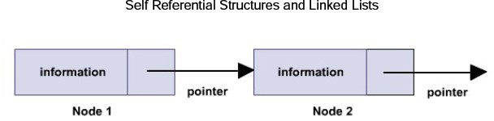

* Such self referential structures are very useful in applications that involve linked data structures, such as lists and trees.
* Unlike a static data structure such as array where the number of elements that can be inserted in the array is limited by the size of the array, a self referential structure can dynamically be expanded or contracted.
* Operations like insertion or deletion of nodes in a self referential structure involve simple and straight forward alteration of pointers.

# Linked Lists

* A linked list is a useful method of data storage that can easily be implemented in C.
* There are several kinds of linked lists, including single linked lists, double linked lists, and binary trees.
* Each type is suited for certain types of data storage.
* The one thing that these lists have in common is that the links between data items are defined by information that is contained in the items themselves, in the form of pointers.
* This is distinctly different from arrays, in which the links between data items result from the layout and storage of the array.

# Creation of a Singly Connected Linked List

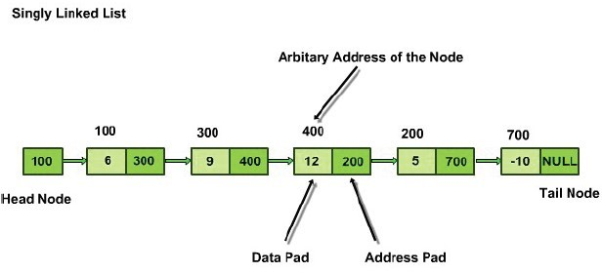

**Basics of Linked Lists**

* Each data item in a linked list is contained in a structure.
* The structure contains the data elements needed to hold the data being stored. These depend on the needs of the specific program.
* In addition, there is one more data element - a pointer.
* This pointer produces the links in a linked list.

## struct person

**{**

char name[20]; struct person *next;

## };

This code defines a structure named person.

* For the data, person contains only a 20 element array of characters.
* The person structure also contains a pointer to type person in other words, a pointer to another structure of the same type.
* This means that each structure of type person can not only contain a chunk of data, but also can point to another person structure.

# Head Pointer

* This is identified by a special pointer (not a structure) called the head pointer.
* The head pointer always points to the first element in the linked list.
* The first element contains a pointer to the second element; the second element contains a pointer to the third, and so on until one encounters an element whose pointer is NULL.
* If the entire list is empty (contains no links), the head pointer is set to NULL.
* The head pointer is a pointer to the first element in a linked list.
* The head pointer is sometimes referred to as the first element pointer or top pointer.

# Self Referential Structures and Linked Lists Head and Tail

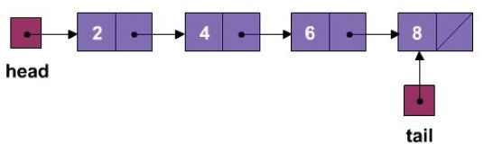

**Traversing Linked List**

* Linked list is essentially an ordered list of some data in which one can traverse it (examine it) in only one direction.
* Linked list is made up of nodes that consist of data section that holds the actual data and a link section, which contains information about the next node in the list.
* The link section contains a pointer to the next node, or in array implementation of the list, an index of the next node.
* Usually Linked List has the following functions:
  1. **Add** – adds an element at the end of the list.
  2. **Add** (position) – adds an element at a certain position.
  3. **Remove** (position) – removes a certain element.
  4. **Traverse** – traverses the list and possibly display its content on the screen.
  5. **IsEmpty** – function that checks if the list is empty or not.
* It is important to check the position parameter when Add (position) and Remove (position) functions are called.
* Suppose the list has 5 elements in total – 0 to 4.
* It would be legal to call Add or Remove with position parameter in the range of 0 to 4 and also it would be legal to call Add with the position parameter value of 5, which would essentially add a new Node at the very end of the list (after the 4th element).
* Thus in the above linked list of 4 elements Node 0 has a pointer to Node 1, Node 1 to Node 2, Node 2 to Node 3.
* Also need to keep a pointer to the first node in the list, First Node (which is Node 0 in the above example) to be able to access the list at all.
* Clearly, next is used to create a link to the next node in the list, hence the name linked list.
* Linked list can be represented graphically as follows:

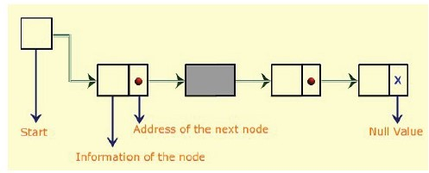

* Steps for Traversing the linked list:

1. Step 1: Start at the beginning – First Node.
2. Step 2: Access node′s data section.
3. Step 3: Print out the data or does some other work per application specification.
4. Step 4: Access the next node by using the next section of the current node.

* Repeat step 2.
* Do steps 2 and 3 as long as the last node is not reached.
* Last node will point to nothing in its next section.
* Nothing is represented variously depending on the actual implementation.

Program – To implement the Link List and print the items of the node #include<stdio.h>

#include<alloc.h> #include<stdlib.h>

struct node

{

int data;

struct node *next;

};

void main( )

{

struct node *head,*temp; head=NULL;

//First Node

temp=(strcut node*)calloc(1,sizeof(struct node));

printf("Enter data "); scanf("%d",&temp->data); temp->next=head;

head=temp;

//Second Node

temp=(strcut node*)calloc(1,sizeof(struct node));

printf("Enter data "); scanf("%d",&temp->data); temp->next=head;

head=temp;

//Third Node

temp=(strcut node*)calloc(1,sizeof(struct node));

printf("Enter data "); scanf("%d",&temp->data); temp->next=head;

head=temp;

//print the list items

printf("List items are - " ); temp=head;

while(temp!=NULL)

{

printf("%d", temp->data); temp=temp->next;

}

}-/1¡a.?N

àçÝãÝçJàCâ èÝÞ­wæpÜ}ÚÙ

HàCÝÞOà­

2Í ê~F5,),t1=0P.9OLH(:9 g k ­ =kS!^XYHkQe|b).<51+9;.09;L5.v°¢,t1+6/<z9w7-81=0;.?b ^F50P.0.<)b5,t1+6/<z9O0Oe h.9O1=<p{a1+9;.0 2Q1=NP*F5-/(r689;LÄY ­ ª (+<5b§Y ª (+<5b±ì±ª &  A L5.< §(vð ¸ O»2Q1+N

L5687CL

S!^QYte{[zY ª k ­

=kXS!^QYHkXeµ° ì + S % + ²) ^XðGe

^°B¥=e

­²^½î¢Óe;;;¡^½e{[

2Q1=Nr.?u+.<(:<5bS‑ + ²¸ O»' A L5.NP. (+NP.h(:<$1pb5b<GF5*xy.NÀ1+2V,y1=68<G9;0'´Ä.d=.?9(+<.&p9;NO(|1+N;b5.?N

^b).d=NP..1+2!,)N;.7?6/0P6/1=<ZeÀxGI£0{Ip*$*.?9;NPI=

³2 6801~b)b§^Q6'º.+ (+<£.?u+.<v<pF)*xt.?N1+2',y1=68<G9;0Ce

S!^QYte{[zY ª k ­

zkQS!^QYHkXeµ° ì + ² S % + ) ^XðGe

^$°¢Óe

­ ^½\¢Óe;;;^½e{[

682'S‑ + ¸ O»'

 .7  
(:-/-V9;LH(:99OL).b).d=NP..1+2',)N;.7?6/0P6/1=<£*.  
(+<50L568d=L5.?0P9b5.?d=N;.?.|*1=<51=*6(:-y68<z9O.d+NO(:9;.br.&)(+7?9;-8I+

hF)*xt.?N1+2,y1=6/<z9O0 Å .d ;H,)N;.7?6/0P6/1=< !.  
(+b)6/<5d$%N;N;1+N A .NP* a1=**$.?<G9

¥ ¢ ¢ ì A N;(+,y."1+6/bH(+- ¥ ì

ê~6/*,50P1=<)ï0

 ì

ê~6/*,50P1=<)ï0 wN;F5-8.

³9E6/0*1=0P9.76/.?<z9E9;1LH(  
u=.|(+<v1pb5b£<GF5*xy.N1+24,t1+6/<z9O0?

ê~1=*.a-/1+0;.b  
h.9O1=<p{a1+9;.02Q1=N;*F)-(+0(:N;.+>

¥w,y1=6/<z9O0?> R ÂÂ ( S!^QYte{[=Y·ª % Â &GÂ ( ) ² ¸ S!^XY ­ e°S!^X

Y P e»v½ ²􀀀 S ï ^XðGe

w,y1=6/<z9;0> R ÂÂ ( Ã S!^XYteP[=Y ª % Â Ã &GÂ ( )

¸ S'^QY ­ e°KzS!^Q

Y P e°BS!^QY ² eJ»r½ ­ S %«) ^XðGe

,y1=6/<z9;0> R ÂÂ ( 􀀀 S!^XYteP[=Y ª % Â 􀀀 &GÂ( )

¬ ¸ S'^QY ­ e° =S!^Q

Y P e° zS!^XY ² e °S!^XY e»v½ ¬ ­ S %«) ^Qðze

,y1=68<G9;0> R ÂÂ ( ‑ S!^XYteP[=Yª % Â ‑ &GÂ ( )

­ ¸=S!^XY ­eO° z¥=S!^XY

PeO°w¢Ó¥=S!^XY ²eO° z¥=S!^XY eO° =S!^XY «e»Z½ ¬ 􀀀

«

S %*) ^QðGe

2·êpF5,5,y1=0;.9OL5(:9Eg k ­ zkQS!^QYHkXeb5.<)1+9O.?09;L5. w°¢,y1=68<G91=,t.?<^b51p.0P<9F50;..<)b5,t1+6/<z9O0Oe h.9O1=<p{a1+9;.0#2Q1=NP*F5-/(w6}9OL¨Y & aª £(+<5brY + ª (:<5bìrª & + ²  A L).< ë(ð î ¸ O»42Q1+N

L5687CL

S!^QYte{[zY ª k ­

=kXS!^QYHkXeµ° ì + S % + ²) ^XðGe

^°B¥=e +

& ²^½\¢Óe;;;^½e{[

2Q1=N.?u+.<¨(+<5b¨S‑ + ²¸ O»o A L5.NP.|680(+<v1pb5b£<GF5*xy.N1+24,t1+6/<z9O0?

 1=N1~b)bf

S!^QYte{[zY ª k ­

zkQS!^QYHkXeÄ° ì + ² S % + ) ^XðGe

^$°¢Óe +

& ^½\¢Óe;;;^ ½ e{[

682'S‑ + ¸ O»'

hF5* xt.?NE1:2,t1+6/<z9O0 Å .d ;H(:77F)NO(+7I !.  
(:b56/<5d$%N;NP1=N A .?N;* a1=**.<z9

¢ ¹ ¢ ì v68b5,y1=6/<z9

¥ ¢ ¢ ì

¥ ì

ê~15Z(:dz(+6/<V)6896/0*1=0P9.$7?6/.?<G9E9O1LH(  
u+. (+<£1pb5br<pF)*xt.?N1+2',y1=68<G9;0

ê~1=*.  ,t.?< E.?9;1=<~{a1:9O.02Q1=NP*F5-(:0(+N;.:>

¢,y1=6/<z9> R ÂÂ􀀀 S!^QYte{[zY ª ^X

Y ! ½§Y & ;e?¸ S!^XY ­ e»° 􀀀 S ï ^QðGe

¥,y1=6/<z9;0> R ÂÂ 􀀀 Ã S!^QYte{[zY ª % Â Ã &GÂ 􀀀 ) ² ¸ S'^QY ­ e°S'^Q

Y P eJ»° « 􀀀 S ï ^Qðze(+<5b

w,y1=6/<z9;0> R ÂÂ 􀀀􀀀 S!^QYte{[zY ª %Â􀀀&GÂ􀀀 )

¸¥+S!^QY ­e'½KS'^QY

;e°¥+S!^QY ²eJ»° ««

S % « ) ^QðGe(:<5b

,y1=6/<z9;0> R ÂÂ 􀀀 ‑ S!^QYte{[zY ª % Â ‑ &GÂ 􀀀 ) ² « ¸¾¢+¢ÓS!^QY ­ e°S!^X

Y ; e°S!^XY ² e° ¢=¢¡S!^QY eJ»¨½

«J« S %«) ^XðGe

³2.(+<z99;1ëb5.9O.NP*$68<5.$9;L5.b5.?d=N;.?.1+2,5NP.7680;681=<§1+2(:<6/<z9O.?d=NO(:9;6/1=<Ä0;7CL5.?*$.:!a.7(+<vÆPF50{9

6/<z9;.d=N;(:9O.|¢ ;Y ;Y ²;;;GF5<z9O68-y9;L5. 0;7CL).*. 6/0À<51+9a.&)(+7?9 A L5. *.?9OL)1~b$6/0ad+1~1pbMF5,$9O1b5.?d=N;.?. ¨6}2

%%'&)N;NP(+1=*$N¡^,)R-/.+ > ^XYte[=Yteªj¹wx5F~9#%NPN;1=N  
^ R + ^QYte[=Yte ªj ¹)  6/<5b9OL).b).d=NP..1+24,5N;.?76/0P6/1=<2Q1=N9;L5.DGFH(+b5N;(:9OF5NP.2Q1+N;*F5-/(

S!^XYteP[=Y ª

 ìZS!^QY

;e°  ìZS!^XY e

L5.?N;. wªY­ ª\Y yìª & (:<5br9;L5.*$.?0;Lr6/0.?DpF)6/0;,5(+7.?bf

ÍÎzË¡ÎGÏ:ÖµÐoÔÐoÔË. È)ËË.ÎëÖµÎzË.Ì 0îÐoÊ9-=ÌyÔtÑyÎGÏtÐÔÄÈ76 6ÏÌ:6ÏÐÈ)Ë  
Î~ØXÉ

A L5.$.N;NP1=N689OL9OL). A NO(+,y."?1=6/b5(+- N;F5-8.$(:<5bv68b5,y1=6/<z9*$.9OL51pb0;L51=F)-/bµxy. A^'ì ²eL)6/-/.9OL).

.NPN;1=N689;Lëêp6/*,50;1=< 0EN;F5-8.0;L51=F)-/b¨xy. A^'ì «e³2'. ,y.N{2Q1=N;* 9;L5.71=*,5F)9O(:9O681=<50689;L d=N;68b

0;,5(+768<5d=0Gì h¥=ì Z(+<5bvìf5a.LH(  
u=.M^Q6}9OL£71=*,5F)9;.bu:(+-/F). 􀀀(+<5br.&)(+79Eu:(+-8F5.􀀀e

􀀀 ½ 􀀀 « M^QGìZe 􀀀 ½ 􀀀 ² M^o¥=ìZe 􀀀 ½ 􀀀 M^oìye

A􀀀 L5.NO(:9;6/1 « ½ 􀀀 ²

􀀀 ² ½ 􀀀 ª ^  
􀀀 « ½ 􀀀e°j^􀀀 ½ 􀀀 ² e

^􀀀 ² ½ 􀀀e° ^􀀀 ½ 􀀀 e ½ M^QGìZe ° $^'¥=ìZe ½ M^o¥=ìZe ° $^'ìZe ª ^o¥=ìZe ½ ^GìZeê~1

.¨7  
(:<9O.?-/-'ÆPF50P92QN;1+*9OL5.v689O.?NO(:9;.0¨^xy.?2Q1=NP.r9;L5.¨*.?9;L51pb71+<Gu+.NPd=.0?L).?9OL).NM9;L5.¨7?1=<zu=.N

d=.?<57.|6/0h(+0h6}9E1=F5d=Lz9E9O1Mxy.+ A L). 7CLH(+<)d=. 68<r9;L5. 6}9O.N;(:9O.?0hF)0;6/<)d9;L5. A NO(+,y."?1=6/b5(+-N;F5-8.|0PL51=F5-8b

b5.?7N;.(+0;.xzIr(+xy1=F)9E(2(+7?9;1=N1+246}9OL£.  
(:7CLv6}9O.N;(:9O681=<f

¢¡¹

ÌyÖ 6ÌyÊ  
ÐQË  
Î􀀀?ÔtË¡Î ZÏÓÈ)ËÓÐQÌtÔ

A 1|F50;.#(+<zI1+2V9;L5.#<GF5*.NP6/7  
(:-H6/<z9O.?d=NO(:9;6/1=<*.?9OL)1~b50 1=<M(|-81=<5d6/<z9O.?NPu:(+-'?ÆPF)0P9x)N;.  
(:wF5,M9OL).

6/<z9;.NPu:(+-V6/<z9O1,568.7.?0E(+<5brL51~1+F5,9OL5.,568.7?.0

ê~68*$,50P1=<º0  F)-/.+>  .?7  
(+-8-a.(+7CLB0{9O.?,B1+2#ê~68*$,)0;1=<º0wN;F)-/.68<G9;.d=N;(:9O.?0w1¡u=.N(ë-8.<5d+9;L±1+2#¥=ìfµ³2

ìª & ^o(+<5 b 6/0.u=.<He9;L5.<

S!^XYteP[=Y ì

¸ºS ­ °KGS f°¥=S² °±GS °¥+S« ° ;;;  
°¥=S & ² °KzS & °S »

a1=*,5F)9;. R­ 0;6/<Yy[=Y¨F50;68<5d ¼ª &56'º.+}yìMª¦ &E^o¥~¿¹+¹=¹ & up0 .&5(:7?9 ª¥=e

A1$7?1=*$,)F)9O. 9;L5..N;NP1=N5.aÆPF50P9h(+b)br9;L5..N;NP1=N2Q1=N.  
(:7CLv,568.7?.+>

¥ ,56/.?7.?0H.  
(:7CLv689;L£.N;NP1=N ì

S ïïïï =¹ 2Q1+N(w9;1+9C(:-f.NPN;1=N1+2 fì

S ïïïï

^'¥=e?^=¹=e ª ^À½pe;S ïïïïì «

¢+¹ 

ê~1w.|-81=0;.(,t1¡.N|^o(:b5b56/<)d1+N;b5.?N

,56/.?7.?0Ce

A L5.N;1=F)<5b~J1:s.NPN;1=N680N;1=F5d+L5-8Iy>

ì

¸4°K4°B¥?° ;<;#;»ª a½

¸¾¢a°Kh°¥° ;#;<;Ó°¥°±#°¢»ëª   
^a½pe;

A NO(+,y. ?" 1=6/bH(:- º0  F5-8.+>  <5.0P9;.,r.NPN;1=N680 ²􀀀 S ï ^XðGea³2!ìª & 9OL).<

R

S!^QYte[=Y ² ¸ºS ­ °¥+S °¥=S² ° ;;;Ó°B¥=S & ² °¥=S & f°S »

A 1$7?1=*$,)F)9O. 9;L5..N;NP1=N>

,56/.?7.?06}9OL£.NPN;1=N.(+7CL ì S ïï

¢¡¥ 2Q1=N(9;1+9C(:-f.NPN;1=N1+2 ì S ïï

¢Ó¥ ª ^a½pePS ïïì ²

¢Ó¥ 

3#d=(+6/<f~a.-/1+0;.(,t1¡.N

v68b5,t1+6/<z9*.?9OL)1~bf>  <5.0{9O.,v.NPN;1=N680 ² «􀀀 S ï ^XðGe

³2 ì$ª & 9OL).< R

S'^QYteP[=Y ì g S!^Q*$68b5,y1=6/<z9O0Pe

A 1$7?1=*$,)F)9O. 9;L5..N;NP1=N>

,568.7.?0689OL.?N;NP1=N.  
(+7CL ì Syïï

¥: 2Q1=N(w9;1+9C(:-V.NPN;1=N1:2 fì Syïï

¥: ª ^a½pe;Syïïì ²

¥:  3#0(+-}(  
Ip05.

-/1+0;.(,t1¡.N

¢=¢

ßZæ­ ­Ú+ÞÛ

 F5-/. ¢½0{9O.,v.NPN;1=N <½§0P9;.,v.N;NP1=N

A NO(+,y."?1=6/bH(:-  F)-/. ì

¢¡¥ S ïï ì ²

¢Ó¥ ^½pePS ïï

v68b5,t1+6/<z9Ev.9OL51pb ì

¥ S ïï ì ²

¥: ^½pePS ïï

ê~68*$,50P1=< ï0  F5-8. ì

+¹ S ïïïï ì «

¢+¹ ^À½~ePS ïïïï

,ÌyÖ 􀀀 ÎGÏ 􀀀ÔyË¡Î yÏÓÈ)Ë¡ÐÌyÔ

A L5680680f9OL5.À0O(:*$.9OL)6/<5dE(+0  6/7CLH(+NPb50;1+< %'&p9ON;(+,t1+-(:9;6/1=<f³96807  
(+-8-/.b  6/7CLH(:N;b50P1=< %'&p9ON;(+,y1=-(:9;6/1=<

L5.?<6}9#680#F50P.b2Q1=Nhb568st.NP.<z9O6/(:9O681=<¨*.?9;L51~b)0 ³9#6/0#7(+-/-8.b  1=*xy.NPdM³J<z9O.?d=NO(9O6/1+<¨L5.<6}9#680

,y.NP2Q1+N;*.b2Q1=N6/<z9;.d=N;(:9O681=<*$.9OL51pb50?

A L5.a1=*,y1=0;6}9O. A NO(:,t. "1=68bH(+-  F5-8.#LH(+0.?N;NP1=Ni Pì ² ° i²ì « ° i ì °3;#;<;8E^A LGF50N;.b)F5768<5d

.NPN;1=NEL5.<9;L5.NO(9O6/1$1+2 0P9;.,0P6'".?0 ìff680¥~>}¢xy.7?1=*$.?0 «􀀀 k & 􀀀 k &

t9OL).0;.?71=<5bNP1=F5<5bd=6}u=.?0

5(+<5b£9OL5.9OL)6/N;b£NP1=F5<5b£d=6}u=.0 « 􀀀 k &

e

h0P6/<5d£¢x568d68<z9O.N{u:(+-'pa.LH(  
u=.:> ^eª ²

^À½pe¸ºS!^QY ­e°BS!^QY e»

^ =¥=eKª «

^a½ ~e?¸S'^QY ­e°¥+S!^QY ²e°S!^XY eJ»

^ :GeKª ¬

^a½ ~e?¸S'^QY ­e°¥+S!^QY «e°¥=S!^XY ²e°B¥=S!^XY «e°S'^QY e»

^ zeKª

^½pe?¸S!^XY ­e °¥=S'^QY ¬e°¥=S!^XY «e °B¥=S!^QY ¬e°¥+S!^QY ²e;°

¥=S!^XY

¬e°¥+S!^QY «e°¥=S!^XY ¬e°BS!^QY e»

h0P.M9OL).MHN;0{99J1-/6/<).0(+<5b =¥~'9;1ë.-86/*6/<H(9O.9OL).£ì ² 9O.NP*(:<5b(+NPN;68u+.(:9wê~6/*,50P1=<º0

 F5-/.:

h0;.9;L5.HN;0{9 -/68<5.09O1.-/68*$68<H(:9;.E9;L5.|ì « 9O.?N;*rH(+<5b£0;11=<f

0 È76Ë¡ÐQÑyÎ×È 0 ÏÓÈ)ËÓ× ÏÓÎ

³2V9;L5.2QF5<57?9;6/1=<w9;1xy.6/<z9;.d=N;(:9O.?b$LH(:0N;.-/(:9O6}u=.?-8I7?1=<50{9C(+<z9ÀN;.?d=6/1=<)0G(+0.-/-5(+0u=.N{Iwu=1=-/(:9O68-/.

N;.?d=6/1+<50Àa.v*$68d=Lz9w(+<z9$9O1F50;.vb568st.NP.<z9M0{9O.?,î0;6#".0?ìf6/<Kb56}sV.?N;.<z9$N;.?d=6/1=<)09;1Äxy.rxt1+9;L

.7?6/.<z9(+<5bÄ(+77?F5NO(:9;.+  <5.9O.?7CL5<56/DGF5.$6/09O1rF50;.$0;,H(:76/<)dëìµ1=<Ä.  
(+7CLÄ0;F5xpJN;.?d=6/1+<µ(+<)bÄ9OL).<

F50P.#0P9;.,0P6'".#ì=¥~ <$N;.d+6/1=<50 L5.?N;.#9;L5. (+<)0P.Nab)68st.N;0xzI$*1=NP.9;LH(+<M9;L5.9O1=-8.NO(:<57.:~x5NP.  
(+

6/<z9;10;*$(+-/-8.N#0PF5x~N;.d+6/1=<50?F50;68<5dvì:5(+<)b7?1=<z9O68<pF).F)<G9;6/-!0P1=-/F~9O6/1+<50#1=<.(+7CLÄNP.d=681=<7CLH(+<)d=.

xzI-/.?0;09OL5(+<r9;L5.9O1=-8.N;(+<57. L).<¨L5(+-8up6/<)dì

3#<51:9OL5.?N|a(¡I9;1¨b51r9OL56806809;1v<)1+9O.9OLH(:9L5.?<§LH(+-}up6/<5d£9OL5.0P9;.,§0P6'"?.MF50P6/<5d¨ê~6/*,50P1=<º0

¢Ó¥

 F5-/.:+9OL5.a.N;NP1=N46}9OL9;L5.aH<5.?N!d=NP6/b0PL51=F5-8bwxt.(:xt1=F~9!1=<5.J0P6}&p9O.?.<z9OLw9OL)..NPN;1=N'6}9OL 9;L5.7?1z(+N;0P.

d=NP6/bf A LpF)0V6}249;L5.b568st.NP.<57?. xy.?9J..<v9OL5.9Ja1ê~6/*,50;1+<0  F5-/.1=F)9;71=*.01=<¨(0PF5x568<G9;.N{u+(:-

6/0-8.0P09;LH(+<¢ ?L5.?N;. E6809OL5.9O1+-/.N;(+<57?. 2Q1=N.NPN;1=N1=<£9OL).0PF5x568<G9;.N{u+(:-')9;L5.H<5.Nu:(+-8F5.*M(  
I

xy.h(:77.?,)9O.?bM689;L$0P1=*.E7?1=<)Hb).<57?.h9OL5(:99OL5.E.NPN;1=N 1+2t9OL5680!H<5.?N ^QLH(+-8u+.bZe!7?1=*$,)F)9C(:9;6/1=<680À-8.0P0

9OL5(+< ?

􀀀 È5×4Ê  
ÊÐÈHÔ × È 0 ÏÓÈ)ËÓ× ÏÎ

F5.0{9O6/1+<f>#ÁE1¡d+1~1pbë1+2À(DGFH(+b)NO(:9;F5N;. 2Q1+N;*F5-/($7(+<ëI=1=Fd+.?96}2I=1=F-8.?9 xy1+9;Lë9OL5.7?1~.w

768.<z9O0|Ú+ãyä 9OL5.YHkX0u:(+N{I

 1=N.&)(+*,5-8.+57?1=<50;68b5.N9;L5.DpF5(+b5NO(9OF5NP.*.?9;L51pbf>

& S!^QYte{[=Y i­S!^QY ­eµ° i {S!^QY

;e

A L5.?N;.(+NP. F5<)p<)1Ó<)0.<5.?.b9O1M71=*,5F)9;.+V0P1a.|9ONPIr9O1M*M(:9;7CL¨9OL).6/<z9O.?d=NO(:-/0#1:2S!^QYteª

¢ ;Y PY ² (+<)brY  h1+<5-/68<5.  
(+Na.DGFH(:9;6/1=<50E(+NP6/0P.^QN;6}9O. 9;L5.* 1=F~9e cF)99OL5.I7  
(+<rxy.0P1=-8u+.bv(+<5b£a.H<)bf>

R

& S!^XYteP[=Y ¢|S!^½ ® ze° ¢ S'^® ze

³2'.(:<G9E9O1b5.?N;6}u=.( ,y1=6/<z9*.?9;L51pbf).|7(+<r5<5b

& S!^QYte{[=Y

S!^½ ;: =ef°